Fun, Family, Friends Evergrace Goldens … Companions for Life
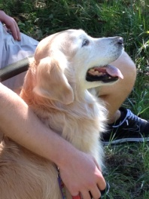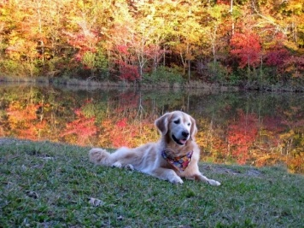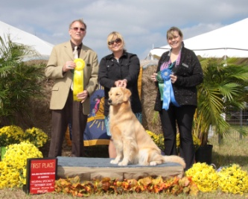
Please tell us a little about you & your family. We hope you will share what you are looking for & why, your hopes with expectations of a puppy, adult, breeder and price. Your assistance in completing this questionnaire will help us make decisions to determine the possibilities of matching puppies to people. Please feel free to share any additional information that may be helpful.
Thank you for your cooperation and interest! Jane Gallagher
NAMES ___________________________________________________________________________
ADDRESS__________________________________________________________________________
CITY STATE ZIP______________________________________________________________________
PHONE &/or FAX work cell ____________________________________________________________
E-MAIL ADDRESS____________________________________________________________________
OCCUPATION_______________________________________________________________________
How did you learn about us?

Why have you decided to purchase a Golden Retriever? Is this your first Golden?

What sex do you prefer? Male? Female? but if not available/Flexible?)

What age do you prefer? Puppy? Adult?
For what purpose are you purchasing a Golden Retriever? Companion Pet? Obedience? Rally? Show? Field? Hunting? Breeding? Tracking?
Do all family members want a new puppy?
Are there children in family? Ages?

Do any family members have allergies to dogs?
Do you own? Rent? Live in a home? Apartment ?
Where will your Golden be accommodated during the day?
For what length of time?
Can you accommodate needs of young puppy?
Dog run with a doghouse? Inside only? Outside only?
Do you have a securely fenced yard?
Are you committed to care for this dog's needs for his lifetime?
What is your price expectation for a quality well bred companion now?
Are you prepared for future investment of time and money?
Your veterinarian is:
Tell us about your other pets now or past pets. Have you previously owned a dog?

Have you ever had to euthanize a dog? If yes, why?

Are you willing to take this dog to obedience classes in order that he will become an enjoyable companion and a canine good citizen?
Who will train this dog? Where?
Have you ever completed an AKC title in obedience, field, breed ring? Please list titles completed:

What type of personality are you looking for in your puppy? Why?

If you ARE considering a competition companion and potentially breeding this dog, are you willing to obtain all the necessary clearances beforehand: OFA hips/ elbows, eyes CERF, heart SAS, and brucellosis?
Are agreeable to co-ownership and/ or consulting us before selecting a proper mate?
Companion dogs will need to be spayed or neutered when mature. Are you willing to spay/neuter this dog? If not, why?
If you are not breeding this dog, are you still willing to obtain clearances of OFA, CERF, and SAS to help us maintain the highest of breeding standards? (Your assistance is critical in establishing this data bank)
Any other comments:

