SPECIAL MEETING
SEPTEMBER 4, 2014

A Special Meeting of the Town Board of the Town of Hampton, County of Washington and the State of New York was held at the Town Hall, 2629 State Route 22A, Hampton, New York on the 4th day of September 2014.

PRESENT: David K. O’Brien----------Supervisor
Tamme Taran---------------Councilwoman
David Jensen----------------Councilman-came at 7:37pm
Donald Sady----------------Councilman
Andrea Sweeney-----------Councilwoman
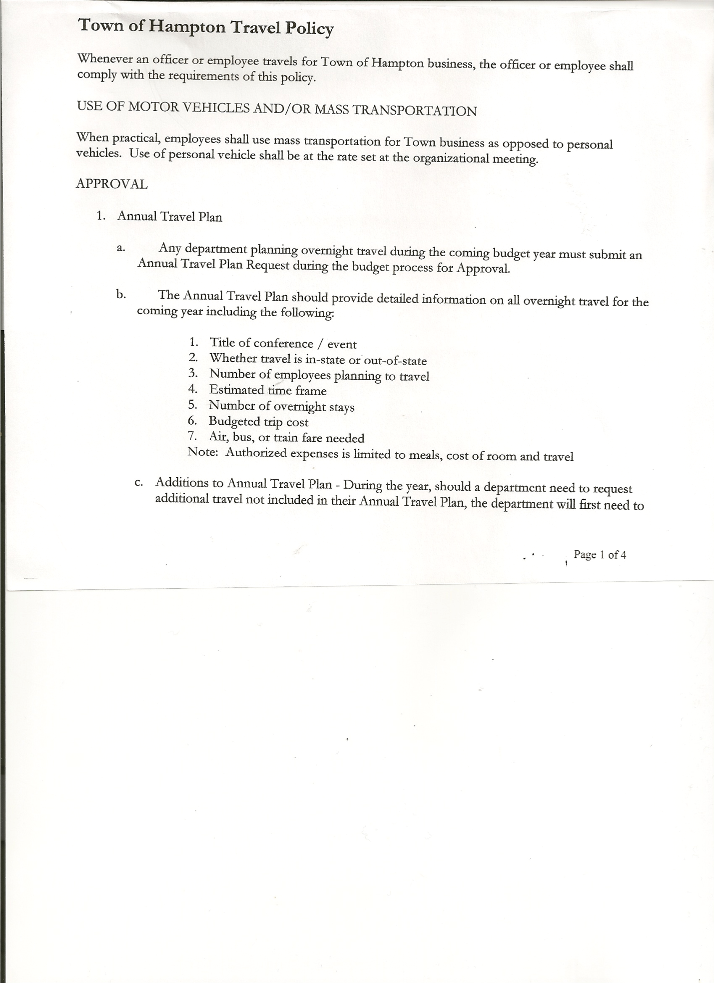
Rebecca Jones--------------Town Clerk
Camilla Shaw---------------Tax Collector/Deputy Town Clerk
Herbert Sady, Jr.------------Highway Superintendent

Planning Board Members: Joe Panoushek and Frank Baker

Also present: Kim Perry, Budget Officer/Bookkeeper, Mary Holland, Artie Pratt and Leonard Reed.

The Special Meeting of the Town Board was called to order by Supervisor O’Brien at 7:30 pm followed by the Pledge of Allegiance. Locations of Fire Exits were given.

OLD BUSINESS

Banking….
RESOLUTION NO. 75 -2014
MASTER CERTIFICATION OF AUTHORITY SCHEDULE TO MASTER BUSINESS SIGNATURE CARD
On a motion of Councilwoman Taran, seconded by Councilwoman Sweeney the following resolution was ADOPTED
Ayes 5 O’Brien, Taran, Jensen, Sady, Sweeney
Nays 0
RESOLVED that Supervisor David O’Brien is the Authorized Representative of the Account Holder “Town of Hampton” who has the authority to execute and deliver said schedule to the Bank.

Update on Executive Session Rules…Town Board Members are usually the only elected officials in an Executive Session and the Town Clerk is usually asked to stay to note time in and out of Executive Session and to take minutes if there is an action taken during the Executive Session.

NEW BUSINESS
Hampton Fire Department…Supervisor would like board to consider a multiple year contract.

Outdoor Furnace…suggestion was made to consider one, cost is approximately $15,000.00. Cord of wood is approximately $100 to $110.
Questions to consider…how much wood to buy?
code requirement/insurance cost?
Distance from building(s)?
TOWN BOARD MEETING
September 4, 2014 PAGE 2

Heating cost has been $7500.00 for 2012
$4500.00 for 2013
$5700.00 so far for 2014
The following suggestions were made… Highway Garage temperature to be lowered and to make sure overhead doors are shut.

Board of Assessment Review…David Bridges is moving out of town, need to appoint someone to replace him.

Personnel & Employee Policy discussion…..Highway and Town Board should work together to come up with job descriptions & expectations, should be reviewed yearly, ask for employees input and/or suggestions.

Supervisor O’Brien appointed a Committee consisting of Councilman David Jensen and Councilwoman Tamme Taran, Highway Superintendent Herb Sady, Budget Officer/Bookkeeper Kim Perry and resident Mary Holland to come up with a Personnel/Employee Policy. Supervisor has asked a few towns for a copy of theirs for examples.

Second quarter audits for Town Clerk, Town Justice, Tax Collector and Bookkeeper need to be completed.

On a motion of Councilman Sady, seconded by Councilwoman Tarn the meeting adjourned at 7:59 pm. All in favor Aye.

Respectfully submitted,

Rebecca S. Jones, RMC
Town Clerk

