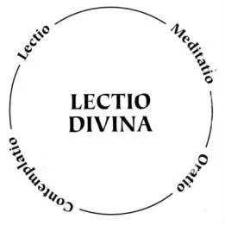
Lectio Divina means ‘divine reading’. It is an active way of reading; where we both pay attention and examine the full range of possibilities within the text we read. We also explore what we bring to the text from our own backgrounds. Put simply, it is active reading, prayerful and with our minds and hearts open to God, as if he was reading the words with us. We are stepping into the silence and letting the Holy Spirit guide our hearts and spirits. The ultimate aims of lectio divina are always to draw God closer to us through our surroundings and through scripture and to seek God’s voice within our lives. David Foster, O.S.B puts it like this: “Lectio divina is a way of praying, but a prayer where we let God start the conversation, rather than bombarding God with our own agendas and pre-occupations”. It is practised in a four-fold way: lectio, meditation, oratio, contemplatio.
Our scripture this evening is from St Paul’s letter to the Romans, chapter 8. 18-25.
I consider that the sufferings of this present time are not worth comparing with the glory about to be revealed to us. For the creation waits with eager longing for the revealing of the children of God; for the creation was subjected to futility, not of its own will but by the will of the one who subjected it, in hope that the creation itself will be set free from its bondage to decay and will obtain the freedom of the glory of the children of God. We know that the whole creation has been groaning in labour pains until now; and not only the creation, but we ourselves, who have the first fruits of the Spirit, groan inwardly while we wait for adoption, the redemption of our bodies. For in hope we were saved. Now hope that is seen is not hope. For who hopes for what is seen? But if we hope for what we do not see, we wait for it with patience
Lectio
Where we take the scripture into our eyes through reading.
Think about what the words might be saying to you.
Meditatio
We repeat them and begin to digest them in our minds.
Does this text make you think about anything in particular?
Oratio
As we repeat the scripture, we use it to frame our own prayers.
What does this text make you want to pray about?
Contemplatio
We listen for God’s response to our prayers, and continue our conversations with God wherever they lead us.
It can be hard to quieten our minds enough to focus, but listening is a skill that can be learnt through practice! Even if you manage a minute for each bit, that is great!
Ending
Once we find our attention being drawn back to the present; we pray the Lord’s Prayer and close our time of prayer with ‘Amen’. Amen means ‘so be it’ or ‘let it be so’.

