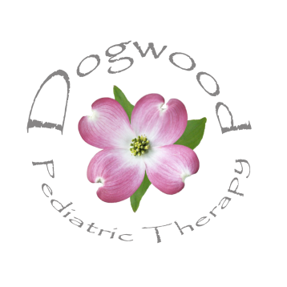
Dogwood Pediatric Therapy
6428 Cape Charles Dr. Raleigh, NC 27617 Ph: 919-247-4551 Fax: 919-882-9569

CONSENT FOR RELEASE OF PATIENT INFORMATION

I hereby authorize Dogwood Pediatric Therapy to release information in my child’s record, including evaluation results, goals, or progress notes to:

- My child’s pediatrician: __________________________________________________________________

- My child’s school / preschool: ___________________________________________________________

- The CDSA

- Other: ______________________________________________________________________________________

The purpose of any exchange will be to coordinate patient care.

I understand that this consent is voluntary and that I may revoke this consent in writing at any time.

___________________________________________________________ ________________________________
Patient Name Date of Birth

____________________________________________________________ _______________________________
Parent / Guardian Name Date

