

SUMMER – 2021 SEASON
4th August 2021
Liberation Club Singles Cup

22 players took part in the 10th Anniversary of the competition.

2020 champion Brian Harris started off with a win over Lorna Limbrick, with the match being timed out at 11 – 7. Three-time champion Andrew Bellamy-Burt also with a win 11 – 8 over Gary Cowburn.

James Rondel beat one of the favourites Andrew Limbrick 13 – 7 and Tom Le Sueur handed Premier League player Joey a big defeat 13 – 4.

Wins also for Toby over Alex, Geoffroy over James and Ross over Cassie as well as Branden with a big result over Jean.

Round 2 saw a repeat of last years final between Brian and Andrew BB with Brian again coming out on top but only just 10 – 9.

Tom Le Sueur kept up his impressive results, this time 12 – 8 over James Rondel. James Villalard beat Tim Jackson 9 – 8 in another really close match.

Lorna had a good win over Kevin Daly and Andrew L won his match comfortably over Wendy 13 – 3. Toby, Ross and Geoffroy all winning their second matches.

Round three saw Jean move onto two wins from three with a close 13 – 11 match against Gary. Andrew L beat Ross to also move onto two wins.

Paul Bell just overcame Lorna 13 – 12 to get his second win as did Andrew B over Joey 13 – 2.

Tim Jackson had an impressive win over James Rondel 11 – 9 and Callum beat Branden as both players moved to two wins.

Round 4 saw Toby recover from his loss to beat Jean 13 – 8 and Tim Jackson beat Andrew L 10 – 9 to move into contention for the Quarter finals

Paul Bell beat Callum, Alex beat Tom and Andrew B beat Ross as all three moved to three wins.

Geoffroy handed Brian just his second loss in the tournament in 11 matches. Wendy beat Lorna 12 – 8and James V beat Kevin.

In the final qualifying round Geoffroy just overcame Paul 11 – 10 to finish top of the rankings with 5 wins from 5.

Andrew B beat Toby 13 – 11 to finished third with Toby finishing fifth. Tim Jackson beat Alex Stewart but again both qualified with Tim in fourth and Alex in eight.

James Rondel 13 – 4 win over James Villalard wasn’t enough as he missed out by 1 BHN point against Alex to finish in 9th. Tom Le Sueur had another great result beating Ross Payne 11 – 8 to go through in seventh place with Ross finishing 14th as a result.

Callum loss to Brian 13 – 11 ended his tournament finishing 13th with 2020 champion Brian finishing second.

So James rondel, Paul Bell and Wendy Ritzema all with three wins not going through on BHN.

FINAL RANKINGS

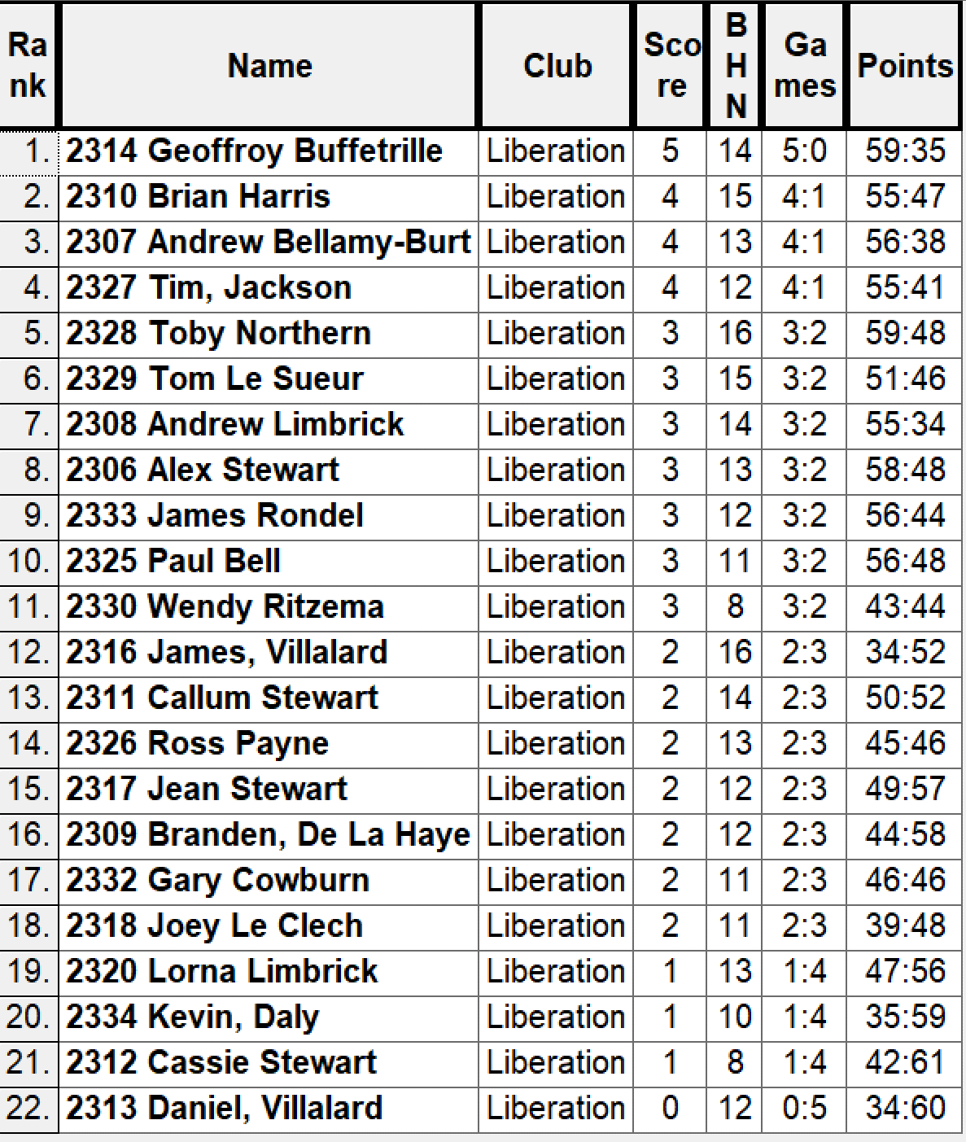

Quarter Finals

Ranked 1st Geoffroy Buffetrille v Alex Stewart Ranked 8th

Ranked 2nd Brian Harris v Andrew Limbrick Ranked 7th

Ranked 3rd Andrew Bellamy-B v Tom Le Sueur Ranked 6th

Ranked 4th Tim Jackson v Toby Northern Ranked 5th

Well Geoffroy made lite work in his match against Alex winning 13 – 1. Tim Jackson had the game of his life with some impressive shooting and placing to beat Toby 13 – 3 and Andrew Limbrick knocked out the champion Brian Harris 13 – 9. Really clos match as Tom just missed out on another big scalp losing 13 – 11 to Andrew Bellamy-B.

So the Semi Finals were played as follows:

Ranked 1st Geoffroy Buffetrille v Tim Jackson Ranked 4th

Ranked 3rd Andrew Bellamy-B v Andrew Limbrick Ranked 7th

Well Tim performance dipped against an impressive Geoffroy who made yet another final winning 13 – 6.

The other Semi-final though was as close as it could get. With 1 minute 30 seconds left Andrew was 8 – 6 up and holding one on the ground with two boules to play with Andrew having played all his. Andrew didn’t get either of his last two in to go into the final end 9 – 6 up but he could have taken the full time to through his boules and won 9 – 6.

So all Andrew L needed to do was ensure Andrew B didn’t get three points and he would make the final. Andrew first boule was a very good, but Andrew just out pointed it. Instead of firing Andrew boule out which would have meant he couldn’t get the three he needed just to tie the match and chose to point his next two but these didn’t beat Andrew Bellamy-B boule and to his credit placed in his last two perfectly to get three points and take it to another end at 9 – 9.

Unfortunately a bad end for Andrew on the next one gave Andrew a 10 – 9 win to make his fourth successive final.

Andrew Limbrick recovered to beat Tim Jackson 13 – 8 for third place, with Tim having another great tournament.

Well the relief for Andrew Bellamy-B must have given him the drive he needed in the final as his placing consistently out did Geoffroy shooting to win comfortably 13 – 4 for his fourth title in ten years, very impressive indeed.

Thanks to James Rondel, Gary Cowburn, Lorna Limbrick, Paul Bell and anyone else who helped on the day.

Champion

Andrew Bellamy-Burt
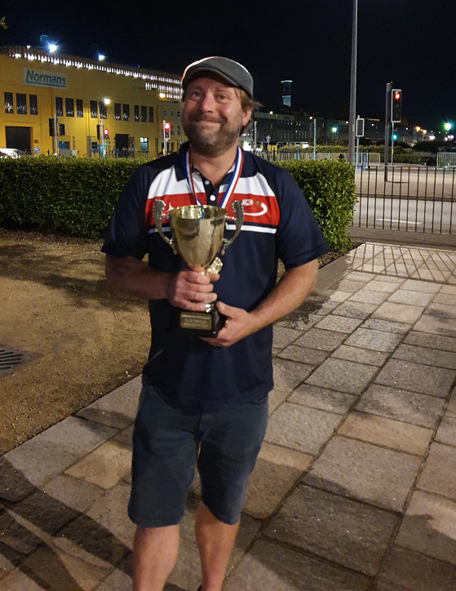

Runner Up Third Place

Geoffroy Buffetrille Andrew Limbrick
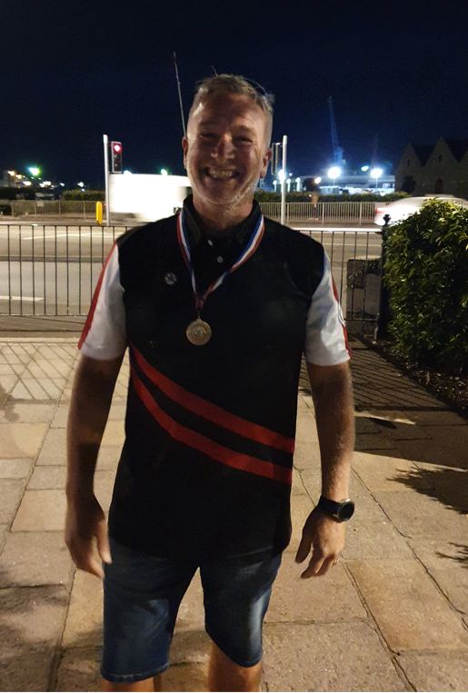
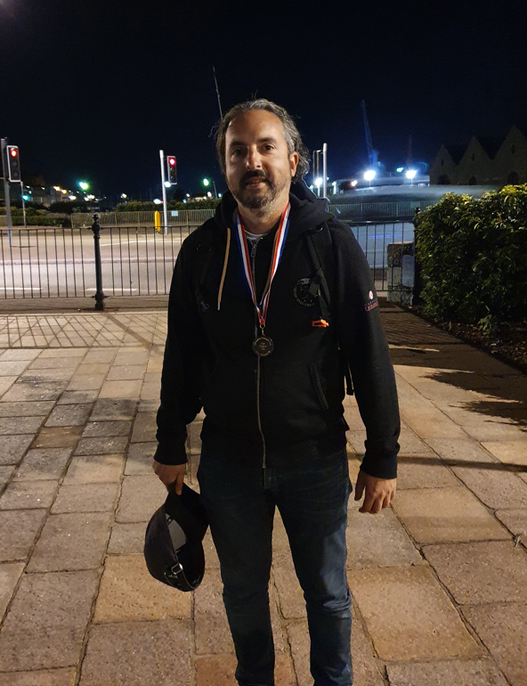

NEXT WEEK - Doubles League

Club email address -

Club Website -

Kind Regards

Toby Northern

Chairman

Liberation Petanque Club

