10/28/2017 Problem Solved

A Preliminary Note

It was noted in the last article that the rider of the white horse was symbolically loosed on the Karaite Day of Atonement, October 1, 2017, when O.J. Simpson was released. O.J was the center of a major media event in 1994 when he captured the attention of the nation as he led police on a chase as the rider of a "white Bronco", symbolizing a white horse.

Then later on October 1 Stephen Paddock allegedly killed 58 people, injured around 527 others, and then killed himself in the Las Vegas massacre. It was noted that the name Stephen means "crown" and a Paddock is "a small enclosure for horses".

These events and names symbolically correspond with Revelation 6:2.

Revelation 6:1 And I saw when the Lamb opened one of the seals, and I heard, as it were the noise of thunder, one of the four beasts saying, Come and see.
2 And I saw, and behold a white horse: and he that sat on him had a bow; and a crown was given unto him: and he went forth conquering, and to conquer.

As this article is being composed on 10/28/2017, a tropical storm with a lot of rain named Philippe is located south of Florida and is supposed to pass over south Florida. The name "Philippe" means "lover of horses". The name is from the Greek philos = loving and hippos = horse. We again have a reference to a horse, this time in a tropical storm.

The Threat to Israel is Solved

In Ezekiel chapters 37, 38, 39, and 40 we see a sequence of events that begins with the gathering of Israel into it's land and the strengthening of the nation in chapter 37.

Then a major attack by surrounding nations and peoples who are defeated by YaHuWaH Elohim Himself in chapters 38 and 39.

Then the dimensions of a temple and certain related instructions are given in chapter 40.

There is a logical progression in the chapters noted above that result in the settlement of Israel in the last days, the nullification of threat from surrounding nations, and a temple that is built in Israel.

Nearly 3 years ago, in November of 2014, YaHuWaH Elohim revealed to me a series of solar eclipses that placed andcient Paleo Hebrew "Tavs", "X's" on the surface of the earth in certain nations. The "Tavs" had certain characteristics such as being 2422 days between the partner eclipses, with the final eclipse always falling on the astronomical 1st of Aviv 2422 days after the first eclipse.

The sequence of solar eclipse Tavs began on 8/11/1999.

Two of the "Tavs" were inscribed on the middle east region and are pictured below.

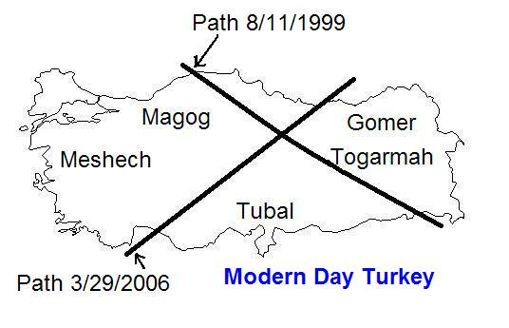
Above: The 1st Tav crossed the Muslim nation of Turkey, and the ancient homes of tribes and peoples mentioned in Ezekiel 38.

The other Tav in the Middle East region will begin on 8/2/2027 and will form a cross with its partner over the Red Sea 2422 days later.

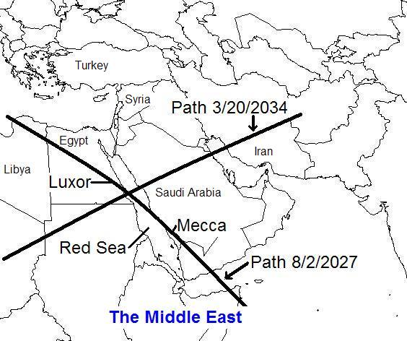

Above: The path of the solar eclipse of 8/2/2027 above will pass directly over Mecca, and the Kaaba, the center of Islamic worship. When the sky darkens in the daytime in Mecca on 8/2/2017, the constellation Leo, signifying Israel's Messiah King, the Lion of Judah, will appear near the darkened sun to Muslim worshipers.

Below: If we look at the paths of both Tavs, all four solar eclipses involved, we see an enclosure approximately centered on the nation of Israel.

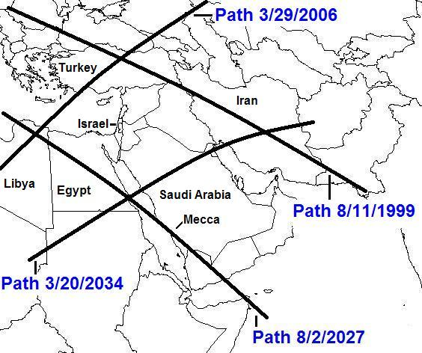

Above: The original two Tavs are now revealed to be 4 "X's", having a total of four crossing points.

The crossing points of the total solar eclipses in the graphic above are revealed to be in Libya, Turkey (the site of ancient Gomer, Meshech, Tubal, etc.), Iran (the site of ancient Persia), and the Red Sea. These nations are mentioned in Ezekiel 38 as being among those who attack Israel in the last days.

Ezekiel 38:1 And the word of YaHuWaH came unto me, saying,
2 Son of man, set thy face against Gog, the land of Magog, the chief prince of Meshech and Tubal, and prophesy against him,
3 And say, Thus saith the Master YaHuWaH ; Behold, I am against thee, O Gog, the chief prince of Meshech and Tubal:
4 And I will turn thee back, and put hooks into thy jaws, and I will bring thee forth, and all thine army, horses and horsemen, all of them clothed with all sorts of armour, even a great company with bucklers and shields, all of them handling swords:
5 Persia, Ethiopia, and Libya with them; all of them with shield and helmet:
6 Gomer, and all his bands; the house of Togarmah of the north quarters, and all his bands: and many people with thee.
7 Be thou prepared, and prepare for thyself, thou, and all thy company that are assembled unto thee, and be thou a guard unto them.
8 After many days thou shalt be visited: in the latter years thou shalt come into the land that is brought back from the sword, and is gathered out of many people, against the mountains of Israel, which have been always waste: but it is brought forth out of the nations, and they shall dwell safely all of them.
9 Thou shalt ascend and come like a storm, thou shalt be like a cloud to cover the land, thou, and all thy bands, and many people with thee.
10 Thus saith the Master YaHuWaH ; It shall also come to pass, that at the same time shall things come into thy mind, and thou shalt think an evil thought:
11 And thou shalt say, I will go up to the land of unwalled villages; I will go to them that are at rest, that dwell safely, all of them dwelling without walls, and having neither bars nor gates,

Ezekiel 38:18 And it shall come to pass at the same time when Gog shall come against the land of Israel, saith the Master YaHuWaH , that My fury shall come up in My face.
19 For in My jealousy and in the fire of My wrath have I spoken, Surely in that day there shall be a great shaking in the land of Israel;
20 So that the fishes of the sea, and the fowls of the heaven, and the beasts of the field, and all creeping things that creep upon the earth, and all the men that are upon the face of the earth, shall shake at My presence, and the mountains shall be thrown down, and the steep places shall fall, and every wall shall fall to the ground.
21 And I will call for a sword against him throughout all My mountains, saith the Master YaHuWaH : every man’s sword shall be against his brother.
22 And I will plead against him with pestilence and with blood; and I will rain upon him, and upon his bands, and upon the many people that are with him, an overflowing rain, and great hailstones, fire, and brimstone.
23 Thus will I magnify Myself, and sanctify Myself; and I will be known in the eyes of many nations, and they shall know that I am YaHuWaH .

Ezekiel 39:1 Therefore, thou son of man, prophesy against Gog, and say, Thus saith the Master YaHuWaH ; Behold, I am against thee, O Gog, the chief prince of Meshech and Tubal:
2 And I will turn thee back, and leave but the sixth part of thee, and will cause thee to come up from the north parts, and will bring thee upon the mountains of Israel:
3 And I will smite thy launchers out of thy left hand, and will cause thine missiles to fall out of thy right hand.
4 Thou shalt fall upon the mountains of Israel, thou, and all thy bands, and the people that is with thee: I will give thee unto the ravenous birds of every sort, and to the beasts of the field to be devoured.
5 Thou shalt fall upon the open field: for I have spoken it, saith the Master YaHuWaH .
6 And I will send a fire on Magog, and among them that dwell carelessly in the isles: and they shall know that I am YaHuWaH .
7 So will I make My holy name known in the midst of My people Israel; and I will not let them pollute My holy Name any more: and the heathen shall know that I am YaHuWaH , the Holy One in Israel.
8 Behold, it is come, and it is done, saith the Master YaHuWaH ; this is the day whereof I have spoken.

The threat from surrounding nations will be neutralized by YaHuWaH Elohim Himself. After that happens, there will be no doubt among the nations that there is an Elohim in Israel.

Let's look at the Tav placed on Libya and its timing in the graphic below.

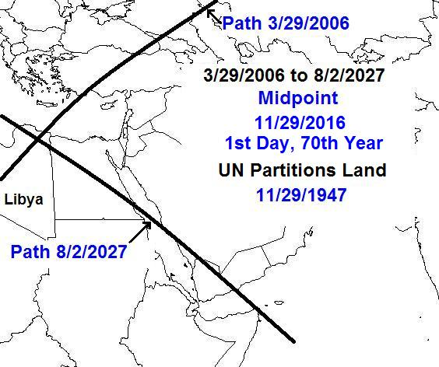

In the graphic above, there are 7796 days between the solar eclipses that inscribed the Tav on Libya.

The central date of those 7,796 days is 11/29/2016.

Let's look at the Tav placed on Iran, ancient Persia, in the graphic below.

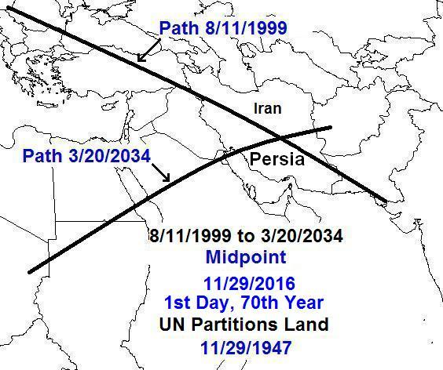

In the graphic above, there are 12,640 days between the solar eclipses that produced the Tav on Iran. The central date of those 12,640 days is 11/29/2016.

Note that the midpoint date of the Tavs in both grapics above is 11/29/2016, which was the 69th anniversary of the dividing of the promised land by the United Nations and parceling it to both arabs and Jews on 11/29/1947. Our Creator Elohim are in precise control of their magnificent clockwork in the heavens and reveal its relationship to the modern nation of Israel.

We know that 69 inclusive years from 11/29/1947 were completed on 11/28/2016, and that the 69th anniversary on 11/29/2016 was actually the very 1st day of the 70th year from the dividing of the land by the U.N.

We are right now in that 70th inclusive year, which will end on 11/28/2017.

The Cutting of the Nations

Zechariah 12:1 The burden of the word of YaHuWaH for Israel, saith YaHuWaH , which stretcheth forth the heavens, and layeth the foundation of the earth, and formeth the spirit of man within him.
2 Behold, I will make Jerusalem a cup of trembling unto all the people round about, when they shall be in the siege both against Judah and against Jerusalem.
3 And in that day will I make Jerusalem a burdensome stone for all people: all that burden themselves with it shall be cut in pieces, though all the people of the earth be gathered together against it.

In Zechariah 12:3 above the part that is translated "cut in pieces" actually says "all that burden themselves with it shall be cut, cut" in the Hebrew text.

The nations in the graphics above, Turkey, Iran, and Libya, are each symbolically cut-cut, cut twice, by the total solar eclipses revealed by YaHuWaH Elohim. The reason for the symbolic cutting of the nations is revealed to be the dividing and parceling out of the promised land by the United Nations on 11/29/1947.

We are going to be visited by a supernatural Being of unimaginable powers and abilities, YaHuShua HaMoshiach, the Salvation of YaHuWaH .

And we know that these Middle Eastern nations are not the only ones to have the markings of the Paleo Hebrew Tav (end mark) placed upon them by our Creator Elohim.

