THE VALUE OF TRANSMISSION MEDITATION

By

**Marguerite dar Boggia**

Through AkuScan1, a form of Kirlian photography, Dr. Elena Smirnova, a modern psychologist and her husband Alexey Smirnov, have demonstrated the value of transmission meditation. For more detailed information on meridians, auras and chakras, see their fabulous website <http://esoterictour.co.nz/new_psychology_practice.htm>

The first two images are the aura of a male 63 years of age (designated aura “K”). He has been practicing transmission meditation for three and a half years; the first image being taken before meditating and the second after he meditated for an hour and a half.

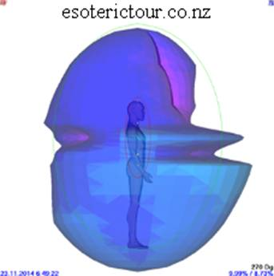 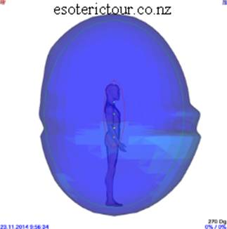

The second image of aura designated “O”, is that of a female 48 years of age. She has practiced the meditation for the first time.

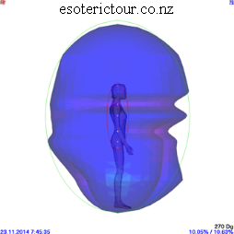 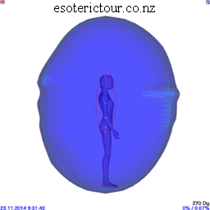

The images were given in three colors: Dark blue represents the normal state.  The light blue signifies a lack of energy, while pink denotes an excess of energy. In the auras of both the male and female, the aura before meditation shows greater distortion than in the image after meditation.

What is transmission meditation? What is being transmitted?

Benjamin Crème in his book “Transmission, a Meditation for the New Age”2 says that it is the Hierarchy of the Masters of our planet that transmits this spiritual energy3. They receive it from higher sources. A group of meditators receive this energy through their etheric body. The force centers (known as chakras) in the etheric body, step down these energies like an electrical transformer. The energy is then used by the spiritual Hierarchy to help humanity. This meditation is performed as a SERVICE to humanity.4 That is the purpose of this meditation. At the same time, the meditators are benefited: The higher chakras are stimulated; the rate of vibration of the cells of their body and brain increase; their health improves; they are more creative and expressive of the soul, etc.

What is the etheric body? Science now acknowledges that all matter whether visible or invisible is energy. Amen! There are seven planes of energies: solid, liquid, gaseous, plus four planes of still finer matter which, four planes, constitute etheric energy. The dense physical plane is a precipitation of this finer energy, which substands the dense physical.5 Some people and especially young children see ‘ghosts’ of people right after they die. What they see is the subtle, etheric body.

What are the chakras? The chakra is a vortex, a force center. An opening into and out of the body and all of the energies impinging on the etheric physical body flow through these force centers.6 It is through their stimulation and development that we eventually achieve soul contact, soul expression and self-mastery.

How is a transmission meditation group formed? It takes at least three people to form this group. Together they choose the time and place when to meet regularly. They determine its length, i.e one hour or more or less. Anyone can leave whenever they feel they had enough. It is, however, restricted to children under the age of twelve, as their chakras are not completely formed. It is open to all people and it is free. What is important is consistency.7

How do you meditate? When you sound aloud the Great Invocation in a focused and attentive state, you make an automatic telepathic link with the Hierarchy of Masters. Then you place your attention on the center between the eyebrows (called the Ajna Center) and hold it there without any kind of strain. Raise your attention until it is behind the eyebrows. At the same time inwardly sound the Mantram OM. As soon as your mind wanders, mentally sound the OM again. Do not meditate on the OM, but use it to bring the attention back to the Ajna center.8 Watching the breath helps to still the mind. It is best to act, as if you are the soul doing the meditating.

What is the Great Invocation? It is a prayer or an invocation to the spiritual Hierarchy. It is recited aloud by the group. It was used by the Christ for the first time in June 1945. It was given to humanity for us to use to change the world, so that it can become a heaven on earth.9 It is extremely potent especially if used in a triangular formation and said aloud by members of a group. The beauty of this service is that it is an easy way to help humanity and the world.

Who is Benjamin Crème? He is a disciple who was contacted by his Master in 1958 and trained to be mentally receptive to the thoughts of his Master. In January 1959 he was overshadowed by the Head of the spiritual Hierarchy, known as the Bodhisattva. He is the one that all religions await. He is called by many names. The Christians know Him as the Christ, the Jews know Him as the Messiah, the Moslems know Him as the Imam Mahdi, the Hindus await the return of Krishna and the Buddhists await Maitreya Buddha. They know his personal name: It is the Lord Maitreya.10

Two thousand six hundred years ago, Gautama Buddha made a prediction that at this time would come another great teacher who would inspire humanity to create a new and brilliant golden civilization based on righteousness and truth. His name would be Maitreya, a Buddha like Himself.11

Two thousand years ago in Palestine, the Lord Maitreya’s consciousness entered into that of His disciple, Jesus, at the Baptism. For three years, Jesus demonstrated the consciousness of the Christ—the Lord Maitreya—and became Jesus, the Christ, or Messiah. Five hundred years earlier, the Buddha worked through His disciple, the Prince Gautama, and Gautama became Gautama Buddha.12

The basic purpose of any meditation is to contact the soul and eventually become at-one with the soul. Transmission meditation attracts only those who have some soul contact and have a desire to serve and that is because it is the SOUL that desires to serve.13

There are thousands of these transmission meditation groups all around the world. If one cannot find one in their city, they can form one. They can receive more information on groups already formed and instructions to form a group from [www.share-international.org](http://www.share-international.org)

The following is the potent:

**GREAT INVOCATION**

From the point of Light within the Mind of God

Let Light stream forth into the minds of men.

Let Light descend on Earth.

From the point of Love within the Heart of God

Let Love stream forth into the hearts of men.

May Christ return to Earth.

From the center where the Will of God is known

Let purpose guide the little wills of men—

The purpose which the Masters know and serve.

From the center which we call the race of men

Let the Plan of Love and Light work out.

And may it seal the door where evil dwells.

Let Light and Love and Power restore the Plan on Earth.

∆ ∆ ∆

*Marguerite dar Boggia* presently serves as Membership Secretary for ISAR, the International Society for Astrological Research. She was past Secretary and Director of ISAR and Publisher of Kosmos, the ISAR journal. She was a co-founder of UAC and its past Secretary and Director. She has written many articles for magazines and astrological journals. Her goal is to serve humanity and the spiritual Hierarchy of our planet. To that end, she offers **free, online**, three pages weekly of the Esoteric Studies as was known by **Pythagoras.** To receive these studies, she can be contacted at her website which she created at the age of 90: [**www.FreePythagorasTeachings.com**](http://www.FreePythagorasTeachings.com)

References:

1The AkuScan was invented from the notes of R.Voll  and  Y.Nakatani.

2Crème, Benjamin, *Transmission A meditation for the New Age*, Published by The Tara Press, 59 Dartmouth park Rd., London NW5 1SL, England.

3Ibid, page 55

4Ibid, page 58

5Ibid, page 1

6Ibid, page 68 Chakras are formed by the interweaving of energy on the etheric plane of matter.

7Ibid, pages 23, 24

8Ibid, page 25

9Ibid, page 16

10Crème, Benjamin, *Maitreya’s Mission* Volume 2, Published by Share International Foundation 1993, page 5

11Ibid, page 5

12Ibid, page 6

13Ibid, page 464