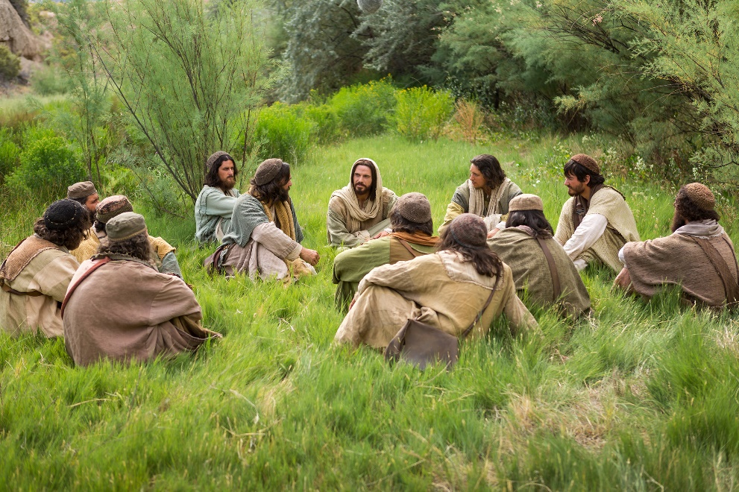

September 12, 2021

16th Sunday after Pentecost

Carson City United Methodist Church

10:30 am
Prelude/Greeting
*Indicates stand as you are able

Call to Worship
From Revelation 21
L: We shall see a new heaven and earth, for the old will pass away.

P: We shall see a new Jerusalem, the Holy City descending from heaven. The Holy City descending from Heaven.

L: “We shall hear a loud voice from the throne say: Behold, God’s dwelling is with mortals. Indeed, God will dwell with them, and they will be God’s people.”

P: God will wipe away every tear from our eye’s, and there shall be no more death.

L: Mourning, crying and pain shall cease, for all former things will pass away.

P: “We shall hear One speak from the throne. Behold I am making all things new. I am the Alpha and Omega, the beginning and the end.”

*Hymn: Lord of the Dance UMH 261

Opening Prayer: (unison)

Almighty God, renew us through the gift of your Holy Spirit, so that our thoughts and actions are pleasing in your sight and in keeping with fulfilling your royal law. So that we who can do nothing good without you in our lives may live a life that testifies to who you are in us and who we are in you. We ask this in Jesus holy and precious name who lives and reigns with you and the Holy Spirit in Heaven, one God forever and ever. AMEN!

Contemporary Song: Good God Almighty (Crowder)

Offering/Offertory Prayer

Doxology UMH 95

Worship War Zone Song: Joshua 1 9 (You Tube)

Presentation of Children’s Bibles

Gospel Reading: MATTHEW 16:15
Old Testament: PROVERBS 15:28
Epistle Lesson: 1 PETER 3:15
*Hymn: How Great Thou Art UMH 77

THE MESSAGE

*Hymn: Let the Worshipers Arise
(Philips, Craig and Dean)

Sharing of our joys and concerns

Call to Prayer: See Ye First UMH 405

Pastoral Prayer

*Hymn: A Mighty Fortress is Our God UMH 110

Benediction

CCUMC – Announcements

========================================
Volunteers needed for: Lighting of Candles and Passing of Collections Plate starts Sunday, Sep 12th. The signup sheet will be passed around today and will be placed on the table with the Sunday Bulletins.
========================================
UMW Come eat with Us: Monday, Sep 13th @ 5:30 pm in the Fellowship Hall. Everyone’s welcome. Bring dish to pass.
========================================
A.R.K. begins Sep 15th @ 6:30 pm to 8:00 pm in Daniels Den. We will be learning about the Names of God in the Old Testament. All kids welcome from ages 3 through 7th grade. Snacks are included.
=========================================
Join us for our next Soup Lunch
Fri, Sep 17th, 11 am - 1 pm
Soup Luncheons email umwluncheon@gmail.com
Announcements cont’d
=========================================
Women’s Small Group Studies will begin again from 6:30-8:00 pm on Sept 19th. All women who would like to be refreshed and energized in this world of ever-increasing fear, bad news and disappointment, are invited to come check us out! We laugh, learn, and intentionally connect with God and each other. New faces are always welcomed and cared for. Contact Nancy Wilson for more info. 989.763.5975
=========================================

Announcement’s cont’d

=========================================
&

Sun, Sep 26th, before, during,
& after Worship Services.
=========================================
Church Directory: It’s time for a new directory. Schedule your photo session on Oct 10 & Oct 11 from 2-8:30 pm. There are signup sheets located on the Welcome Center. Informational documents & instructions are located Welcome Center & on table with the Sunday Bulletins.
========================================
OCC Shoebox: Deadline for collection is Sun, 11/14. More information to come.

Serving and Supporting Sunday Worship
Audio/Video: Pat Monroe

Joys, Concerns & Prayer Request
For those battling cancers: Wendy Crawfis,
Beth Grienke, Jim Dunlap,
Carolyn Nykerk, Ray Seaman

For everyone who needs support,
guidance or has health concerns.

Monthly Giving
8/29 $910.01 9/5 $3427.57

Coming Up
9/13 UMW Come Eat with Us 5:30 pm
9/14 Cub Scouts 6:00 pm
9/17 UMW Soup Luncheon 11:00 am - 1:00 pm
9/18 Dinner for Two 5:30 pm
9/19 Women’s Group 6:30 – 8:00 pm

Our Church in Ministry This Week

Mon 6:30 pm | Personal Transformation Class
Wed 6:30-8:00 pm | A.R.K.

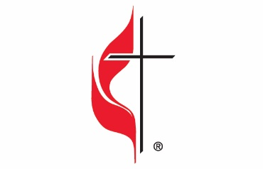

Carson City United Methodist Church
Location: 119 East Elm St., Carson City, MI
Mail: PO Box 298, Carson City, MI 48811
Phone: 989-584-3797 Email: carsoncityumc@gmail.com
Website: carsoncityumc.com
Office Hours: Monday-Thursday, 9:00 am-12:00 pm
After hours by appointment
Pastor: Ian McDonald 906-322-5318
Secretary: Bonnie Seaman 989-763-1674

Weekly Sunday Bulletin now available on our website
@ www.carsoncityumc.com

“Dear God, I invite You to transform me by renewing my mind today. Thank You for all that’s possible when I surrender to You”

