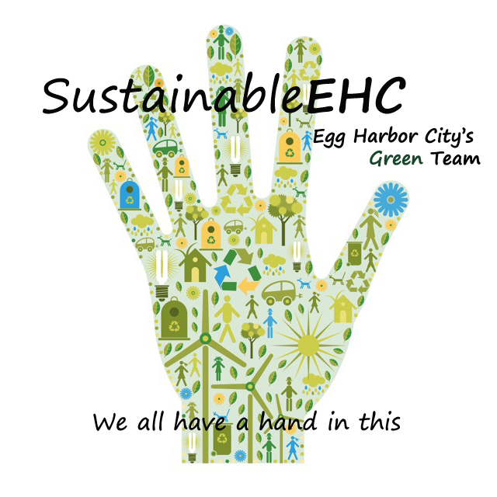
SustainableEHC
500 London Avenue
Egg Harbor City, NJ 08215

www.sustainableehc.org

Dear Neighbor:

We are pleased to announce that Egg Harbor City has been awarded a NJ Urban & Community Forestry grant to replace street trees that were removed during past road construction projects. The grant will allow the city to plant approximately 100 trees on blocks affected by road projects over the last 5-10 years. Your block has been identified as needing new street trees.

You are eligible to apply for a tree to be planted in the public right-of-way (curb lawn) in front of your house while supplies last. Trees may not be placed on private property. If space and conditions allow, you may choose up to two trees from the city’s pre-approved species list. The list includes small, medium and large tree species that will diversify the city’s street tree canopy, add beauty, serve as habitat for wildlife, and protect against loss from diseases.

Tree planting sites must be approved by the city’s landscape professional and the selected species must be appropriate for site conditions. Trees will be planted by a city contractor in the fall of 2022.

Property owners will be required to sign a two-year tree maintenance pledge, indicating your commitment to caring for the tree according to specifications. Maintenance includes watering, mulching, and pruning, if necessary. Property owners will also be required to attend a mandatory meeting about tree maintenance to be held at City Hall. Date to be announced.

If you would like a street tree planted in front of your house at no cost to you, please fill out the attached Tree Request Form and return it to SustainableEHC, 500 London Ave., Egg Harbor City, NJ 08215, or email it to sustainableehc@eggharborcity.org no later than March 30. A fillable form is also available at sustainableehc.org.

Sincerely,

Nanette LoBiondo Galloway
Chair, SustainableEHC Green Team

