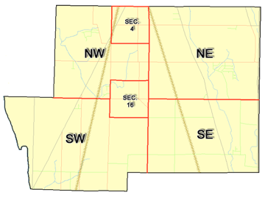 | Pleasant Township  Zoning Commission Minutes  1035 Owens Rd W.  Marion, Ohio 43302
Meeting called by: | Scheduled | Type of meeting: | Regular Monthly
Chairperson: | Mr. Holler | Secretary: | Tim Michael
Timekeeper: |  | Date: May 21, 2020 | Time 7:30 pm
Call to Order by: | Mr. Holler Moment of silence followed by the pledge to the flag.
Roll Call: | Scott Ballenger, Jack Dean, Harry Holler, Tom Leib, Dwight Williams  Tim Michael Secretary / Alternate
Minutes: | Read and approve minutes from previous meeting. (May pass out earlier)  Motion to approve minutes by: Mr. Williams Seconded by: Mr. Dean Roll call: All approved
Attendees Address Board: Have sign in sheet on desk by door.
Type in attendees and addresses:
.
----- Agenda Topics -----
Business
Zoning Reports: | Zoning Inspector goes over reports and provides copy to board.
Unfinished:
New:
Announcements: | Next meeting will be: June 18, 2020
Adjournment: | Motion to adjourn by: Mr. Williams Seconded by: Mr. Leib all in favor: all approved
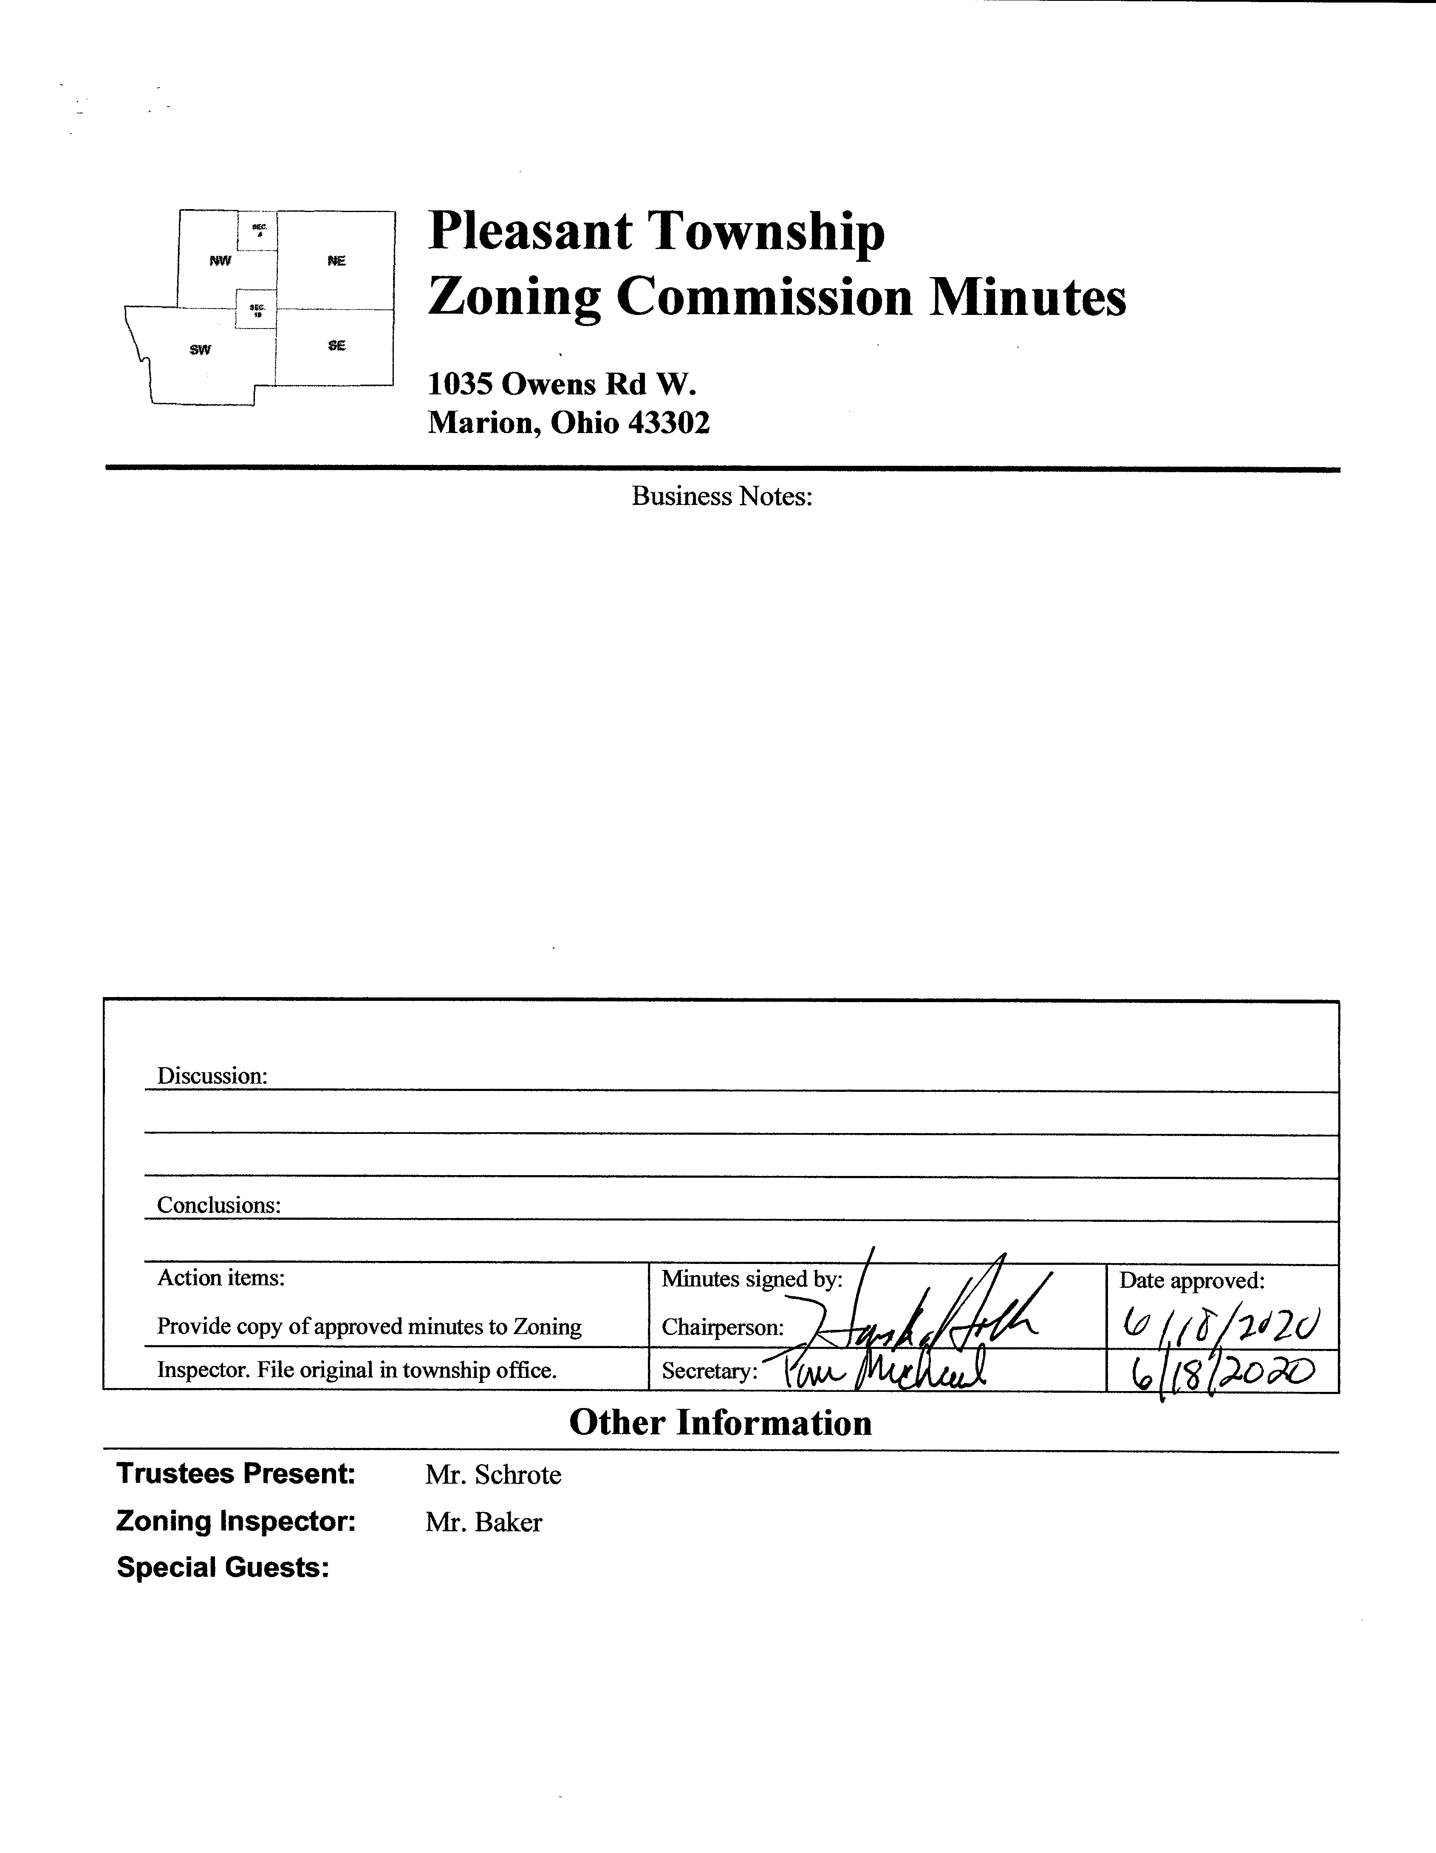

Minutes
- The Pleasant Township Zoning Commission met for their regularly scheduled monthly meeting on May 21st 2020 at the Pleasant Township Senior Center. Zoning Commission Board members present were: Mr. Dean, Mr. Leib, Mr. Williams and Chairperson Mr. Holler, Secretary Mr. Michael, and Township Zoning Inspector Mr. Baker.
- Minutes were read from the February 20th 2020 regularly scheduled Zoning Commission meeting. There being no stated corrections a motion to approve the minutes was made by Mr. Williams and seconded by Mr. Dean. All members present agreed to passage of the minutes.
- Mr. Tom Baker Pleasant Township Zoning Inspector submitted the following inspection report for the months of February, March and April 2020: there were 5 permits for new homes, 1 permit for an addition, 1 permit for a sign, 4 permits for an accessory buildings, 4 permits for fences, 2 permits for decks, 3 permits for pools, and 1 use permit. Dollar amount for new construction totalled $2,143,526.00, income from permits totalling $2,094.10, and income from appeals totalling $1,200.00.

- Mr. Leib raised the issue of notification from the Appeals Board prior to their meetings. I emailed and also spoke to the Appeals Board Secretary and reminded her of the request that this notification be made. She advised that going forward this notification will be made to me and I will in turn forward the information to the Zoning Commission members.
- Mr. Leib recommended that the issue of porch sizes be addressed when the Zoning Commission reaches the applicable section of the Zoning Resolution during the on-going review process.

- Mr. Robert Morris of the Marion County Regional Planning Commission joined the meeting via telephone in order to discuss the proposed draft model language document covering solar energy for inclusion in the Pleasant Township Zoning Resolution. It was decided by the board that the paragraph pertaining to reduction of required setback by up to 50% will be struck from the document. Additionally Mr. Morris was asked to review the legality (and will add if allowable) requirements for both Residential Value and Environmental Impact Studies to the site plan which is required to be submitted at time of application. There was also a discussion regarding the various tax implications of a solar energy farm, Mr. Morris sent me and I forwarded to the Commission members the documents supporting this discussion. It is noted that Mr. Morris is no longer with the Marion County Regional Planning Commission. I have followed up with the Planning Commission concerning the status of the addition of the Impact Studies but at this point have no resolution.

- There being no additional business for discussion Mr. Williams made motion to adjourn, seconded by Mr. Leib all Zoning Board Members in attendance agreed and the meeting was adjourned. The next scheduled Zoning Board Meeting will be held on June 18th 2020 at 7:30 PM.

