2023 NC MOMs Convention Registration Form
New Bern, NC November 3-5 2023

Registration $80 if postmarked or emailed by Sept. 15th
$85 if postmarked or emailed by Oct. 1st
$90 if postmarked or emailed by Oct. 12th

Registration Deadline is October 12, 2023 NO REFUNDS

Hotel Information: Springhill Suites
300 Hotel Dr. New Bern, NC 28562
(252)637-0017
Double Queen Suite $125
King Suite $125
Each room has one or two beds and a sleeper sofa.
“NC MoMs” is the discount code, call to make reservations by Oct 3rd.

Name:__________________________________________________

Address:_______________________________________________

_______________________________________________________

Club Affiliation:______________________________________

_______________________________________________________

Phone Number:__________________________________________

Email:_________________________________________________

I am staying at the Springhill Suites: ____Fri ____Sat

I have a guest attending:________________________(Name)

Additional fee for guest: _____Lunch $25
_______Dinner $35
Nostalgia Ornament: ________ $10 each (Sneak Peek on page 4)

Registration Fee:________
Guest Fee:________
Nostalgia Ornament Fee:______
Total:________

Send your payment: Checks made out to NCMoms ℅ Stephanie Clinch 103 Date Palm Ct. Hampstead, NC 28443 or Venmo:https://venmo.com/u/Stephanie-Clinch 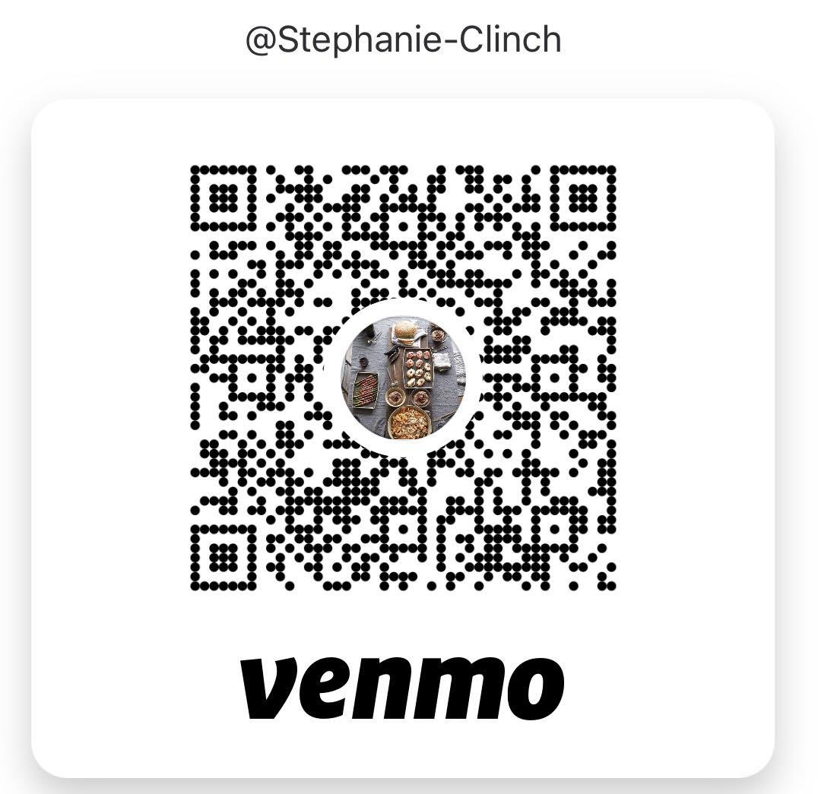

Children: NAME AGE GENDER

_______________________________________________________

_______________________________________________________

_______________________________________________________

_______________________________________________________

_______________________________________________________

_______________________________________________________

_______________________________________________________
Is this your first NC MOMs convention?_________________

How many NC MOMs conventions have you attended if not your first?____________________________________________

Any food allergies or dietary restrictions:____________

_______________________________________________________

_______________________________________________________

_______________________________________________________

Saturday afternoon will be free to explore New Bern, hang out with friends, or even nap.
Please send or email your registration form to:

Katherine May
3112 Side Saddle Ln
Trent Woods, NC 28562

KatsStang@gmail.com
Cell Number (252)259-3627
Text or email if you have any questions.

2023 Nostalgia Ornament
Handmade Bear

Profits to go to our NC MoMs Scholarship Fund.
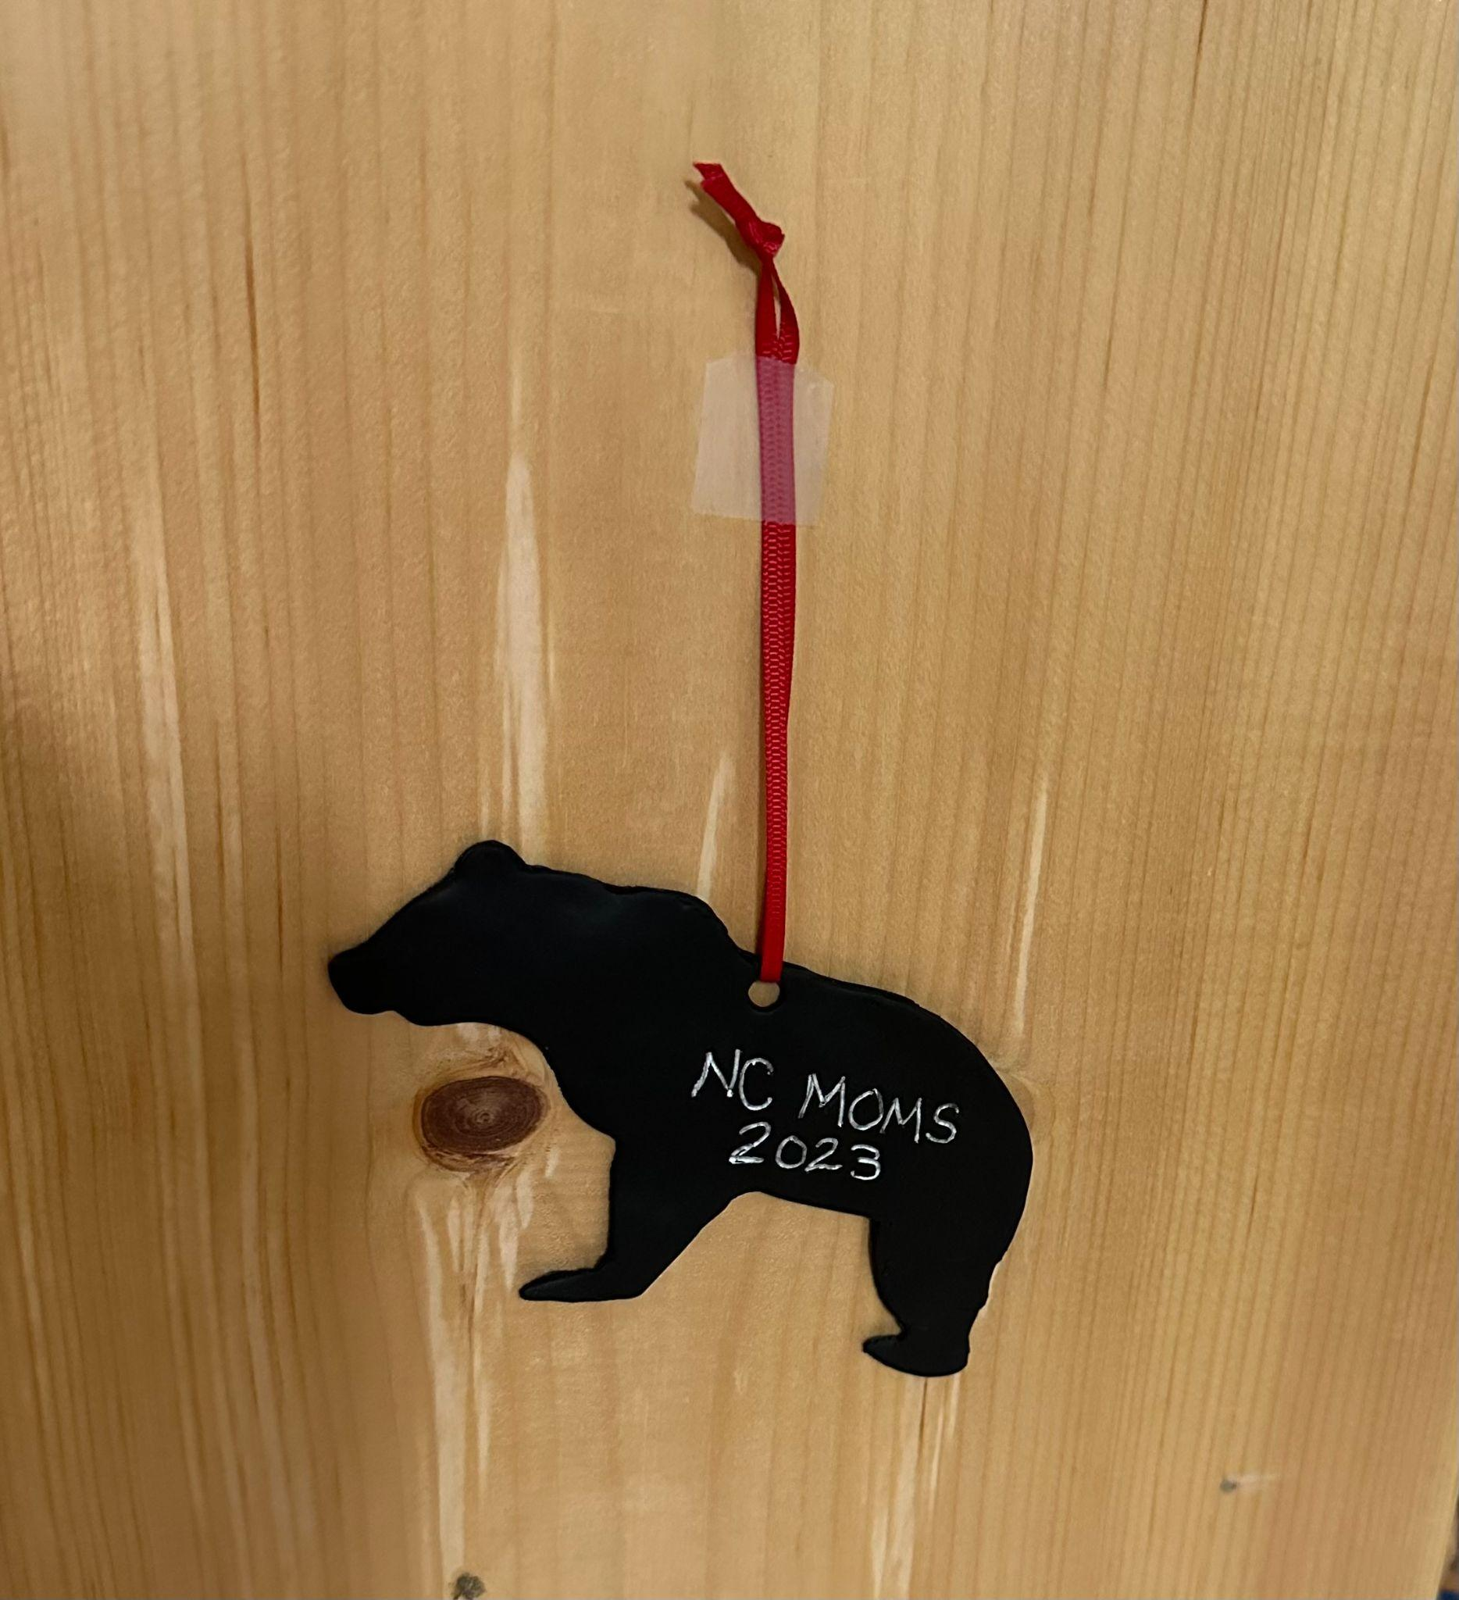
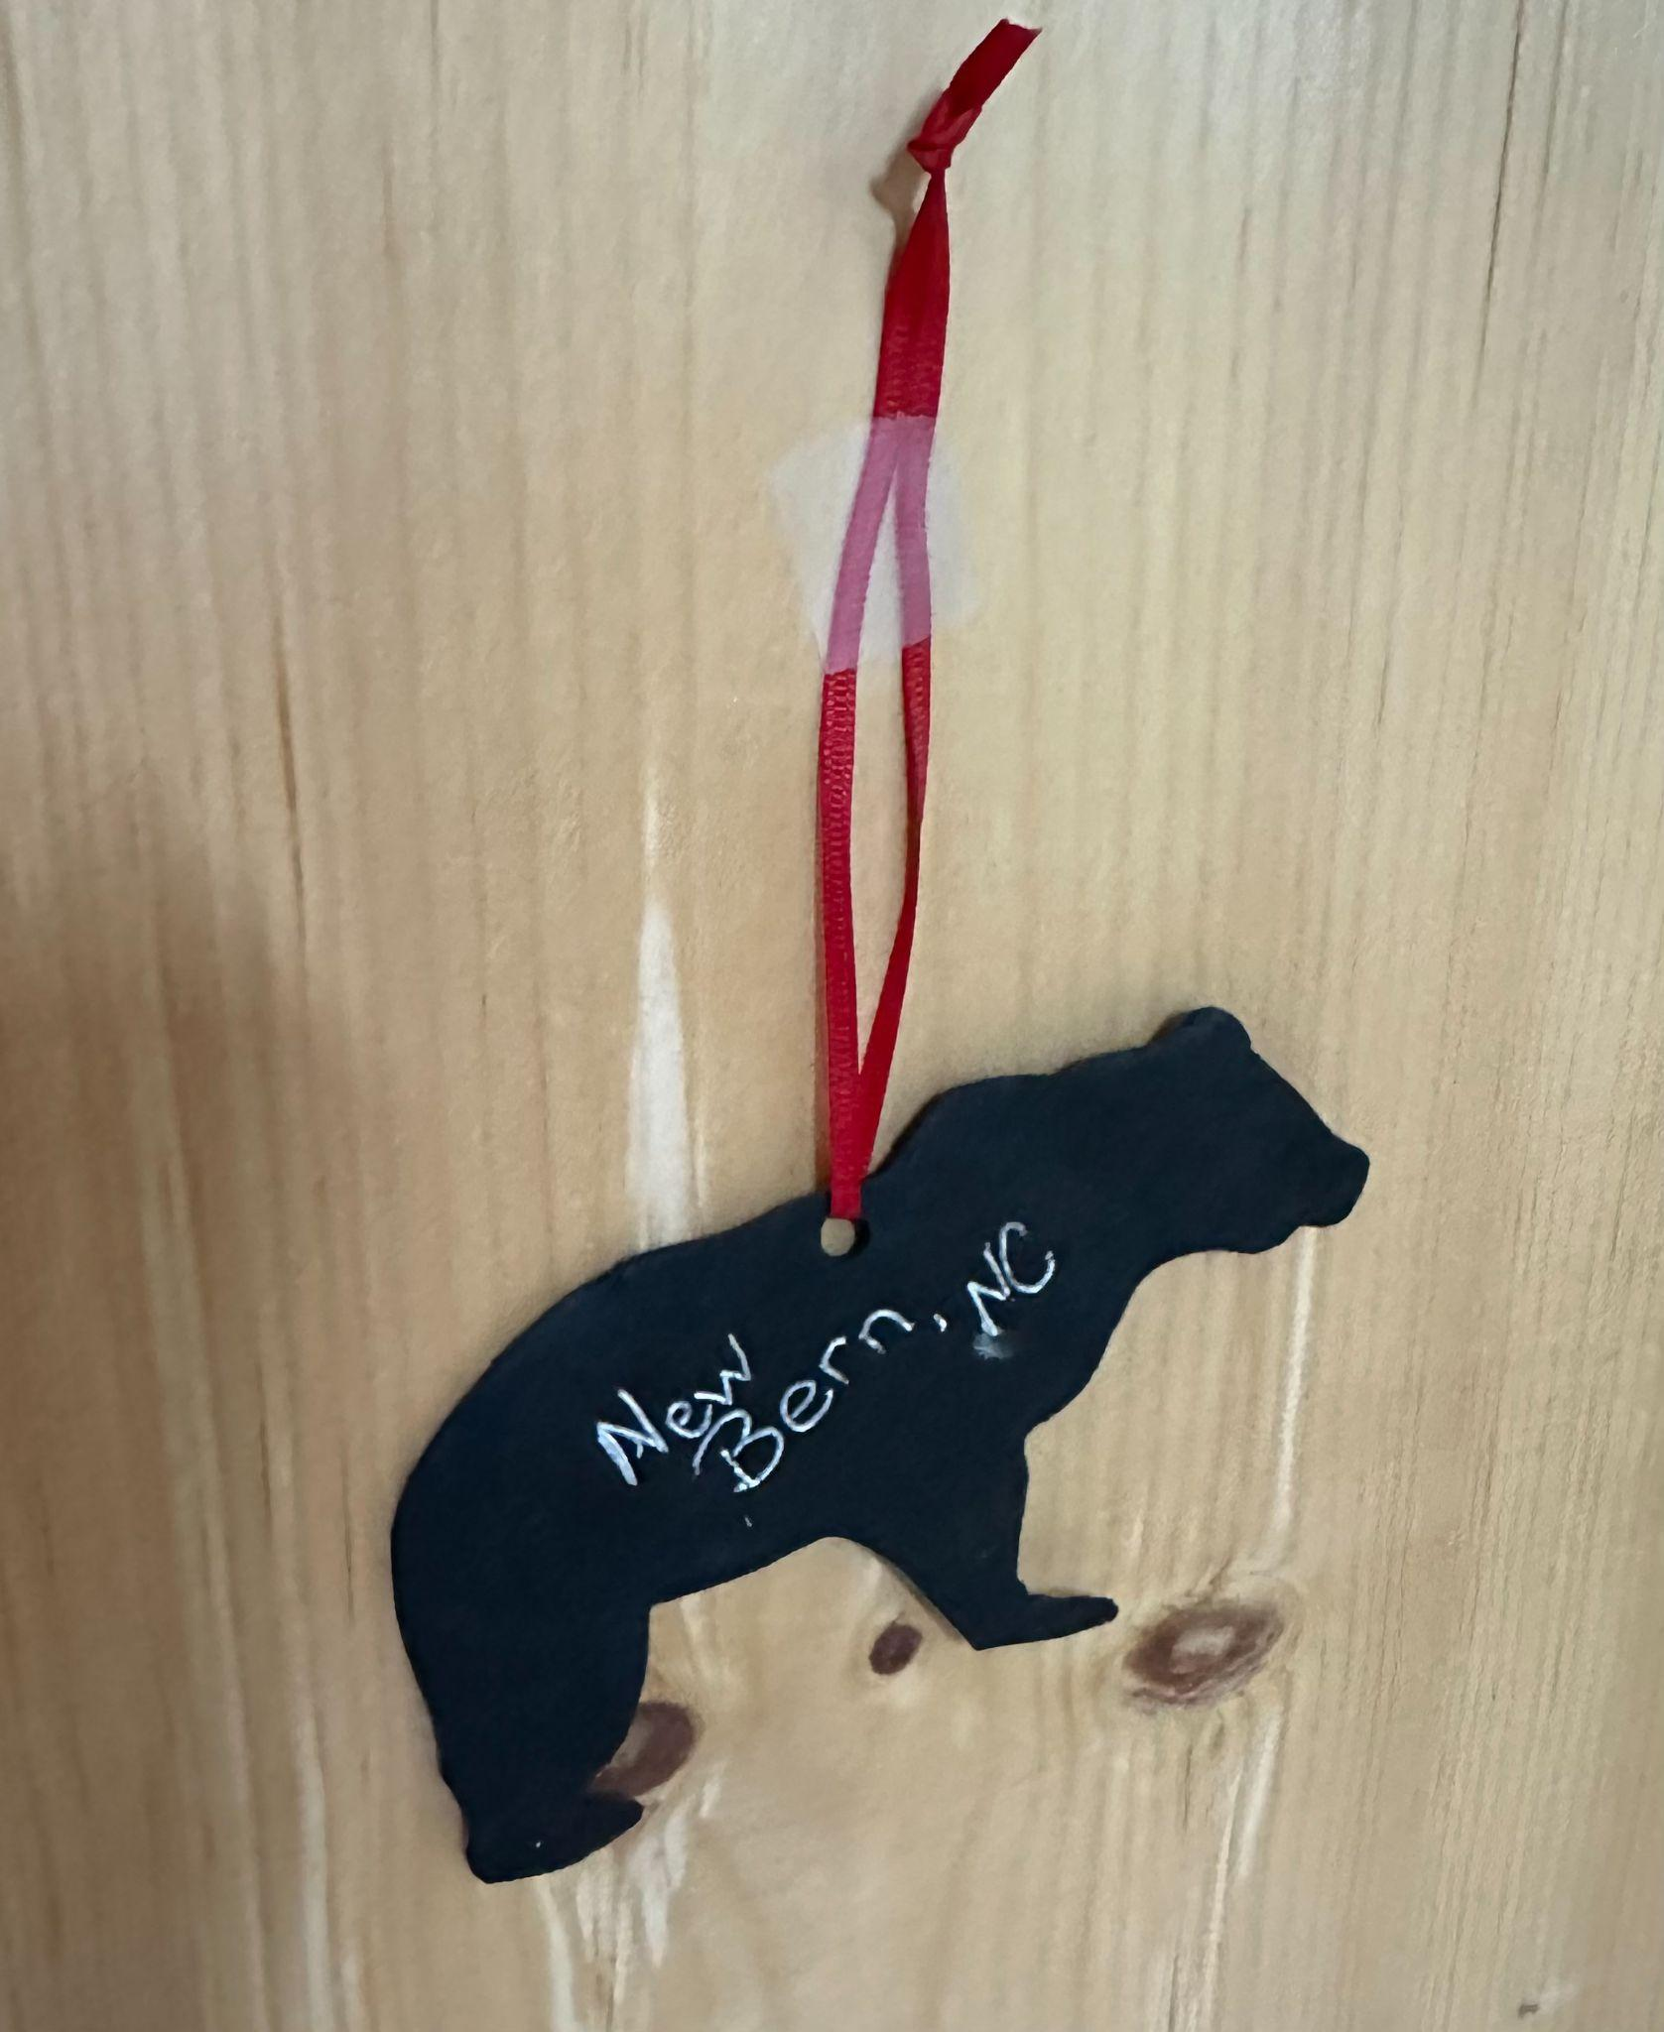

Each Bear is $10.

