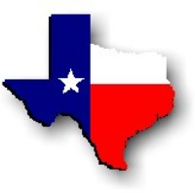Texas History with Mr. Brown Name _____________________________ Period _____

Directions: Complete the chart below with your prior knowledge about industries and businesses in Royse City Texas. Name five industries and at least 8 businesses for each industry.
What industries do we have in Royse City? What businesses are related to those industries?
Industry  Oil/Gas Stations | Industry  Food/Restaurant | Industry  Retail Shopping | Industry  Insurance/Financial | Industry  Medical/Health
Businesses  Exxon Tiger Mart | Businesses | Businesses | Businesses | Businesses

