BENEFITS THE FIGHTER COUNTRY PARTNERSHIP IN SUPPORT OF LUKE AIR FORCE BASE
Saturday, November 4th, 2017, 9AM - 2 PM

Midway Chevrolet

2323 W. Bell Rd, Phoenix, AZ (On Bell Rd - One Light East of I-17)

Fun for the Whole Family

Food Drive Donations Accepted

Trophies, Dash Plaques Free Food, Vendors, 50/50 Raffle

Entry Form for Participants on the Back

2017 Fast Glass Corvette Club
Registration/Entry Form:
(Please Print)

First 100 registered cars will be judged in separate classes by body style: Cl, C2, C3, C4, C5, C6, and C7. Cars will be evaluated on the appearance of the exterior, the interior, and under the hood. The number of trophies given in each class will depend on the number of entries in each class. Additional trophies will be given for Best of Show, Club Participation, Fast Glass Corvette Club Choice, and Dealer’s (Midway Chevrolet) Choice.
FGCC MEMBERS WILL NOT BE COMPETING AGAINST OUR GUESTS
For Show Information contact Robert Kay at (480) 518-7604 or email: rkay1962@live.com

Registration:
Preregistration is $30, includes show t-shirt if postmarked by October 6th, 2017; additional show shirts available to pre-registrants, please indicate quantity below.
Schedule of Events:
Check-In 7:00am to 9:00am
Judging 10:00am to 1:00 pm
Raffle Prizes 9:00am to 1:30pm
Awards Ceremony 2:00pm

Owner Info: (used for show purposes only)

Name:

Street Address City State Zip _

Home Phone Cell Phone E-mail

Corvette Club Affiliation:
Club Name

Car Info:
Year:

Model Type:

Color:

Body Style/Class (circle one) Cl | C2 | C3 | C4 | C5 | C6 | C7
1953-1962 | 1963-1967 | 1968-1982 | 1984-1996 | 1997-2004 | 2005-2013 | 2014-2015
T-Shirt Size:

Early Registration T-Shirt Size (circle one only) | S M L XL XXL 3XL
Additional T-Shirts @$15 each (indicate quantity) | S M L XL XXL 3XL

Make checks for registration and additional T-Shirts payable to Midway Chevrolet and mail to:

Ron Kolacek
14631 W Sentinel Drive Sun City West, AZ 85375

Registration Fee Additional Show Shirt(s) Total Amount of Check
$
$

$_________________

Liability Disclaimer: Entrants and participants by execution of this form, release and discharge the Fast Glass Corvette Club their officers, directors, members and employees, sponsors and any others connected with the presentation of this car show, from any and all known and unknown damages, injuries, losses, judgments and/or claims from any cause or causes whatsoever that may be suffered by any entrant or participant to person or property. Alcohol is not allowed at the show.

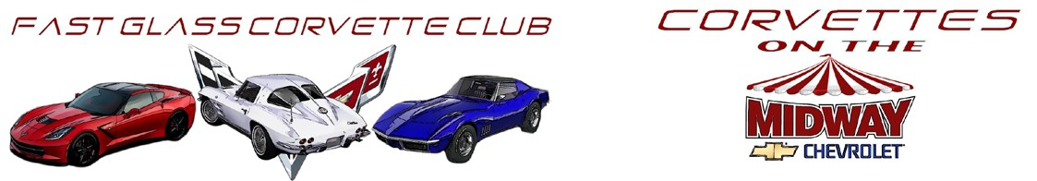

November 4th, 2017
Midway Chevrolet 2323 W. Bell Rd., Phoenix, Az. 85023 Vendor Registration Information
Name: Phone: Address: City: State: Zip: E-mail:
Product or Services Provided:

- Cost for a Vendor Space is $20.00
- Spaces will be 20 feet wide by 20 feet deep (larger spaces available upon request if available)
- No electrical or utility services will be provided
- Generators and open flame devices subject to City of Phoenix Fire Department regulations and/or ordinances.

For additional information call, Phil @ 602-820-2914, Brian 623-210-8937 Robert @ 480-518-7604 Make Checks payable to Midway Chevrolet and completed form to:
Fast Glass Corvette Club
16845 N. 29th Ave. Ste. 1 Box 427
Phoenix, Az. 85053

***
*** Proceeds to benefit the Fighter Country Foundation ***

Liability Release:
The undersigned does herby release Fast Glass Corvette Club, members, agents, volunteers, and anyone else connected with the event from known and unknown damages, injuries, losses, judgments and/or claims from any cause whatsoever that may be suffered by anyone participating in this event or by any spectator. The undersigned is fully responsible for his/her vehicle. Pets are the responsibility of the owner. Entries not transferable, and may not be sold or given to another individual.

Signature: Date:

Note: Booth setup can be completed Saturday November 4th from 7:00AM to 10:00AM. Booth equipment can be removed from the field following the car show on Saturday November 4th 3:00PM No refunds – Show goes on, rain or shine.

Fighter Country Foundation Tax ID 20-5633760

Fighter Country Foundation is an Internal Revenue Code Section 501(c) (4) social welfare organization. Donations are not deductible as charitable contributions, though they may qualify as business expense deductions, if applicable -- please consult your tax advisor for more information.

2017 Vendor Registration R2

