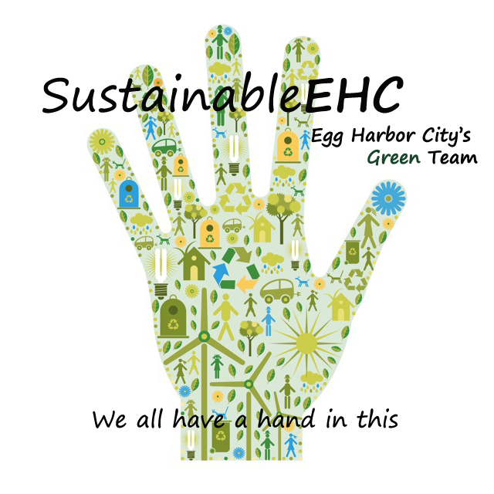
SustainableEHC

Tuesday, March 7, 2017
Agenda

I. Welcome & Introductions

II. Approve minutes of Jan. 24 meeting

III. Financial Report

IV. Farmers Market: Down on the Farm

V. Tree Grant

VI. Anti-idling Program
Signage, brochures, school pledges

VII. Sustainable Jersey Small Grant Application $2,000 for operating expenses

VIII. Sustainable Jersey Certification Cycle – Application deadline June 4

IX. Earth Day, Sunday April 23, 2017

X. Sustainable Landscaping Series/Native Plant Appreciation Month-June
Aysia Gandy

XI. AmeriCorps Vista Katherine Johnston – Resiliency for vulnerable populations/Emergency Communications

XII. Comments

XIV. Next Meeting, March 28, 2017

XV. Adjournment

www.sustainableehc.org

