CENTER DIRECTOR: NANCY LEE

ASSISTANT DIRECTOR: DEANA DILLON

TELEPHONE: (614) 837-3020 / FAX: (614) 833-6471
HOURS: MON-THURS 8:30 a.m. - 4:30 p.m.
FRIDAYS 8:30 a.m. – 2:30 p.m.
WEB PAGE: http://pickeringtonseniorcenter.org
EMAIL: NLee@pickeringtonseniorcenter.com

$10.00 CLUB
Just a reminder that we have a donation called the $10.00 Club. You can donate any amount you would like. The money donated helps with the purchase of items that we need for the kitchen and
office supplies, etc.

NEW MEMBERS
We welcome the following new members to our Center and hope they will join us for some of our activities: Mary Baker, Marianne Brooks, Valeria Grace Engell, Denise Feeley, Susan Hess, Karen Hixenbaugh, Linda O’Connor, Marva Pettit, Michelle Richardson, and Janice Wharton.

MEMBERSHIP INCENTIVE PROGRAM
Any member who signs up four new members will receive a $25.00 gift card. Tell the office to put your name on the form when you sign up a new member. All you need is four members!

OUR PARKING LOT ENTRANCE & EXIT
Arrows have been painted on the surface of our Center’s parking lot designating the entrance and exit. Please be sure to observe them. This has been done for everyone’s safety and to avoid accidents, after some near misses. As always, be sure to drive slowly and courteously while in our parking lot.

TUESDAY, NOVEMBER 2nd
- GENERAL ELECTION DAY -

Pickerington Senior Center will be closed.

SUNDAY / NOVEMBER 7th

“Spring forward – Fall back.” Daylight Savings Time ends the first Sunday in November. Remember to set your clocks back one hour before retiring on Saturday night.

This is also a good time to check the batteries in your smoke detectors, carbon monoxide detectors and other electronic devices. Please don’t climb on ladders or chairs to change them. Ask one of your kids or a neighbor to take care of it for you.

BLANKETS FOR THE HOMELESS
Seton Homeless Comfort Crew is collecting old bedding, curtains, material, etc. They make sleeping bags for the homeless. When the sleeping bags are finished they are given to the Holy Family Soup Kitchen who distributes them to the
homeless.
VOLUNTEER OF THE MONTH
Our Center would like to honor Julia Archer as the volunteer for November. She made the bean and vegetable soups for our Annual Soup Dinner & Bingo. She’s always willing to help us when needed. When our pancake breakfasts restart she will be making the batter for the great pancakes. Julia will receive a $15.00 gift card. Enjoy your reserved parking space for the month of November. Thanks for all your help.

SOUP SUPPER AND BINGO

Thanks to Annabelle Marion for being in charge, Julia Archer for making the bean and vegetable soup, and to all the kitchen helpers: Shirley Bowler, Candy Moore, Jeri Heskett and Richard Anderson. Thanks to Deana for setting up the room and a big thank you to John Samborsky for calling Bingo.

We would also like to thank Alter Care, Sandy McPeek, for providing all the desserts, and Oasis Senior Adviser Natalie Buschor for calling back Bingo numbers.

UPCOMING EVENTS

BINGO
TUESDAY / NOVEMBER 23rd
On the fourth Tuesday of every month we play Bingo!! No potluck this month.

NOODLE MAKING
TUESDAY / 8:00 a.m.

We will be making noodles on the following dates:
Tuesday / November 9th
Tuesday / November 16th
Tuesday / November 30th
If you would like to help us, call our office at (614) 837-3020.

ATTENTION: NOODLE MAKERS

Each time you help with noodle making, see Jeanne Carroll to put your name on her sheet of workers. After you have helped six times, your name will be entered into a drawing for a $10 gift card.

OUR NEW TV

Thank you to our President, Doug Hoek and his wife, Faith, for the new 82” TV they purchased for our Center. We used it for the first time to watch the Buckeyes vs. Rutgers game. The Buckeyes played a great game and we had lots of fun. We look forward to having more game parties. Thanks again Doug and Faith.

BOARD NOMINEES

In December we will be electing three members for our Pickerington Senior Center Board of Trustees. They will serve for the next three years. The following Board members are up for re-election: Linwood Connell, Larry Frazee and Annabelle Marion.

If you would like to run for the Board, or if you know someone that would, please let us know so we can put the name on the ballot.

CHRISTMAS DESSERT EVENT

December 9th, Thursday, we will be hosting a special Christmas Dessert Event at our Center, from 1:00–2:30 p.m. The event will be sponsored by Brookdale Lakeview Crossing, Brookdale Hospice, Springs Health Campus and Summit Healthcare. We’ll offer a selection of desserts with coffee, tea or water for everyone.

Voting for the three Board Members will occur during this event.

FOOD PANTRY FOR ANIMALS

If you know of anyone struggling financially to feed their pet companions, please have them call (614) 966-1777. Tricia Gerencser would like to thank everyone for the generous donations she has already received.

WATERCOLOR CLASS
(Free to Members)
Every Monday from 1-3 p.m.
Join Jenene Warmbier for adventures in watercolor painting at our Center. Jenene is a great teacher. No previous training, or talent necessary, just the desire to express yourself with “Paints and Brushes.” You can stop in our office and get a list of supplies you will need for the class.

TITLE BOXING
(Free to Members)
THURSDAY / NOVEMBER 4th, 11th & 18th
Maria Manzo from Title Boxing will lead the class at our Center from 9:00 to 9:45 a.m. Sessions are around the Rock Steady Boxing curriculum which increases the neuroplasticity of the brain to help produce healthy brain cells. The exercises are designed to improve quality of life, have fun, and get results - all at the same time! You can purchase a bag and gloves for $25.00 at the class.

LINE DANCING
MONDAY / NOVEMBER 1st & 8th / 11:15 a.m.
There will be no other classes for the remainder of November or December of 2021. Classes will resume in January of 2022. For additional information you can contact our instructor, Marilyn Morgan, at mnm@columbus.rr.com

CRAFT GROUP
(Free to Members)
EVERY WEDNESDAY / 10 a.m. – noon
The main purpose of our craft group is to offer fun activities for our seniors, but the group also raises money for our Center. They provide tray favors for two carry out meals that our Center provides for our shut-in members. The most important fundraising activity they participate in is our Breakfast with Santa, which is normally held on the first Saturday of December. Due to Covid, our “Breakfast with Santa” will not be held this year.

STRENGTH CLASS
(Free to Members)
MONDAYS and/or WEDNESDAYS / 10-11 a.m.

Come join us in our strength classes lead by Kelley Deibert. The focus is on building upper and lower body strength, stretching and improving your balance.

CORNHOLE
(Free to Members)
EVERY TUESDAY / 11 a.m.

We play Cornhole every Tuesday. On the last Tuesday of each month, we have a tournament with prizes for the winning team. The winning Team for September was Richard Villec and RuthAnn Garand . Come in and join in on all the fun. If you don’t know how to play, Deana or Doug will be happy to teach you.

EUCHRE
EVERY WEDNESDAY / 12:30 p.m.

Come in, join your friends, and play some Euchre. We start playing at 12:30 p.m. The cost is only $2.25, which includes the games and the loner pot. Please be here at least 10 minutes ahead of time to Get signed up so we can start on time at 12:30.

VINTAGE FITNESS
(Free to Members)
EVERY FRIDAY / 9:00 – 9:45 a.m.
Sign up starts at 8:30 a.m. This is a 45 minute Cardio Class. It is a total workout. Come see the power you have and make great things happen for your health and well-being. We have plenty of room for you to move and groove to great music. Michellle is a certified instructor and will guide you through a safe and effective workout.

SOCIAL EUCHRE
(Free to Members)
EVERY FRIDAY / 11 a.m.

This is a slower paced Euchre game where we can meet and play cards non-competitively. If you like to play cards for fun, at a relaxed pace and you don’t mind teaching others when needed, then please join us. We welcome anyone who wants to
play cards.

CHECK OUT THE VIDEO SECTION OF OUR LIBRARY
(Free to Members)
Take one home, watch it and return it. Any video donations to our library are welcomed. We also have a very large selection of books you can choose from.

SQUARE DANCING
TUESDAY EVENINGS / 6:30 p.m.

Come join us! Fun, fitness and friendship – square dancing has it all. We’ll show you what modern western square dancing looks like.

WEATHER DELAY OPENINGS AND/OR CLOSINGS

As we approach the winter months, we want to remind everyone that our Center follows the Pickerington School District inclement weather schedule. This information will be posted on Channel 10.

LIONS CLUB - RECYCLE FOR SIGHT

The Lions Club has a Recycle for Sight box in our Center’s library. You can donate your old eyeglasses there. The glasses will be given to individuals who cannot afford to purchase glasses.
Remember, our game room is open all day, every day with our new shuffleboard table and dart board. No need to call ahead, just come and en

LANCASTER-FAIRFIELD PUBLIC TRANSIT
IMPORTANT INFORMATION
Exact change is required, drivers are not permitted to make change. The bus makes several stops at our Senior Center every hour starting at 9:05 a.m. Groceries and bags are limited to what you can fit
in your area. As always, should you have any questions or concerns: Call (740) 681-5086.

LIONS CLUB - RECYCLE FOR SIGHT

The Lions Club has a Recycle for Sight box in our Center’s library. You can donate your old eyeglasses there. The glasses will be given to individuals who cannot afford to purchase glasses.

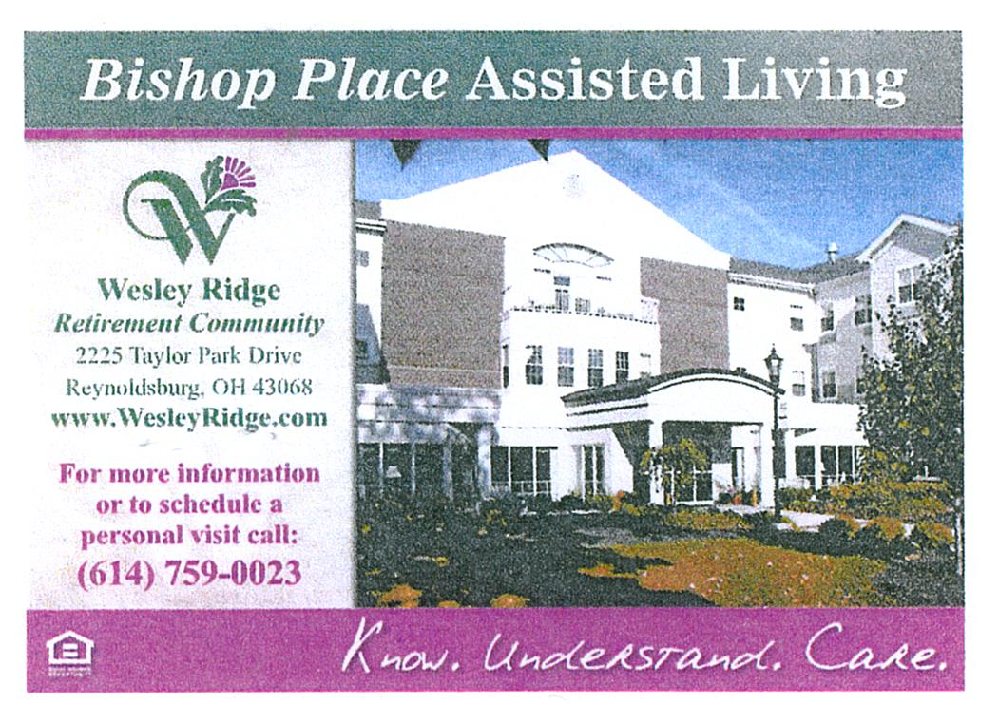
UPCOMING TRIPS

JINGLE JANGLE CHRISTMAS JUBILEE
WEDNESDAY / NOVEMBER 10th
Bus departs our Center at 9:30 a.m.
Please arrive 15 minutes early for check-in.

PENNSYLVANIA AMISH HOLIDAY TOUR
NOVEMBER 16th – 19th

DAY 1 – Check into the Heritage Hotel for a three-night stay. We will enjoy dinner at the Esh Farm.
DAY 2 - Enjoy breakfast at our hotel before leaving for a guided tour of the Amish Countryside including an Amish Craft Farm and a Bake Shop. Lunch is on your own at Kitchen Kettle Village where you can shop the many specialty shops. Next is the Sight & Sound Theatre for a live performance of “Queen Esther.” Enjoy one of the most riveting Bible stories of the Old Testament as it comes to life with magnificent sets, special effects, and live animals. After the show we will enjoy a delicious dinner at the Hershey Farm Restaurant.
DAY 3 – After breakfast we’ll visit the Mennonite Information Center & Biblical Tabernacle to learn the unique way of life of the Amish & Mennonites. See a 17 minute documentary on how Mennonites differ from the Amish. Then go to the town of Lititz where we’ll have free time for lunch and to visit the shops, including Wilbur Chocolates. Later, we will enjoy a tour of the Julius Sturgis Pretzel Bakery. We’ll return to the hotel to freshen up before departing for dinner and for an abundant musical revue at Shady Maple Smorgasbord. After dinner we end the day at the American Music Theatre to see a musical revue “Winter Wonderland,” including awe-inspiring music, dance, outstanding voices, warm humor, and familiar holiday cheer.
Day 4 - After breakfast we depart for home with wonderful holiday memories. The cost is $429.00 per person for a double room and $608.00 for a single. Payment due on sign up.
Space Available
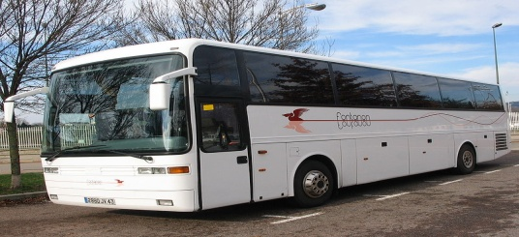

OGLEBAY PARK
NOVEMBER 30th

Bus departs our Center at 1:15 p.m. Please arrive 15 minutes early for check-in. Join us as we travel to Wheeling Park, a sister park to Oglebay for a buffet dinner. After dinner we’lll go to Oglebay Park for a driving tour to see the beautiful Christmas lights and visit the gift shop for a little Christmas shopping. Dinner will be around 4:00 p.m., so you might want to bring a snack for the trip home. The cost is $63.00 per person, which includes dinner, motorcoach transportation, and all taxes and gratuities on included items. Payment due on sign up. Space Available

NEW TRIP FOR 2022

ISLANDS OF NEW ENGLAND
AUGUST 12 – 19, 2022

HIGHLIGHTS:
Providence, Newport, choice of options on tour, lobster dinner, Block Island, Cranberry Bog, Plymouth Rock, Cape Cod, Martha’s Vineyard, Provincetown, Hyannis, and Nantucket. Save $100 if booked before February 12th.

Cost: Single $4,049 - Double $3,249 - Triple $3,219. Flyer available in our office.

FROM DEANA 😊
REMEMBERING EVERYONE WITH
WARMEST WISHES ON THEIR BIRTHDAY!!

(1) Michelle Acquista, Ann Budreau, Pat Gemeinhardt, Bettie Hurley, Douglas Keadey, Danny Mathew; (2) Susan Couden; (3) Daniel Murphy, Mary Stemen; (4) Melissa Bechtel, Ruth Ann Garand, Nelda Johnson, Fran Skinner; (5) Sharon Greedy; (6) Eleanor Berry, Judy Creviston, Bill Taylor, Thomas Tooill, Lori Wagner; (7) Marti Fisher; (8) Marlene Mueller; (9) Pam Cheek, Kay Vankeuren; (10) Brenda Albertini, Karen Callahan, Polly Kupniewski, Ellen Laughery, Ron Roby; (11) Susan Carr, Tom Legg; (12) Linda Boisvert, Etha Brown, Jeannie Mathew; (13) Mary Jane Brandt; (14) Bessie Miller, Margaret wolfinger; (15) Charlene Newlon; (16) Maggie Arendt, Brian Casner, Paula Gross; (17) Sylvia Chadwell; (18) Becky Ashcroft, Denise Hoermle, Larry Larson, Sunny Schewe, Mary Jane Sheline;
(19) Linda Scott, Rosalee White; (20) Brenda Dunnette, Melody Fuller, Becky Todd;
(22) Lois Bushby, Mike Kilroy, Steve Knorr;
(23) Edward Akers, Jennie Chrysler, Vicki Hunt; (24) Ann Hackworth, Sherry Neeper, Vikki Perry, Patty Schlager; (25) Donna Carr, Debbie Faiella, Cheryl Lewis; (26) Floyd Collins, Susan Fetters, Cheryl March, Sara Schwab;
(27) Joyce Collins, Jean Cox, Doris Moor, Stan Runyan; (28) Al Sharpless; (29) Shirley Kotchou, Janet Kuhn, Frances Marchese, James
Northrop; (30) Rex Bentziner, Nancy Johnson
IN LOVING MEMORY OF

Bob Holst
Bonnie Holst
Dottie Seitz
Dick Smith’s son, Jeff

MEMBERS KNOWN ILL

Larry Frazee – Knee injury

Martha Gravatt – Back surgery,
home recovering

Sharon Greedy – Knee replacement

Tom Legg – Ohio State University Hospital

Mary Patton – Fell, broken vertebra in back

“BEAT MICHIGAN WEEK KICKOFF PARTY”

MONDAY, NOVEMBER 22nd / 1:00 – 3:00p.m.

Wear your Buckeye gear and join in the fun at our “Beat Michigan Party!” Food, games and prizes. RSVP in our office by November 15th.

HAPPY THANKSGIVING

Follow us on Facebook at:
Pickerington Senior Citizens Center

