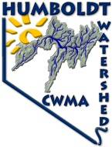
Humboldt Watershed Cooperative Weed Management Area
HWCWMA P.O. Box 570 Elko, NV 89803-0570 hwcwma@gmail.com
www.HumboldtWeedFree.org aporreca@humboldtweedfree.org
Providing land managers, owners and local weed control groups assistance
through funding, agency and weed group coordination, communication and cooperation
Hello from the Humboldt Watershed Cooperative Weed Management Area! This month we would like
to introduce you to another state listed noxious weed, Canada Thistle (Cirsium arvense). Though its name would indicate otherwise, Canada thistle is a native of the Mediterranean region and southeast Europe. It likely was introduced into North America in contaminated hay and grain seed during early colonization in the 17th century. Canada thistle has become very well established in North America and is now considered a noxious weed in at least 35 states and much of Canada.

Canada thistle usually grows 2 to 3 feet tall with alternate, dark green leaves that vary in size. The leaves are generally oblong, the length 3 to 5 times the width, usually deeply lobed, and have spiny toothed edges. The leaf edge spines vary in size and number according to variety. Canada thistle is a perennial spreading both by seed and underground rhizomes. It generally forms colonies and is found in cropland, roadsides, and disturbed pasture soils. However, Canada thistle is not very competitive in healthy turf.

Canada thistle grows best in the northern regions of North America where temperature and rainfall are moderate. Canada thistle rosettes require at least 14 hours of day length to bolt and flower. Its growth is limited or stopped when temperature exceed 85⁰ F for extended periods. Although it will grow in a wide range of soils, Canada thistle produces deeper roots in clay or muck soils than in sand or gravel.

Once the plant becomes established, roots are the most important means of propagation. Canada thistle has an extensive underground root system that may penetrate the soil to a depth of 10 feet or more and grow laterally 12 to 15 feet per year. Root buds occur randomly along the roots and initiate new shoots whenever environmental conditions are favorable. Root segments as small as 0.6 inch can initiate shoot growth and become established.

The key principle to Canada thistle control is to stress the plant and force it to use stored root nutrients. Canada thistle can recover from almost any stress, including control attempts, because of root nutrient stores. Therefore, returning infested land to a productive state occurs only over time. Success requires a sound management plan implemented over several years.

Cultural control. Grasses and alfalfa can compete effectively with Canada thistle if their growth is favored by good management. Maintain fertility and, if possible, moisture at optimum levels to favor grass or alfalfa growth. Soil analysis can easily determine fertility needs. Be cautious with nitrogen fertilizers, because excess available soil nitrogen may favor weed growth. These are essential management steps to ensure optimum desirable plant growth and competition. However, competition alone seldom is effective against Canada thistle.

Mechanical control. Mowing hay meadows can be an effective tool if combined with herbicide treatments. Mowing alone is not effective unless conducted at one-month intervals over several growing seasons. Always combine mowing with cultural and chemical control. Mowing at hay cutting stimulates new Canada thistle shoots to develop from its root system.

Chemical control. Read the label, follow directions and use precautions. Research has shown that Tordon 22K (picloram), Milestone (aminopyralid), Transline (clopyralid), Banvel/ Vanquish/Clarity (dicamba) and Telar (chlorsulfuron) are effective against Canada thistle. Canada thistle is difficult to control and re-treatment for one to three or more years after the initial application is common. Refer to following table for use rates and application timing. These herbicides are most effective when combined with cultural and/or mechanical control.

Herbicide to control Canada thistle in pastures, rangeland, natural and noncrop areas.
Herbicide | Rate (Production/A) | Application  timing | Comments
Tordon | 1 quart | Anytime when weeds are rapidly growing | Fall applications consistent results; may need re-treatment 1 to 2 years
Milestone | 5 to 7 fl oz | Spring at prebud growth stage; or fall | Use higher rate for older or dense stands; Milestone may be used to edge of ponds or streams; may need re-treatment 1 to 2 years
Transline | 0.67 to 1.33 pints | Spring after all shoots have emerged, rosete to early bud growth stages; or fall | Apply 1 pint/A or more in fall; may need re-treatment 1 to 3 years
Telar | 1 oz | Spring bolting to bud growth stages; or fall | Fall applications most consistent results; essential to use non-ionic surfactant at 0.25% v/v; may need retreatment 1 to 2 years
Banvel,  Vanquish, or Clarity  (diacamba) | 2 quarts | Spring rosette growth stage; or fall | Fall applications most consistent results; may need re-treatment 2 to 4 years

Please notify the HWCWMA if you see Canada thistle growing along the Humboldt River. Our staff can provide the property owner or appropriate public agency with site-specific advice on how best to remove it. We have an opportunity to stop it from spreading if we act quickly. We map all known locations of regulated noxious weeds in order to help us and others locate new infestations in time to control them.
The Humboldt Watershed CWMA has also developed a website to serve as a clearinghouse for information on weeds in the Humboldt Watershed. Our website (http://www.humboldtweedfree.org) contains fact sheets for state listed noxious weeds in Nevada, Board of Director’s information, funding partner’s links, and many more features including a detailed project proposal packet that you can print, fill out and mail back to us at your convenience. We are looking to expand our project area outside of the Humboldt River and always welcome new funding opportunities and partnerships.
If you have any questions, please feel free to contact Andi Porreca, HWCWMA Coordinator at (775) 762-2636 or email her at aporreca@humboldtweedfree.org. Or you may speak with Rhonda Heguy, HWCWMA President at (775) 738-3085, email: hwcwma@gmail.com.

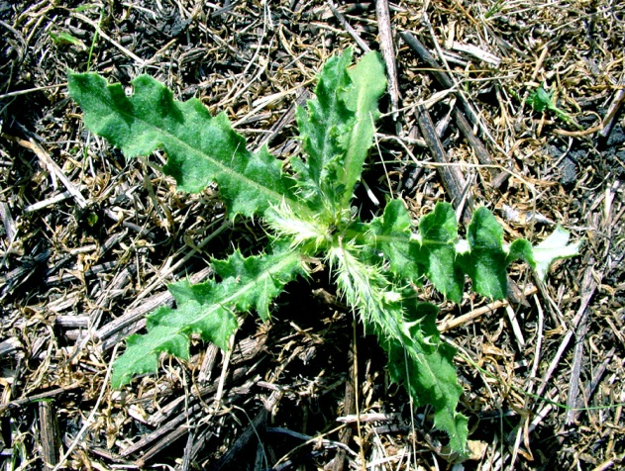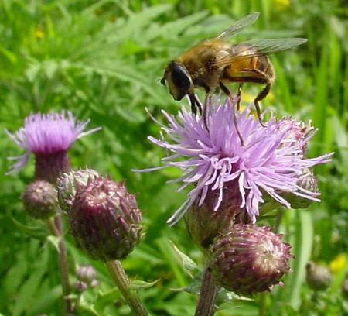
Canada thistle rosette. Canada thistle flower.

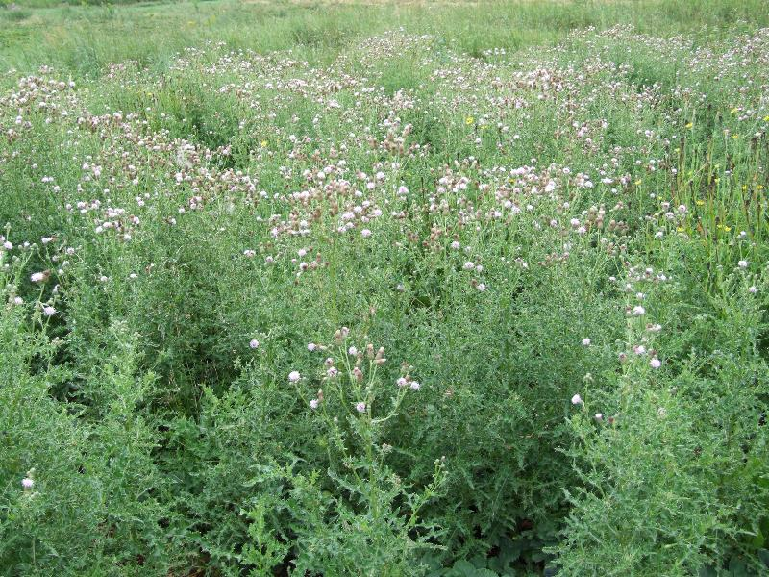
Field of Canada thistle.

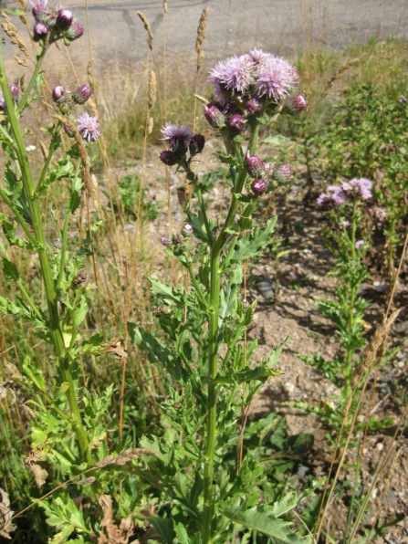
Individual Canada thistle plants.

