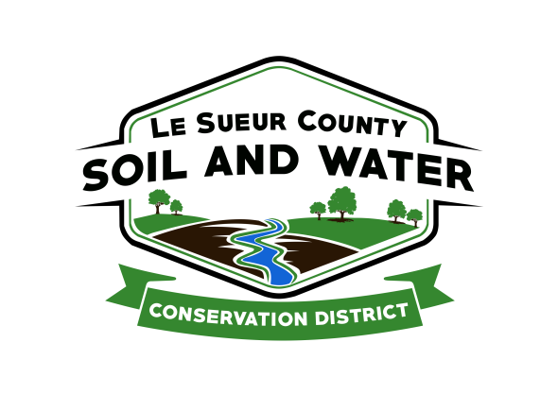

Le Sueur County Soil & Water Conservation District

Le Sueur County SWCD Tel. (507) 357-4879 Ext. 3
181 W Minnesota St Website: www.lesueurswcd.org
Le Center, MN 56057

Minutes from September 11, 2018 regular meeting of the Le Sueur County SWCD Board of Supervisors. SWCD building, Le Center, MN.

Meeting was called to order by Chairman Struck at 9:00 a.m.

Members present: Chairman, Jim Struck
Vice-Chairman, Greg Entinger
Secretary, Earle Traxler
Treasurer, Cletus Gregor
PR&I, Glendon Braun

Others present: District Manager, Mike Schultz
District Conservationist, Steve Breaker
District Technician, Joe Jirik
Farmbill Tech, Karl Schmidtke
Ditch Specialist, Nik Kadel
Program Specialist, Sue Prchal
BWSR Board Conservationist, Jen Mocol-Johnson

The Pledge of Allegiance was recited.

The secretary’s report from August 13, 2018 was approved.

Treasurer’s report from August 31, 2018 was read. Motion to approve and pay bills by Traxler, second by Entinger.
Affirmative: All
Opposed: None
Motion carried

There will be a TSA meeting on Tuesday, September 18, 2018.

The board opened bids for janitor services. Motion by Entinger, second by Braun to hire Dawn Ruhland at $700/month for the time period October 1, 2018 through September 30, 2019.
Affirmative: Struck, Entinger, Gregor, Braun
Opposed: Traxler
Motion carried

BWSR Academy will be October 29-31, 2018 at Breezy Point.

Schultz discussed internet costs with the board. The SWCD will be updating so costs will be increasing.

GBERBA conservation and drainage projects were discussed.

CRWP policy meeting will be on Wednesday, September 26, 2018.

Lower MN River WRAPS is completed and the summary report was handed out to the board.

Motion by Traxler, second by Gregor to encumber $12,750.00 for Shawn Onken Lake Volney terrace project. Contract #LV-2018-3.
Affirmative: All
Opposed: None
Motion carried

Motion by Gregor, second by Entinger to encumber $5100.00 for Robert Goettl Lake Volney terrace project. Contract #LV-2018-2.
Affirmative: All
Opposed: None
Motion carried

Motion by Entinger, second by Traxler to encumber $10425.75 for Constance Brastad Lake Volney terrace project. Contract #LV-2018-1.
Affirmative: All
Opposed: None
Motion carried

Motion by Gregor, second by Traxler to encumber $20,587.50 for Le Sueur County Highway Department grade stabilization project. German/Jefferson contract #JG-2018-1.
Affirmative: All
Opposed: None
Motion carried

Motion by Gregor, second by Braun to encumber $25,440.94 for Jeff Gibbs waterway project. Capacity c/s contract #CAP-2018-1.
Affirmative: All
Opposed: None
Motion carried

Motion by Entinger, second by Traxler to encumber $4125.00 for Jim Struck terrace project. Capacity c/s contract #CAP-2017-3.
Affirmative: All
Opposed: None
Motion carried

Motion by Gregor, second by Entinger to sign the FY19 Capacity and Buffer Grant with BWSR in the amount of $125,000.00.
Affirmative: All
Opposed: None
Motion carried

Motion by Gregor, second by Entinger to sign the FY18 Farm Bill Assistance Grant with BWSR in the amount of $87,992.00.
Affirmative: All
Opposed: None
Motion carried

Nik gave the board an update on the buffer law and the November 1, 2018 deadline for buffering county ditches.

Steve gave the board his NRCS report. He discussed CRP, CREP, fall projects and 2019 EQIP. NRCS has a new State Conservationist, Tony Daniell. NRCS is beginning to back fill some of the vacancies in the agency also.

Jen gave a BWSR update of clean water apps and other grant applications that are coming due.

The storage building is currently under construction.

Vouchers were reviewed and filled out.

There being no further business, meeting adjourned at 10:50 a.m.

____________________ _______________________________________
Date District Secretary

