BOSTROM SHOW PIGS
SHOW PIG SALE APRIL 25TH 1:00 PM
(26566 POLK ST NE ISANTI, MN 55040)
11:00 am- Viewing of Pigs
12:00 noon- Complimentary lunch (Sponsored by Maverick Nutrition
1:00pm- Bostrom’s Show Pig Auction
-HIGH QUALITY SHOW PIGS FOR A REASONABLE PRICE!!!!!!
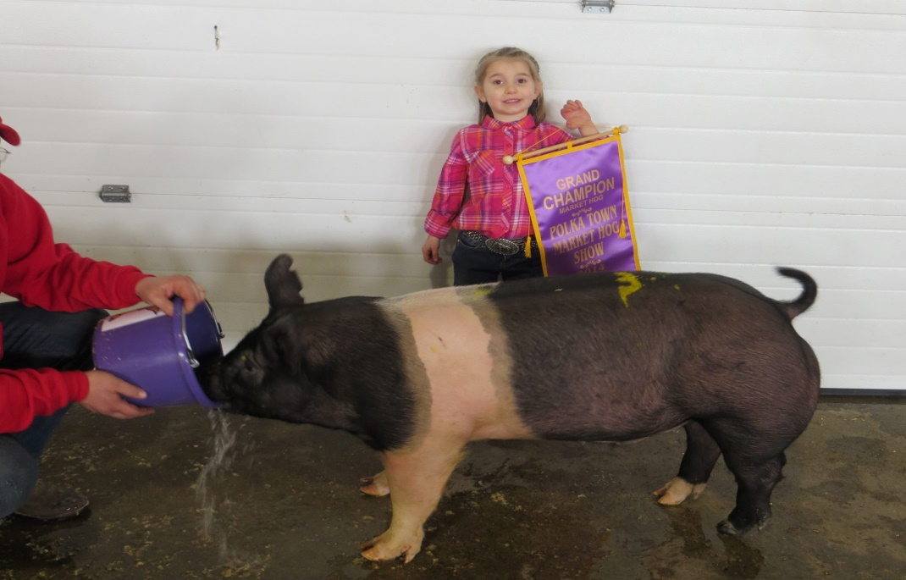
Congratulations to all the 2014 winners!!!!!
Questions feel free to call-Nathan Bostrom (763-286-6840)
*Check out our winners on the Maverick Nutrition Inc Facebook Page!!!!*

