Healthy Living Dentistry
Guidance

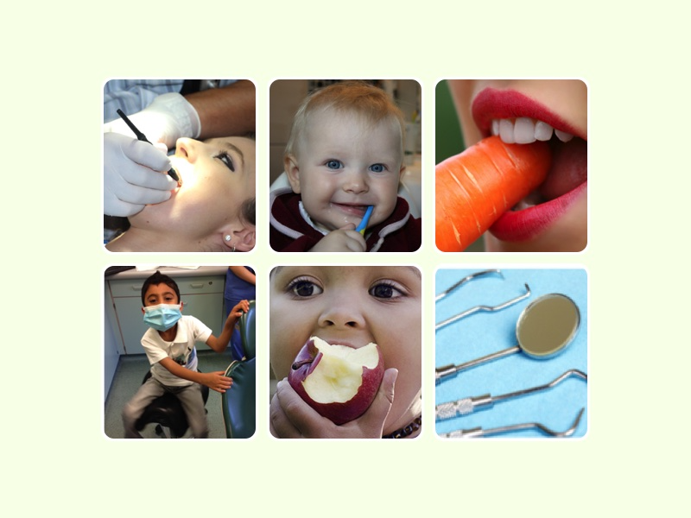

Produced by:
Greater Manchester Health and Social Care Partnership
Greater Manchester Local Dental Network

1 Introduction for Dental practices

The Healthy Living Dental Practice (HLD) framework is focused on improving the health and wellbeing of the local population and helping to reduce health inequalities through the provision of inclusive, holistic high quality care in general dental practice across Greater Manchester.

On behalf of Greater Manchester Health and Social Care Partnership and in conjunction with the Greater Manchester Local Dental Professional Network, it gives us great pleasure to introduce the Healthy Living Dentistry (HLD) Programme to Greater Manchester.

As we head towards a new contract where quality of delivery will be a key component of the contract, Greater Manchester dental practices will find that they will be able to demonstrate these quality improvements by following the HLD Programme.

This programme will help recognise the general health messages that are delivered by the dental team and provide the opportunity to take this service to another level. It recognizes the contribution that dental practices are already making to improve the health and wellbeing of their patients in line with Delivering Better Oral Health.

Dental practices continue to have an important place at the heart of local communities and the HLD programme will help to build on this through programmes such as ‘Baby Teeth Do Matter (BTDM)’ and by establishing links with early years settings, as well as improving communication with other health professionals, especially Healthy Living Pharmacies and Healthy Living Optical practices.

Practices will be able to demonstrate a commitment to patients’ dental and general wellbeing under an endorsed programme led by practice based and qualified Health Champions. It will help with the development of our dental teams’ leadership and communication skills, and establish good teamwork.

This programme will provide extensive evidence to the Care Quality Commission (CQC) as a caring practice. Practices working towards the BDA best practice award will find that they already meet much of the criteria and this will provide evidence for the BDA award application.

Finally, as health care professionals, we will be able to improve the care we offer our patients which can only lead to an increase in job satisfaction for us all.

Mohsan Ahmad
GM LDN chair

The HLD framework is used for engaging in public health services through two levels of increasing complexity and requires expertise within dental practices aspiring to go from one level to the next.

This Guidance presents the HLD Framework in two parts:

Level 1 –recognises the good practice that is in place in many practices to be accredited as a Health Living Dental Practice
Level 2 – which includes a higher level of quality standards and the opportunity to provide additional commissioned services by the practice. The detail of these additional services would be agreed between the practice and commissioner.

To be awarded the HLD ‘quality mark’ a dental practice must demonstrate a healthy living ethos and a proactive approach to health. HLD’s should use the skills of their Health Champions to support the health and wellbeing of patients and public within the communities they serve. The dental practice should meet all Level 1 essential criteria which are demonstrated by 100% compliance against the self-assessment criteria.
On achieving recognition of HLDF status (Level 1), the dental practice will be issued with a certificate to display to patients and the public of their achievement.

2 Aim & Objectives
Aim: improving the health and wellbeing of the local population and helping to reduce health inequalities through the provision of inclusive, holistic high quality care in general dental practice across Greater Manchester.

Objectives
- To recruit practices to be healthy living dental practices
- To provide training and resources to dental practice staff to increase their awareness and skills in addressing health needs
- To ensure a standard of quality dental care
- To improve accessibility for vulnerable groups
- To harness the opportunity to make every contact count in preventing and promoting oral health and general health.
- To enhance the work of practices in delivering better oral health.

3 Benefits

3.1 Benefits for practices

Recognise the work that you are already doing to improve oral health and general health

Quality mark for your practice- a practice builder

Training and development for staff

Team development

Access to useful resources for health education

Evidence for CQC of a caring effective practice

Demonstrates engagement with commissioners, particularly at level 2

Builds relationships with other healthcare providers and local care organisation.

3.2 Benefits for patients, local people & Health & social care system

Improved quality of care

Risk factors and opportunities to improve health identified

Advice and support provided to address wider health needs.

Healthcare more joined up and seamless

Greater partnership working across Local authorities, NHS, dental practices and primary care locally.

4 Achieving Healthy Living Dentistry Status

4.1 Prerequisites
There are a number of prerequisites to the Healthy Living Dentistry scheme

- General adherence with contracted requirement of NHS dental services, including compliance.
- Infection control compliance in accordance with HTM 01-05 essential standards
- Care Quality Commission compliance
- Safeguarding training for Awareness of Child Abuse and Neglect – Foundation Level 2 and Safeguarding Adults (including signposting where appropriate) for all dentists.

There are two levels of Healthy Living Dentistry in Greater Manchester.

4.2 Level 1
What does the practice need to do?
- Identify a Dental Lead to be responsible for leading the Healthy Living Dentistry programme within practice. This needs to be someone with influence and leadership within the practice- e.g. dentist or practice manager.
- Identify a Health Champion to bring the programme alive in the practice and undertake the RSPH level 2 qualification. This could be a dental nurse or receptionist.
- Commit to Delivering Better Oral Health by
  - Clinical staff undertaking the free revised e-learning baby teeth do matter preventive programme that includes:
  - Welcoming children within practice & providing oral health advice and fluoride varnish treatments when indicated
  - Dental checks by 1.- accepting patients into the practice
- Display health promotion materials within practice and participate in 4 agreed health promotion campaigns and two dental health campaigns. These are likely to be Stoptober, Dry January, Antimicrobial resistance and Sugar reduction, national smile month and oral cancer awareness month. Access to resources will be facilitated- the practice will just need to display and use the resources.
- Provide very brief advice to patients on health risks relevant to both dental and general health & signpost to local lifestyle services where appropriate.
- Develop an action plan and keep evidence of working towards the developmental priorities below. The details of this will be outlined in the training.
Monitoring
  - Evidence of compliance with criteria, action plan and progress.
  - Tally chart of Number of brief interventions/ interactions
  - Any Case studies of people who have demonstrated change

4.3 Roles & responsibilities

Oral health lead

The oral health lead will be someone with a leadership role within the practice. This could be a practice principal, partner, practice manager- it is for the practice to determine the most appropriate person.

The Oral Health lead will undertake one evening CPD training session provided by Health Education England. The training will include details of the healthy living scheme, the role of the lead and action plan.

The role will include:
- Leading and responsibility for Healthy Living Dentistry in practice
- Develop action plan & provide evidence
- Organizational support to enable health champion to deliver
- Ensure monitoring takes place
- Network with leads in other practices.

Dental Champion
The dental champion will be someone within the practice who can implement the healthy living dentistry scheme. It may be a dental nurse or receptionist and the person needs to be given some time within their workload to undertake this work.

In addition to the training session with the lead the champion will undertake a Royal Society of Public Health training programme. Part of this will be online (approx. 8 hours) and part through a one day bespoke training course delivered by Health Education England. All practices need to have one champion. Large practices can have more than one champion. Priority for training places will be given to training one champion in each practice in the first instance.

Their role will include:
- Organising the campaigns
- Disseminating learning throughout the practice
- Supporting the lead in implementing the practice action plan
- Support any monitoring and gathering of evidence
- Network with health champions in other practices to share ideas.

4.4 Working towards Level 2 Developmental Priorities.

Once accredited as level 1 the practice will commit to achieve the following developmental priorities. Once these have been achieved the practice can move to level 2. Some practices will be able to move to level 2 very quickly but all practices should aim to achieve this within a maximum 3 year period.
- Evidence from practice of implementing better oral health (e.g. fluoride varnish application).
- Demonstrate action to reduce antibiotic prescribing (e.g. antibiotic audit and sign up as an Antibiotic Guardian)
- Pride in Practice training – delivering a fully inclusive patient-centered service
- Implement GM Dementia Friendly Dental Toolkit & Kings fund audit
- Implement Healthy Gums Do Matter Toolkit
- Implement Saving smiles toolkit.
- Ensure medical histories are consistently embedded within practice- e.g. using Medical Histories Do Matter toolkit

4.5 Level 2- Advanced Healthy Living Dentistry Status
The dental practice is required to complete the following as part of the HLD Programme:

- Maintain the standards required to be accredited as a HLDP including having at least one accredited Health Champion and an accredited clinical leader. In addition all members of staff will have undertaken online or face-to-face training in Making Every Contact Count (MECC). This could be online training or free local training.
- Maintain the health promotion zone with relevant materials and literature and support public health campaigns.
- Raise awareness of public health matters through very brief interventions with patients / public on the 6 key health topic areas Long Term Conditions, Alcohol, Smoking, Oral Health Assessments, Oral Screening, BTDM.
- The practice will have met all the developmental standards outlined in level 1- e.g. dementia friendly practice.

- The practice undertakes an audit of Anti-microbial prescribing and can demonstrate impact on practice.
- Additional services may be commissioned to extend the role of dental practices. This may include:
- Implementation of Baby Teeth Do Matter
- Buddy Practice schemes with links to:
- Local nurseries and Early Years settings
- Local nursing or care home to provide responsive treatment to residents

- Dependent on the method of contracting it may be required that a minimum data set of outcomes is reported via an IT platform.

Monitoring
- Evidence of compliance with criteria, action plan and progress.
- Number of brief interventions tally chart
- % patients who are smokers, drink alcohol
- Number of brief interventions that resulted in demonstrable change- mini case studies
- Evidence of delivering additional services
- Evidence of antibiotic audit

5 Conclusion
We hope that this will have encouraged you to become a healthy living dental practice. For more information visit http://psnc.org.uk/greater-manchester-lpc/dental Or email england@healthyliving.gm@nhs.net

