HR Management Solutions for your company
LifePlan Partners, LLC provides an integrated HR and benefits portal to help you manage your employees, improve communication and assist with disclosure and other compliance requirements.
Connecting with your staff: Business executives are constantly looking for ways to improve communication with their staff, including federal or state disclosure requirements, company policies and forms, benefit communication or enrollment. HR in Hand, with the help of LifePlan Partners, LLC allows you to pick and choose the components which fit best in your organization.
Solving HR’s communication and disclosure requirements: A simple first step can be to post federal forms and notices, such as SPD’s for your welfare benefit plans, SBC Notices required by Healthcare Reform and CHIP notices. You can also make your employee handbook, corporate forms, or benefit summaries available to your employees online and on the mobile app.
Portal Features

Employee Access & Branding
- Shared ID: Provide quick & easy access with a universal ID for your entire staff.
- Individual ID: Provide a personalized experience by importing employees to allow HR to customize what documents employees can view.
- White label: Customize your site with you company logos and colors
- Company directory: Add HR users outside organization

Much more than notes: We’ve taken notes to the next level. Not only can HR easily add personnel notes, they can share them with employees, and their broker. HR can also comment on notes and “follow” notes. Finally, HR can easily get a comprehensive view of the organization and its activities.
Benefit communication: At the heart of the system is a robust communication engine to help brokers and HR collaborate on the messaging for employee benefits or company perks. Features support:
- Policy summaries & documents
- Side-by-side plan comparisons
- Carrier phone numbers
- Plan rates, eligibility and contributions
- Customizable contacts, documents, links and user defined text

Mobile Apps: Employees and HR can also securely access company resources on the go, helping you improve communication whether employees are across the country or across the street at the doctor’s office. HR managers can quickly access employee records, enrollment details (if configured), dependents as well as plan premiums and eligibility information.
Employee Self-service: HR systems are traditionally used by large organizations, but with HR in Hand, you can give your employees access to more company information than ever before including:
- Permit employees to update their address
- Track and approve changes
- Access the company directory
- Manage emergency contacts,
- Update education, licenses and certificates
Document Resource Library: The powerful document library lets you link documents to benefit plans, create workflows or categorize HR forms, for example, New Hire forms.
Rules Engine: As companies grow, so does the need to customize benefits, policies or processes by business units. You can categorize employees based on their class, department, etc. which allows HR to control who see what documents. Share billing policies with accounting or create complex rules to further delineate your population allowing you, for example, to show employees in New Jersey a custom benefit summary.

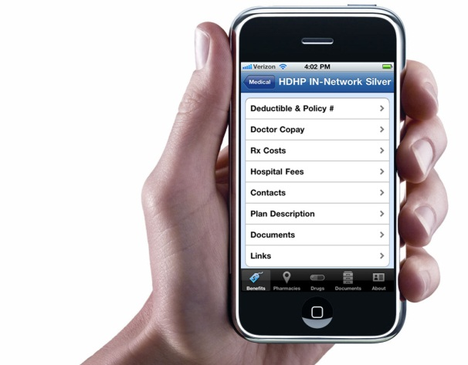
Virtual Personnel File: Easily track and report on critical HR data. Fields that are important to your organization can be marked as required which allows HR to easily report on missing data to keep in compliance. Additional tracking includes:
- Leave status & review dates
- EEOC & veteran status
- Payroll groups
- Salary history
- Birthdays and anniversaries
Communication: The communications capabilities let HR managers post custom alerts to employees and add company articles or news to the employee portal. Office contacts, RSS feeds and links to web resources as well as system emails are customizable
Reporting: Systems are only as good as the reporting system, and the custom report writer allows HR to configure row or column reports they can save and share. Standard reports give you quick access to your data and help meet HR compliance such as tracking HR page views.

Online Benefits Management
Selecting the right level of service for your company:
- Online plan Selection: This service level allows HR to roll out a complete self-service enrollment experience for their employees including new hire, open season and life events. Changes made by your employees will be posted to your “Wall” or HR can receive email notifications. HR, in turn, can make the changes on the carrier portals.
- Carrier feeds: Larger organizations or companies with higher turnover may require carrier feeds. This requires configuration and carrier reconciliation prior to beginning transmission of eligibility and may require the audit of error reports.
Enrollment Features

Benefits administration services
- Open Season
- New hire
- Life events
- Beneficiary tracking
- Alerts for missing beneficiary, dependent information, etc.

Plan configuration options
- Rules based eligibility
- Contributions by “classes”
- Open enrollment including passive re-enrollment
- Customizable communication for plans
- Documents: Rules for docs, EOI, SBC, Show in enrollment, Required,
- Rate adjustments for age band changes
- Cafeteria and HSA contingency support

Reporting
- Over 40 standard reports
- Custom row and column report engine,
- Save, share and export reports
- Custom event tracking via “Wall”
HR features
- Evidence of Insurability
- COBRA tracking
- Pend enrollments
- HR user restrictions
Benefit administration best practices: All carriers are required to accept HIPAA feeds, but that does not mean they do it well and benefit systems are not perfect. HR can reduce the administrative errors by making a few administrative changes:
- Have benefits begin on the 1st of the month rather than date of hire
- Convert to self-billing for ancillary coverage

