Evolution Dr. K.Brilakis
Evolution is a scientific theory that describes the development of species on our planet. This scientific theory relies on factual data, not mysticism and should not be confused with theological explanations of life.
First, let’s explore the meaning of the word
theory
To many of you, the word theory suggests an unproven hunch or guess. In societal terms, you are correct. But a scientific theory is different. Recall Newton’s Theory of Universal Gravitation or Einstein’s Theory of Relativity. These theories are supported by a wealth of supporting data, rendering them virtually uncontested. Although the Scientific Theory of Evolution is similarly supported, it continues to attract as much controversy as it did when first introduced to the Linnean Society in the mid-nineteenth century. When Newton first presented his theory of gravitation, it was considered heresy. Today, his theory of gravitation is universally accepted as fact. Why? Perhaps disagreeing with thousands of years of accepted religious dogma makes people uncomfortable or feel like they are disrespecting their theological beliefs. Especially when evolution describes the descent of humans from other primates. Most modern theologies describe humans as being divinely created. In order to understand evolution, it is necessary to understand the difference between science and theology. Science is based on explaining the unknown via the analysis of observable phenomena and data. Theology requires the acceptance of a belief system without testable hypotheses.
Next, let’s talk about time.
LONGGGG periods of time are often hard to get your head around. Millions and millions and MILLIONS of years! The evolution of most of what we see today living on our planet took MILLIONS of years. Can you visualize a million years? A hundred million years? I can’t! We want to SEE evolution occurring. But the time it takes is just too great. There are scientific methods by which time is measured. But even they involve ideas that are hard for some to grasp. So it is easier to just say it didn’t happen. Please remember though…just because someone doesn’t understand the science does not mean the science is not true. We don’t need to have ALL of the answers this very day to accept that there are answers yet undiscovered that do explain the mysteries of the universe, We have come a LONG way since Galileo reached for the stars. But in evolutionary terms, he lived VERY recently. It is allll relative.
Embrace the certainty that it is OK not to know everything right now…that we are still discovering amazing things about our species, our environment, our planet and our universe. Think of all that we have discovered just in the past century. Let’s not create supernatural explanations for natural phenomenon. Let’s instead have the patience, grace and fortitude to accept that we’ll never know it all. And that’s ok.
Have you ever used the term “survival of the fittest” outside of the context of science. (the phrase was actually coined by Herbert Spencer but popularized by Charles Darwin). It is routinely inserted in our popular language. But its scientific meaning is, again, different from its societal meaning so…
1. Don’t listen to politicians, economists (like Malthus),theologists,isolationists or any other “ist” who might use this idea to justify ruthlessness in global decisions. In nature, it is not always the powerful that survive.
2. Realize that evolution has stirred the pot of controversy for decades and will continue to do so for generations.
3. Try not to tune out this scientific theory as a way to remain loyal to your theology. Knowledge is not an enemy. The search for knowledge should strengthen your beliefs.
4. Accept that humans are skeptical by nature…we love to ask WHY…but we also are most comfortable when our questions are answered .
Look at the early humans, by the 12th century, Copernicus in the 16th century, Newton in 1790, and by the early 19th century with Cuvier….Lyell…Lamark…and DARWIN
Yes, Charles Darwin, The man…the legend…
Born 1809 (same Bday as Lincoln), 1831-1836 HMS Beagle, 1842 completes On the Origin of Species, along comes Alfred Russel in 1858 (and a tough bout with malaria),
Co-operative effort with Russel at the Linean Society. Darwin’s book On the Origin of Species is published in 1859
First, Darwin’s observations:
1. Populations have the potential to increase in size exponentially but usually don’t because they are limited by resources (carrying capacity).
2. Within populations, there are variations among individuals that appear to be inherited
Second, Darwin’s deductions:
1. There must be a struggle for existence resulting in just some of a population surviving
2. Surviving individuals have favorable variations which enhance chances of survival
3. Surviving individuals are able to reproduce and pass on favorable variations
4. Accumulation of many favorable variations over time is leads to a change in the genotypes and phenotypes of the population which is….evolution
Darwin’s Observations and deductions can be used to explain the process of evolution, often called Natural Selection.
1. Members of a population inherit variations of a gene which produces a particular phenotype.
2. More individuals in a population are born than a given habitat can sustain
3. Those individuals with the phenotype most compatible at that time with the habitat survive and reproduce, passing on this phenotype to the next generation. This is a measure of fitness of the individual. Those with an unfavorable phenotype die. If you are dead, you cannot reproduce and pass on the less favorable phenotype.
4. Each generation has a higher proportion of individuals with the adaptive phenotype
5. The end result is a population with many individuals with phenotypes which are favorable for that environment…the species has adapted to its environment.
How do we get these different phenotypes??? Mutations
Mutations just occur…they JUST HAPPEN!
Mutations change genotype
A changed genotype results in a different phenotype
Phenotype change may improve chance for survival in given environment by allowing the individual to outcompete those without the mutation.
Survivors with new phenotype mate and pass on phenotype/mutation. In this way, nature “selects” for helpful mutations = NATURAL SELECTION”.
Natural selection does not cause mutations, only determines the “fitness” of mutation.
Environmental changes may alter criteria for “fitness”. Fitness is the measure of adaptation to a given environment
Why there are still fish if amphibians evolved from fish???
Speciation follows two main paths:
When mutations change part of a population enough so that they can no longer interbreed, a new species is formed. Speciation is the development of a new species. Species are distinct populations that cannot interbreed. New species are formed as a result of:
1. Allopatric speciation: geographic separation of members of a population.
(How might migration influence this form of speciation?)
2. Sympatric speciation: occupation of different habitats within the same range usually because of overcrowding and competition. Habitat variation includes food choice,
nest/den sites, breeding time/ habits.
New species are formed over time through the gradual accumulation of mutations that eventually prevent members of the population from interbreeding.
What are some patterns of Evolution:
1.Convergent Evolution: unrelated species living in a similar environment may develop similar adaptations to that environment. (shark and dolphin)
2. Divergent Evolution: closely related species living in environmentally different areas develop different characteristics. A form of divergent evolution is Adaptive Radiation…a number of species may develop from a single, ancestral species.
3. Co-evolution: the evolution one species is influenced by the evolution of another.
4. Gradualism: slow and steady accumulation of adaptations resulting in a new species.
5. Punctuated Equilibrium: Brief (tens of thousands of years) periods of change followed by long periods of stasis.
Other terms associated with evolution:
Natural Selection: Differences in survival and reproduction among individuals with
different inherited phenotypes
Directional selection: allele frequencies shift in a consistent direction (peppered moths)
(pesticide and antibiotic resistance)
Stabilizing selection: Intermediate forms of a trait are favored…extreme forms are
eliminated or greatly reduced in expression (height)
Disruptive selection: Extreme forms of a trait are favored…intermediate form reduced in
expression or eliminated
Sexual selection: via non-random mating, the alleles for preferred traits in males or
females are favored
Sexual dimorphism: species having distinctly male and female traits (anglerfish)
Extinction: irrevocable loss of a species
What other forms of evidence supports evolution?
1.Biochemical evidence: Protein clock: the number of amino acid differences among organisms is proportional to the length of time since the two organisms began to evolve separately from a common ancestor, scientists are able to determine the amino acid sequence of Cytochrome C, part of the electron transport chain found in the mitochondria of ALL living organisms. Divergence data is readily available for hundreds of genes.
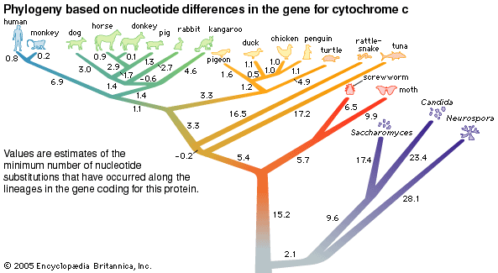
2. Embryological evidence: There is a saying that Ontogeny recapitulates Phylogeny…meaning that the entire evolutionary history can be summed up in the embryological development of one organism. As embryos, all vertebrates display a notochord, paired pharyngeal pouches and gill arches even though non-aquatic organisms certainly don’t need non-functioning gills and the primal notochord has been replaced by the spinal cord and vertebral column in higher vertebrates.
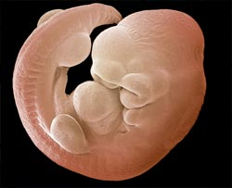
The genes that assemble you are strikingly similar to those that assemble a fly. So why do you and the fly look so different as adults? Evo-devo explores where, how, and for how long genes are active during embryonic development, accepting the basic premise that all animals share the same basic toolkit of body-building genes.
The early instructions for creating limbs, developing heads etc. are dictated by key regions and molecules which are conserved across species. For example,
Hox genes set up the formation of body segments from head to tail. Hox genes are examples of these control genes that serve as important elements in building complex
organisms. What makes all the difference is how much you turn a gene on, when you turn it on, when you turn if off…regulation of that gene. Specific genes are essential to make any beak. It is the tweaking that creates the variations.
3.Comparative adult anatomy: When studying evolution, the terms homologous and analogous are used quite frequently. Homologous organisms or structures have similar composition and embryonic origins. Analogous structures only have similar functions. Organisms can be classified by their homology to another group of organisms. Look at vertebrate forelimbs (specifically the similarity between the radius, ulna, carpals and metacarpals) and see how their homology shows a common ancestor. Look at the variations in structure and compare structural differences to functional differences among species.
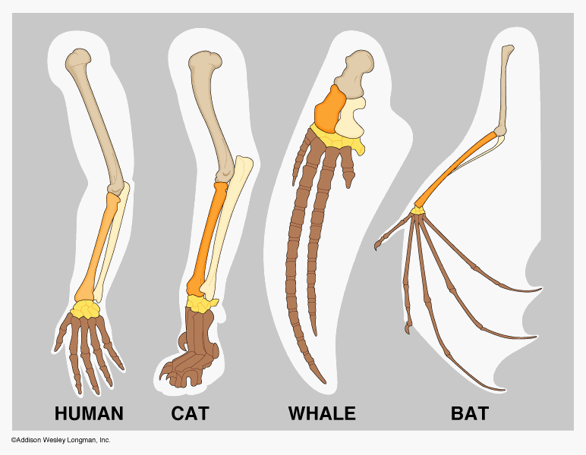
4. Fossil evidence and radiometric dating: By measuring the radioactive decay of fossils and surrounding rock, a fossil record has traced life back 3.5 billion years. (The most common is Potassium 40 to Argon 40 with a half life of 1.25 billion years.) The decay of a radioisotope occurs at a fixed rate regardless of ANY environmental variables, therefore, it is an extremely precise system of measurement. Radiometric dating is the precise measurement of the proportion of radioisotope (with unstable number of protons/neutrons which releases energy until it reaches a more stable configuration) in mineral rock vs. daughter isotopes formed from radioisotope decay. It is calculated using the known half-life of an element which is the time it takes for ½ of the radioisotope to decay (change) into a daughter isotope. Example: Carbon-14 has a ½ life of 5730 years)
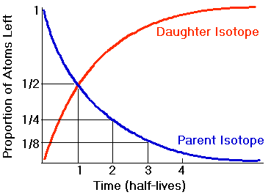
5. Current and historical Husbandry Practices: great danes and teacup
Maltiespoos belong to the same species of Canis lupus familiaris (C. domesticus) but they hardly appear related to their ancestor Canis lupus, the gray wolf. Most breeds of dogs are just a few hundred years old or less, having been developed through artificial selection for a particular look or behavior. Via selective breeding, we now have hundreds of breeds. The dog exhibits more variation than any other land mammal.
Evolutionary biology and the Eugenics movement:
In the mid-19th century, the eugenics movement gained wide attention when Galton published Hereditary Genius which suggested that the Human species would benefit from selective and controlled mating among those most “gifted”. We must presume those considered unfit would not make the cut.
In the U.S., passage of the 1924 Immigration Restriction Act limited the entrance of certain populations based on their perceived inferiority. Racism, classism, and isolationism fueled these sentiments. Not until the Immigration and Nationality Act of 1965 was passed that entrance to the US was made more egalitarian. Why did the mainstream support for this idea fade in the mid 20th century?
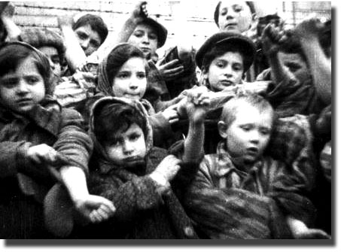
BTW….Did you ever hear of:
Better Baby Contests

They were “Scientific Baby Contests” such as this one at the Louisiana State Fair, 1908.
Grading sheets for contestants evaluated physical measurements with standardized measurements of intelligence. The child with the most points (and the least defections) was ideal.
Fitter Family for the Future: 1920/Kansas. Fitter Family competitions jusged families in
several different categories: Size of the family, overall attractiveness, and health of the family. Since it was believed that behavioral qualities were inherited from your parents,
generosity, self-sacrificing, and quality of familial bonds were also rewarded while selfishness, jealousy, suspiciousness, high temperedness, as well as feeblemindedness,
alcoholism, and paralysis were point losers.
Euthanasia programs in OUR country:
A mental institution in Lincoln, Illinois fed its incoming patients milk infected with tuberculosis (reasoning that genetically fit individuals would be resistant), resulting in 30-40% annual death rates. Other doctors practiced eugenicide through various forms of lethal neglect.
Compulsory sterilization in OUR country:
In 1907, Indiana passed the first eugenics-based compulsory sterilization law in the world. Thirty U.S. states would soon follow their lead. Some states sterilized "imbeciles" for much of the 20th century. Although compulsory sterilization is now considered an abuse of human rights, Virginia did not repeal its sterilization law until 1974. Between 1907 and 1963, 64,000 individuals were forcibly sterilized under eugenic legislation in the United States.
From 1930 to the 1960s, sterilizations were performed on many more institutionalized women than men. 61 percent of the total eugenic sterilizations in the United States were performed on women. A favorable report on the results of sterilization published by
biologist Paul Popenoe was heavily cited by the Nazi government to support sterilization programs as humane.
Men and women were compulsorily sterilized for different reasons. Men were sterilized to treat their aggression and to eliminate their criminal behavior, while women were sterilized to control the results of their sexuality.
In 1927, a Fortune magazine poll found that 2/3 of respondents supported eugenic sterilization of "mental defectives", 63% supported sterilization of criminals. Only 15% of respondents opposed both.
What are some of the many fatal flaws of eugenics.
1. Complex traits like intelligence are not determined by single genes and simple Mendelian inheritance.
2. Complex traits exhibit a strong environmental component.
3. Homozygosity, the end game for eugenics, is genetically disadvantageous for a species.
4. Inbreeding increases the likelihood that inherited defects appear in subsequent generations.
5. Those most suited for survival out produce those poorly suited, therefore, the genetically fit survive naturally.
Is traditional eugenics alive and well today?
http://www.hgalert.org/topics/geneticSelection/eugenics.htm
With the development of new artificial reproductive therapies, is a “new eugenics” movement on the horizon?
As the earth’s population grows, and a shortage of resources becomes critical, will healthcare rationing pressure societies to mandate genetic screening programs as cost-saving public health measures?
What would be the standard of the perceived ideal phenotype? Does such a phenotype exist?
If the success of a population is dependent on its genetic diversity, and parts of our genome function in ways that have not yet been elucidated, will the search for this genetic ideal alter our genome in ways we cannot possibly predict today?
These are issues YOU will need to address, either in the lab or in the voting booth.
Bottom line…
Our planet is rich in diversity with so many unique species occupying specific niche. Yet, we are ALL related. We ALL possess the same fundamental DNA, tweeked during the millions and millions and MIILLIONS of years our planet has supported life. It isn’t always easy for humans to accept that we are not the result of a single master blueprint. Evolution is messy and may seem improbable. But that is because we often look at our species existence as a terminal event, not as part of a bigger picture involving the past, and future, development of life on Earth. It is important for all of us to understand the science behind the reality of our existence. History shows that when humans choose to believe in their own superiority and divinity above all others, they cease to see others, whether it be other humans or other species, as valuable and worth preserving.
Here’s a brief history of our planet…(just for fun!!)
Origin of our planet: 4 –4,500,000,000 years ago
Origin of life: 3,800,000,000 years ago (early prokaryots)
Origin of eukaryots: 1,200,000,000 years ago
Origin of plants: 1,000,000,000 years ago
Origin of animals: 900,000,000 ya (9 hundred MILLION years ago!!!)
Mass extinction of dinosaurs: 65,000,000 ya…great opportunity for mammals!
Origin of modern primates: 1,500,000 ya
Origin of Homo sapiens: 100,000 years ago
40,000 years ago… modern humans shared the earth with Neanderthals
6,000 years ago…recorded time
200 years ago beginning of “modern” medicine with introduction of penicillin
60 years ago DNA discovered…40 years ago computers invented…
and here you are…
a virtual single grain in the sands of time!

