REGULAR MEETING
AUGUST 15, 2019

A Regular Meeting of the Town Board of the Town of Hampton, County of Washington and the State of New York was held at the Town Hall, 2629 State Route 22A, Hampton, New York on the 15th day of August, 2019.

PRESENT: David K. O’Brien------------Supervisor
Tamme Taran----------------Councilwoman – absent
Donald Sady-----------------Councilman
Andrea Sweeney------------Councilwoman
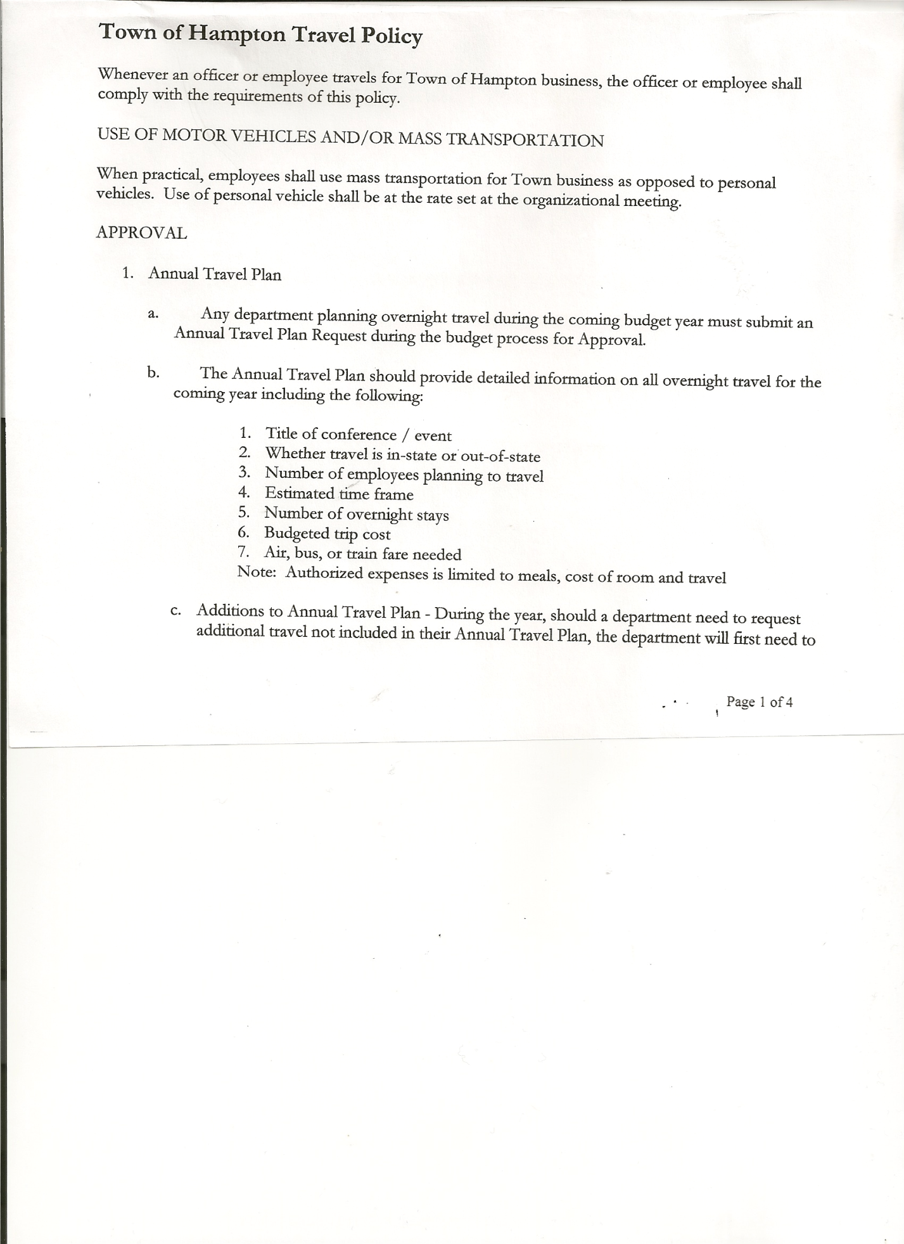
Roger Weeden---------------Councilman
Rebecca Jones---------------Town Clerk
Camilla Shaw----------------Tax Collector/Deputy Town Clerk
Herbert Sady, Jr.-------------Highway Superintendent

Planning Board Member(s): Bonnie Hawley, Chair, Matthew Pratt and Renee Rountree

Also present: Vicki Hayner, Laura Chadwick, Ed Longley, Highway Employee, and Leonard Reed

The Regular Meeting was called to order by Supervisor O’Brien at 7:30pm, followed by the Pledge of Allegiance. Location of Fire Exits were given. Quorum of board members present.

Supervisor O’Brien asked for a moment of silence in memory of Bill Clark, Samantha Panoushek and Pete Bunker.

RESOLUTION NO. 76-2019
APPROVAL OF THE MINUTES
On a motion of Councilwoman Sweeney, seconded by Councilman Weeden, the following resolution was ADOPTED: Ayes 4 O’Brien, Sady, Sweeney, Weeden
Nays 0
Absent 1 Taran
RESOLVED, that the Regular Town Board Minutes for July 18th, 2019 are approved.

ASSESSOR INTERVIEWS….Town Board interviewed (Councilwoman Taran listened in via conference call)
- Laura Chadwick, Director of Real Property Tax Service, who was representing the County and
- Victoria Hayner, who is currently the Assessor for the Towns of Granville, Hebron and Fort Edward in Washington County; Town of Galway in Saratoga County and Town of Caroga in Fulton County.
Discussed the need and cost for a revaluation of the Town of Hampton. Board further agreed that its nice for the people to have one contact person not several. Following the interviews of each candidate, the following Resolution was introduced:
RESOLUTION NO. 77-2019
ASSESSOR APPOINTMENT
On a motion of Councilman Sady, seconded by Councilwoman Sweeney the following resolution was ADOPTED:
By Roll Call Vote: Supervisor O’Brien AYE
Councilman Sady AYE
Councilman Weeden AYE
Councilwoman Sweeney AYE
Councilwoman Taran ABSENT

TOWN BOARD MEETING
AUGUST 15, 2019 PAGE 2

RESOLVED, to hire Victoria Hayner as the Sole Assessor for the Town of Hampton. Her term of appointment is October 1, 2019 to September 30, 2025. Her salary will be $10,000.00.

Camilla Shaw, Tax Collector - Zero balance. Submitted a Bank Statement to the Board for review and signatures.

Larry Carman, Dog Control Officer…no report
Supervisor O’Brien is still acting Dog Control Officer, Larry is still recovery from knee surgery.

Planning Board Report…
- Continuing to work on Farm Land Ag Protection Plan.
- Next meeting will be September 11th, 2019 @ 7:00pm at the Town Hall

Herbert Sady, Jr., Highway Superintendent submitted his report, copy of which, is attached.
Herb introduced Ed Longley, he’s the new Highway Employee. Chart of Highway Equipment handed out to Board members, showing the year, hours/mileage, condition and notes about each.
The 2009 International Tandem needs new tires, 8 of them. Herb received the following three quotes:
- Pete’s Tire Barn (Continental Tires) $481.76 each; $25.00 mounting fee per tire…
total $4054.08
- Warren Tire (Goodyear Tires) $493.21 each; $32.50 mounting fee per tire plus recycling
fee… total $ 4325.68
- Adirondack Tire (Goodyear Tires) $493.21 each; $25.00 mounting fee per tire….
total $4145.68
Following a discussion of the quotes, the following Resolution was introduced:

RESOLUTION NO. 78-2019
PURCHASE NEW TIRES-2009 INTERNATIONAL TANDEM
On a motion of Councilman Sady, seconded by Councilman Weeden, the following resolution was ADOPTED: Ayes 4 O’Brien, Sady, Sweeney, Weeden
Nays 0
Absent 1 Taran
RESOLVED, to authorize Highway Superintendent Herb Sady to purchase tires for 2009 Int’l Tandem from Pete’s Tire Barn.
HIGHWAY INFO
Herb will be checking on equipment & price of equipment to be able change tires at the Town Garage by the Highway crew.
Councilman Weeden and Highway Superintendent Sady and Highway Employees (Tyler & Ed) continuing to work on 5-year plan.
Grant for Highway Truck…Disbursement Agreement signed by Supervisor and sent back.
Copy of the Procurement Policy for 2019 was handed out…parts of Policy not being followed and needs to be.
Paving….discussed at great length whether to pave or not this year. Pros and Cons were both discussed. Town would lose approximately $25,000 (Pave NY & Extreme Winter funds) if paving is not done. Following an extremely long discussion and deliberation, the following resolution was introduced:

TOWN BOARD MEETING
AUGUST 15, 2019 PAGE 3

RESOLUTION NO. 79-2019
PAVING
On a motion of Councilwoman Sweeney, seconded by Councilman Sady, the following resolution was ADOPTED: Ayes 4 O’Brien, Sady, Sweeney, Weeden
Nays 0
Absent 1 Taran
RESOLVED, to go ahead and complete the Paving as outlined in the Agreements To Spend Town Highway Funds for 2019.

RESOLUTION NO. 80-2019
APPROVAL OF SUPERVISOR’S MONTHLY REPORT
On a motion of Councilman Sady, seconded by Councilman Weeden, the following resolution was ADOPTED: Ayes 4 O’Brien, Sady, Sweeney, Weeden
Nays 0
Absent 1 Taran
RESOLVED that, the Supervisor’s Monthly report be accepted as submitted for JULY
06/30/19 07/31/19
ACCOUNT BALANCE RECEIPTS DISBURSEMENTS BALANCE
General Fund $ 62,066.48 $ 925.08 $ 6,544.41 $ 56,447.15
Highway Fund $118,560.40 $ 4.93 $ 14,708.43 $ 103,856.90
Equipment Reserve $ 29,846.88 $ 1.27 $ 0.00 $ 29,848.15
Fire #1 $ 20,808.00 $ 0.00 $ 0.00 $ 20,808.00
Fire #2 $ 3,878.00 $ 0.00 $ 0.00 $ 3,878.00
Cemetery $ 1,719.97 $ 1.16 $ 0.00 $ 1,721.13
Totals $236,879.73 $ 932.44 $ 21,252.84 $216,559.33
All Board Members present signed Supervisor’s Report.

BROADBAND update….
- Charter is on in some places in Low Hampton
- Slic Network will be going down County Route 18 to State Route 22A, going up
South Road; North Quivey Hill Lane; Rainbow Way and Hampton Heights Way.

The Town Clerk’s report for July 2019 was submitted to the Board. The Town Clerk had Board Members review and sign bank reconciliation statements for the Town Clerk Account and Special Town Clerk Account dated July 30th, 2019.

PUBLIC COMMENTS
Renee Rountree commented that Dave’s title should be Compliance Officer vs Code Enforcement Officer. Supervisor will check on this.

TOWN BOARD MEETING
AUGUST 15, 2019 PAGE 4

RESOLUTION NO. 81-2019

AUDIT OF CLAIMS
On a motion of Councilman Sady, seconded by Councilman Weeden, the following resolution was ADOPTED: Ayes 4 O’Brien, Sady, Sweeney, Weeden
Nays 0
Absent 1 Taran
RESOLVED that the bills have been reviewed by the Town Board and are authorized for payment in the following amounts.
General Fund No. 115 through No. 124 $ 1,208.86
Highway Fund No. 77 through No. 84 $ 16,741.37
Total both funds $ 17,950.23

On a motion of Councilman Sady seconded by Councilwoman Sweeney, the meeting adjourned at 10:20pm All in favor Aye.

Respectfully submitted,

Rebecca S. Jones, RMC
Town Clerk

