Sponsored by:

Download My Mobile App!
Search for your perfect next home
using iPhone, iPad or Android device.
http://getmobile.remax.com/98191354

___________________________________________________________________________________________

JANE BERG-SABOL
All phases of Domestic Duties
Call: 754.366.9863

Dog Sitting • All Party Services • Cleaning • Laundry
Ironing • Closet Organized • Certified Home Health Aide

_________________________________________________________________________________________________

Along the Way: Going Fishing

Have boat, will rescue. As word of the “Cajun Navy” spread, locals in the flooded regions of Mississippi and Louisiana joined the effort to use personal fishing boats to help neighbors and strangers out of dangerous waters. The flat bottomed boats designed to navigate the shallow bayous are ideal for use along flooded streets.The “Cajun Navy” actions were a literal embodiment of Jesus’ call to fish for men and women. (Animals were rescued, too.) According to The Wall Street Journal on August 28th, the volunteers have helped rescue over 30,000 people stranded by the deluge.
First formed after Hurricane Katrina, this time Facebook, cell phone apps and GPS have made the “Cajun Navy” more efficient in identifying and quickly rescuing those in distress. The association has inspired the “Cajun Army,” comprised of folks who help displaced families find temporary housing with other families. As the WSJ states, “There will always be a role for operations such as the Federal Emergency Management Agency, Coast Guard and National Guard. But citizen volunteers often are in position to get there first and have the gumption to take the initiative rather than wait for a federal directive.”

Jesus spent a lot of time among the boating crowd; fishermen were his first disciples. These were people with gumption and Jesus recognized them for the leaders they would become. During September we’ll be focusing on gospel accounts of fishing in both Sunday morning worship and Wednesday bible studies. You may not be called to “fish for people” using a boat like the “Cajun Navy” but you are called to fish for people using what the Lord has entrusted to you.

There is a vast number of non-religious and nominally religious people in our area in need of a life-giving relationship with Jesus. How are we to be instrumental in the Holy Spirit’s work? Fishing for people means sometimes coming up empty, sometimes having to change our location or bait, and at all times having patience to keep casting the net or putting out the line. Flood waters will threaten to swamp us, the wind will buffet, but as the old song says, “With Jesus in the boat we can smile at the storm.”

In this issue of the Courier you will see there are many opportunities to get on board with the mission to make disciples of Jesus Christ for the transformation of the world. Instead of standing on the shoreline waiting for someone to invite you please get in the boat and be part of the crew. Jesus will direct us where to fish, and because with God all things are possible, get your spiritual muscles ready to help bring aboard the haul.

Bon voyage,
Pastor CJ

One day as Jesus was walking along the shore of the Sea of Galilee, he saw two brothers—Simon, also called Peter, and Andrew—throwing a net into the water, for they fished for a living. 19 Jesus called out to them, “Come, follow me, and I will show you how to fish for people!” 20 And they left their nets at once and followed him.
21 A little farther up the shore he saw two other brothers, James and John, sitting in a boat with their father, Zebedee, repairing their nets. And he called them to come, too. 22 They immediately followed him, leaving the boat and their father behind. —Matthew 4.18-22 (New Living Translation)
_________________________________________________________________________________________________
Have lunch with Pastor CJ on Sunday, 18th September, 12.30 in the Library to get to know more about what it means to be a disciple of Jesus and a member of Cokesbury. She is eager to hear your story of “God sightings” in your life! Sign up on the black friendship pads in the sanctuary or call the Church Office (954) 972-3424 so we’ll prepare properly.

Your Church Home” —Notes from the Trustees

Hope everyone had a good summer. Your Trustees continued their work throughout the summer. We spent a good deal of our time cleaning. Thanks to Ron Huffman and Phil Gough Courtyard Room 9 has a new laminate floor and looks terrific. While the room was empty Joan Martin, Joan Carlson, Sondra Bass and myself took on the project of cleaning out the closet. After three trash bags had been taken to the dumpster the closet got put back in order in containers and where Joan Martin could find what she needed. The items the guys removed from the room to do the flooring was put into Bay 3 of Settle Hall. That too was gone through and much was taken to the dumpster but Victory Living People was able to use some of the craft stuff and both Margate Elementary and Michelle's Leaning House were able to use much of the items we were getting rid of as well as items donated to us by Pastor CJ's sister.

We contracted a tree removal company to take out all the invasive holly bushes on the North side of the office/Sunday School wing. It looks great but when I saw how open it was and how the condos across the canal could see what was in back of that area I was appalled at all the "junk" that was back there. There were old Bar-B-Q grills (3); hay bales; broken cabinets; a broken basketball hoop; and an old hot water tank. Thanks to Mike Uber and Garrett Gruber all of that was hauled over to the Toombs house for bulk pick up. It looks 100% better.

We had to replace one of the compressors for the sanctuary and bless David Toombs who was able to get us a new one for far less than our A/C company plus Phil and he installed it. Thank you, thank you!

While cleaning the closet in Courtyard Room 9 we saw that the sink was rusted through. Also the faucet in Courtyard Room 8 was frozen in place. We ordered new sinks & faucets and David Nero will install them. We are so blessed to have wonderful people in our church to do so much of the work that needs to be done.

When Carole Howell came for a visit she gave the Trustees money to purchase 50 new folding chairs which are now in Settle Hall. She also gave us enough money to purchase a new A/C unit for the food pantry in Courtyard Room 1 which will have a thermostat so it will not run all the time.
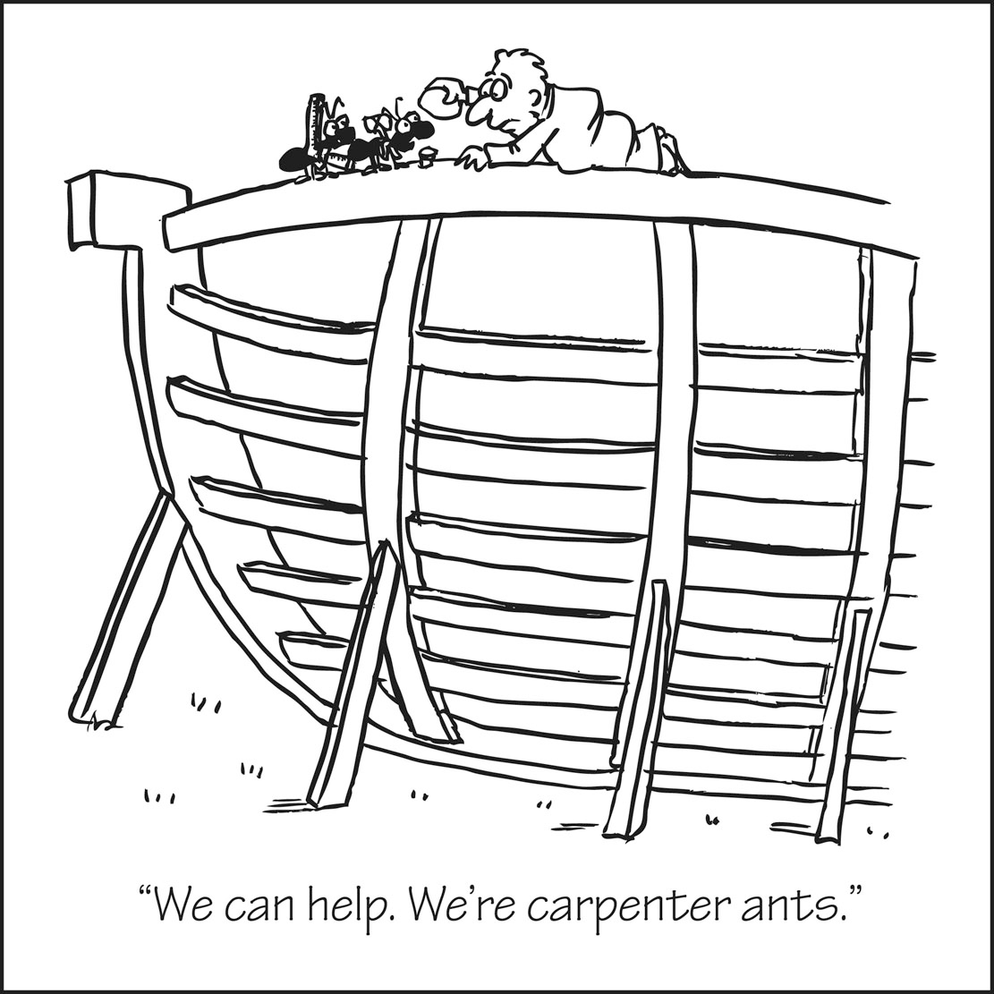
We had a company come to fix our sprinkler system. The first step was to replace the large pipe by the pump that had been cut in two places. Once that was replaced they found we had electrical problems as well. This needs to be addressed in order to get the system up and running. We are in the process of getting a quote on that part before we proceed.

While we were on the cleaning kick, Wendie Carper and I went through the "overflow" area of the kitchen and organized it and got rid of some stuff which we donated to Salvation Army. I would like to ask all of you to be aware of what you use in Settle Hall, the kitchen and the Sunday School rooms. If you turn on the lights and the A/C please be sure to turn them off when you leave. If you use the kitchen please put whatever you use back were you found it. Don't leave dishes in the drainer and please dump the sink strainers. I have come in and found the sink filled with ants because of food left in the strainers. And last of all please do not leave leftover food in the refrigerator including drinks in the dispensers. If it will not be used the next day, please dump it. This is your church home so please treat it as you would your own home. Thank You!

In His Service,
Linda Hollen, Trustee Chairperson
_________________________________________________________________________________________

Current worship series and Wednesday Small

Group Bible studies:
GOING FISHING: SECOND CHANCES WITH JESUS Many of the great gospel stories having something to do with fishing. Jesus called fishermen to be his disciples; he preached from the fishing boats; he called his followers to “fish for people”; he multiplied the fish and the loaves to feed the multitudes; he told parables about fishing, and the last scene we see in the gospels is Jesus helping his disciples fish. Whether you’re into fishing or not, you’ll love this special series of messages!

Sept. 4 Labor Day Weekend “I’m Going Fishing” John 21.1-13 (focus of Small Group Bible Studies Wednesday, Aug. 31)
Sept. 11 Patriots Day “Cast Your Nets Into the Deep” Luke 5.1-11 (focus of Small Group Bible Studies Wednesday, Sept. 7)
Sept. 18 “Fishing for People” Matthew 4.12-13, 17-22 (focus of Small Group Bible Studies Wednesday, Sept. 14)
Sept. 25 ONE SERVICE: Feature the Cantata, WITNESS. Reflection on “Parable of the Nets and Fish” Matthew 13.47-50
(focus of Small Group Bible Studies Wednesday, Sept. 21)
Oct. 2 World Communion Sunday “ Five Loaves and Two Fish” Matthew 14.13-21 (focus of Small Group Bible Studies Wednesday, Sept. 28)

_________________________________________________________________________________________________
September Shoebox Collection:
“Children’s-size” Toothbrushes & Toothpaste
Please place your collected items on table in Narthex.
THANK YOU for your generosity.

Sign up for the Pumpkin Patch beginning Sunday, 11th September.

Cokesbury hosts a popular patch for a large part of October. Many families have a tradition of coming to the church to take pictures in the patch and to buy their pumpkins here because they want to support the good work of the church. We get the opportunity to meet the neighbors and to provide farmers on the Navajo Indian Reservation in Farmington, NM meaningful employment. According to our partners, Pumpkin Patch Fundraisers (www.pumpkinsusa.com), approximately 2 square miles of pumpkins are grown and 700 Navajo are employed during the harvest months of September and October. There is also a full time off-season NM staff comprised of Navajo—a great boon in a region with 42% unemployment.

We pay ONLY for the pumpkins we sell, with 75% going to the growers and 25% going to the mission and ministry work of Cokesbury. It is a win-win situation that depends on your participation and support.

HOW YOU CAN HELP:
- Pray for good weather, solid pumpkins, and community support of the patch.
- Sign up for as many two hour shifts staffing the patch as you possibly can. Please don’t simply “take a turn” because some folks cannot participate so we really need able-bodied people to contribute a lot of time.
- Invite people you know to come to the patch and tell them about the support they will be giving to Navajo farmers. Our pumpkins cost more but the positive impact on lives is greater.
- Volunteer to unload pumpkins—scheduled for 3 pm on Saturday, 8th October. Volunteer to clean up the patch by sorting out rotting produce, which has to be done on a daily basis.
- Cook and feed the pumpkin unloaders on the 8th October. Includes hungry boy and girl scouts!
- We have a modest craft table alongside the patch; how about making some items for sale?
- Phone call and text reminders are needed to ensure each shift’s staff is able to be present.
- Counters are needed to ensure the funds are deposited each evening so we keep a good account.
- VERY IMPORTANT: we host over 300 pre-schoolers during the patch season. The children come with their teachers during the school day and receive a small pumpkin, goody bag, and a lovely story read to them. We need people willing to greet the children, hand out the bags and read one of the books from our collection.

This year we are having a community meal and outdoor praise concert the evening of Sunday, 30th October instead of a Saturday night block party. The city and Margate Elementary host parties; we have a unique contribution to make and will have the help of our sister churches in our cluster. WOULD YOU BE WILLING TO HELP ORGANIZE THIS EVENT? We will have a cake auction but the rest of the evening is free to the community. Our partners, Margate Elementary and Michelle’s International House of Learning are participating as well as the cluster churches.

Questions about the Patch itself? Please direct them to Pat Uber, home (954) 968-7668 or cell (954) 448-2474. THE BEST WAY TO THANK PAT for years of service as the Patch Coordinator is to volunteer early and faithfully participate!

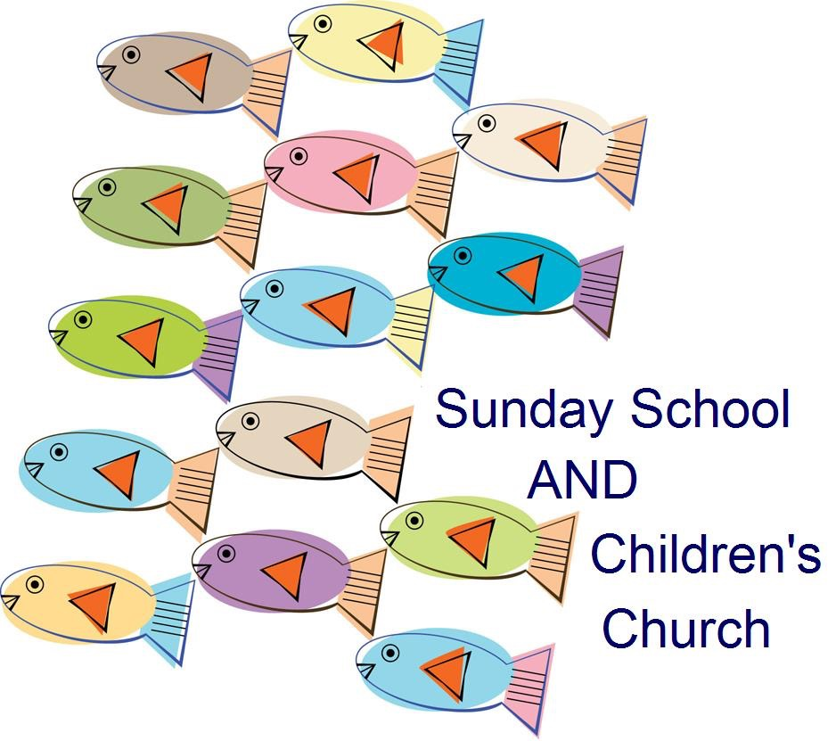

Joan Martin, Coordinator
Change lives! Be a team member in Cokesbury’s children’s ministries.
SUNDAY MORNINGS: teach/co-teach Sunday School @ 9.30 or Children’s Church @ 11.
Help two children in first or second grade be good readers through THUMB’S UP THURSDAY program. Team meeting on September 8th @ 3 pm; program with the children begins the 22nd.*
Bring children to SS & CC all year and save the date for the Children’s Christmas Program, Sunday, December 18th in the evening.

Keep the week of June 12-16 free for HERO CENTRAL Vacation Bible School 2017.

- Dates for 2016-2017 Thumb’s Up Thursdays:
September 8th: Team meeting @ 3 pm;
September 22 & 29; October 6, 13, & 20; November 3, 10 & 17; December 1, 8, 15 & 22; January 19 & 26; February 2, 9 & 16; March 2, 9, 16 & 30; April 6, 20 & 27; May 4, 11, 18 & 25 for Children and Team.

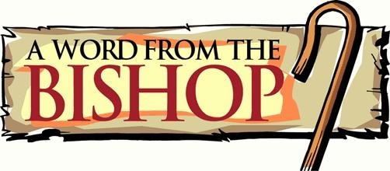

September’s Town Hall Meetings

To the Clergy and Laity of the Florida Annual Conference:

As I begin my second quadrennium of service as your Bishop, I want to invite each of you to join me for a regional Town Hall gathering in September. Each gathering will begin at 6 p.m. and conclude with light refreshments. [Our closest one is Sunday, September 25 at Christ UMC, Fort Lauderdale. Please register to attend by following the link at http://www.flumc.org/townhall ]

You might wonder: Why should I attend one of these gatherings?

First, this is a chance for us to connect. I spent a good portion of my first four years trying to connect with as many congregations and clergy in the Florida Annual Conference as I could. This is a chance to continue to connect with you, to hear your concerns, to understand your context and to grow our connection together.

Two-thirds of our time together will be spent answering your questions. You can submit your questions via the registration link on the conference website, write your questions on a card when you arrive at the gathering and, if there is time, share your questions verbally at the event.

Second, we are at a unique moment in our connection. I have written about this in other places, and you can find the link to my statements and the statement of our Council of Bishops and information about my role as a moderator for the Bishop’s Commission on “A Way Forward”. This will not be the focus of these events, but it is the context in which we gather.

I remain very hopeful about our future and the unity that is possible. I believe the work that the Council of Bishops proposed and the General Conference authorized can lead to a future with hope. At the same time, I realize we live in a polarized culture and, in some cases, a polarized church. I do not have all the answers. I can share about the process that is being developed through “A Way Forward.”[http://www.flumc.org/newsdetail/bishop-carter-to-serve-as-a-moderator-of-the-way-forward-5452820] I am honored to serve as one of the moderators of this commission.
Change lives! Be a team member in Cokesbury’s children’s ministries.

SUNDAY MORNINGS: teach/co-teach Sunday School @ 9.30 or Children’s Church @ 11.

Help two children in first or second grade be good readers through THUMB’S UP THURSDAY program. Team meeting on September 8th @ 3 pm; program with the children begins the 22nd.*

Bring children to SS & CC all year and save the date for the Children’s Christmas Program, Sunday, December 18th in the evening.

Keep the week of June 12-16 free for HERO CENTRAL Vacation Bible School 2017.

As a note, unity is not the same as unanimity; but a call to unity is also a call to humility, a call to listen to one another, a call to love graciously and seek to stand together under God’s grace within our diverse viewpoints.

Third, there are some exciting initiatives to share with you. In the last third of our time together at the gathering, I will share a vision of what it means for us to embrace this future with key initiatives that God can use in every place in our connection. This will include new information about Fresh Expressions, the Nehemiah project and our new initiative to connect every church with a local school serving at risk children. I will share specific steps and ways in which you can be a part of this work and invest in our future together.
For all of these reasons, I hope you will join me and other Conference leaders for this conversation. It will be a safe and open space. I am coming with expectations to learn from your questions, further understand your context and work together on our future.

The next four years of ministry among you begins with a chance to connect. See you in September.

The Peace of the Lord,

Bishop Ken Carter
Florida Episcopal Area

_______________________________________________________________

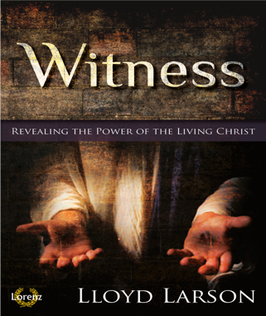
Hear the WORD of GOD through a special musical presentation:
COMBINED Worship Service on Sunday 25th September at 10.30
followed by potluck lunch.

Witness takes us to the heart of the story of redemption as we view Christ's journey to the cross through the varied eyewitness accounts of devout believers, angry deniers, and puzzled skeptics. Will you be a witness? Those who witness Jesus through the eyes of faith see a Savior who lives and loves, a Redeemer of grace and compassion. We are living witnesses to the reality of Christ. What will we do with these realities? "You are My witnesses, and My servants whom I have chosen that you may know and believe that I am God." (Isaiah 43:10) Jesus told a doubting Thomas whose weakened faith had been restored, "You believe because you have seen. Blessed are those who have not seen and yet believe." (John 20:29)
Join the Sanctuary Choir on Sunday, September 25 for a moving cantata, “Witness," revealing the power of the living Christ. Will YOU accept the challenge? Will YOU be a witness?

Other News:

Congratulations to HARVEST CROSSING and
FAITHFUL MEN for an excellent concert at
Cokesbury on Saturday, 27th August.

Save the dates for next Church Directory!
LifeTouch will be taking photos Thursday-
Saturday, 27-29 October. Jennifer Millis and
Patsy Watkins are coordinating the project.

YOUTH in need of service hours for school can
sign up for the pumpkin patch to help roll
pumpkins, sell pumpkins, toss rotten pumpkins,
distribute flyers, unload pumpkins….
See Mrs. Pat for details.

HELP NEEDED:
Fill and distribute welcome bags on Sundays;
Pick up readied orders of supplies at Sam’s Club;
Sign up to work with Jen & Patsy on photo
project for new church directory;
Be part of the Community Cookout (Oct 30)
organizational team;
RIGHT AWAY: help coordinate potluck Sept. 25th.

We have paid $23,834.62 of $29,805.00 (80%) in apportionments through August.

The offering you make each week empowers ministry within our congregation and in response to the needs of our community. It also helps support the work of ministries beyond the local church that empower the whole church to reach out to those who need to hear the good news of love and redemption. Every day, through our connected United Methodist Church, lives are touched, hearts are stirred, and people answer God’s call in many different ways. Through the ministry of our General Board of Global Ministries, which your offering supports, in July 45 young adult missionaries were commissioned to take the good news of Jesus Christ to places close to home and far way. This ministry happens thanks to the generous support of United Methodists like you.
Lean more about young adult missionaries at: http://www.umcmission.org/learn-about-us/news-and-stories/2016/july/0728newyoungadultmissionaries
__________________________________________________________________________________________________
Digital Photo Discovery
Calendars from Digital Photo Discovery Group are available now at $8 each. Call John or Gerry Leone at (954) 380-0487 or (954) 979-9855. The calendars will be sold between church services on September 11th and 18th.
The September meeting of the Photo Group is September 19th. Bring a picture of a subject that looks like or starts with the letter “C.” Meeting will be at 7 pm in Lowe Chapel.
_________________________________________________________________________________________

Fresh flowers on the altar are symbols of resurrection life. In addition to beautifying the sanctuary, unclaimed flowers are taken to local nursing homes or folks in need of a bit of cheer. Bulletins help folks follow the worship service as well as provide written reminders of upcoming opportunities for service and growth.
The cost of two bouquets of flowers($25 each) and bulletins ($12) is borne by the congregation when they are not sponsored. Many people sponsor flowers and bulletins in honor or memory of loved ones but sponsors may also do so simply to support this ministry. SIGN UP sheets are by the water fountain in the Narthex (sanctuary front hallway). Enclose your payment in the provided envelope found by the sheets and put it in the offering plate. Thank you!

The Walk to Emmaus is a three-day experience, a highly structured weekend, which takes a New Testament look at Christianity as a life-
style. The program is designed to strengthen and renew the faith of Christian people and through them their families, congregations, and the world. The dates for the upcoming walks are: Men''s Walk: Sept. 29-Oct. 2; Women’’s Walk: Oct. 6-9. Please speak to/contact Mike Uber (954) 609-8626 or Liz Haley (561) 317-3812 if this is your season to participate.

__________________________________________________________________________________________________

The Green Earth Community Garden is looking to expand now, the beginning of the new planting season. If you are interested in growing organic food for the Food Pantry and yourself speak with Eric Gibian, the garden coordinator. Eric writes that areas to tackle this season are:
*Fundraiser - online
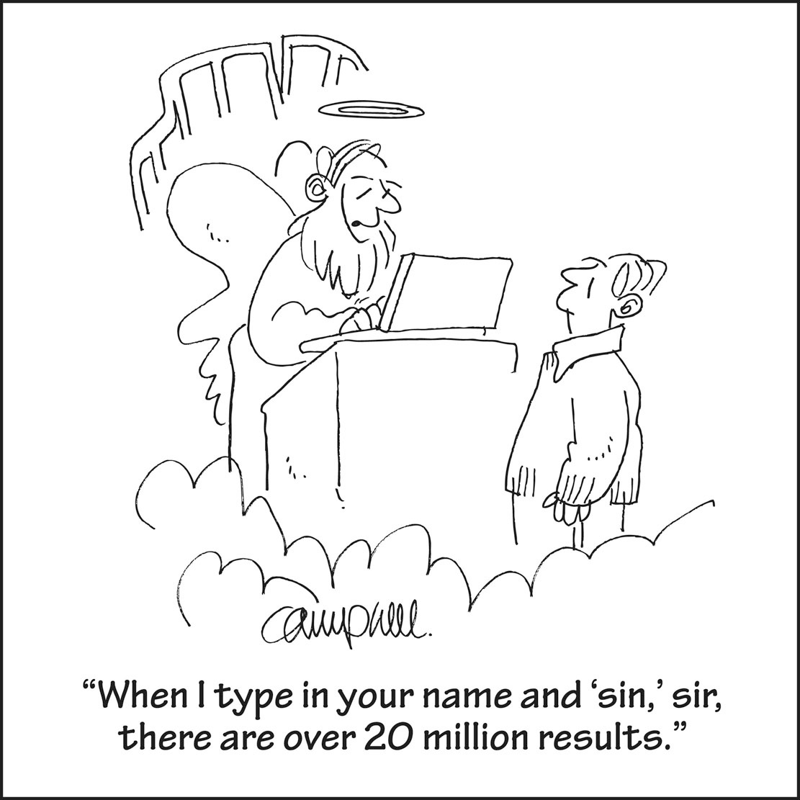
*Volunteer Recruitment
*Ideas and assistance in promoting/launching the fundraiser
*Garden Signage
*Seed Table Construction
*Irrigation setup, rope barrier, iguana protection
*String trim and mulching a permanent pathway
*Review of crop list and suggestions from the group
*Hay-rides and other events
*Nomination of a new board member.
“Please feel free to contact me directly with any questions or input.
Thank you.”— Eric Gibian, 954-789-2014 www.GreenEarthCommunityGarden.org

CALENDAR FOR SEPTEMBER
Other Groups Sharing the Campus:
Monday through Friday, Victory Living, 7 am- 4 pm, Rooms 2, 3, 4
Mondays, Tuesdays, Fridays, Spanish Alcoholics Anonymous, 8-10 pm, Grace’s Place (Room 4)
Tuesdays the 6th, 13th, 27th and Monday the 19th: Cub Scouts—7:00 – 8:00 pm
Wednesday and Fridays, Anglo Alcoholics Anonymous, 7-8 pm, Don Lowe Chapel
Thursdays, Spanish Al-Anon, 8-10 pm, Don Lowe Chapel
Always check with our Church Secretary about room availability before you schedule usage as there are “one-off” meetings NOT listed. Thank you.
01 7:00 pm Praise Band Practice, Sanctuary

03 9:30 am GALS (God’s Angels Loving Servants), Settle Hall

04 9:30 & 11:00 am Worship; also Sunday School & Children’s Church
9:45 am Choir Practice,Room 7
10:45 am Bible Study, Lowe Chapel
6:00 pm Youth Group, Room 6

05 LABOR DAY – CHURCH OFFICE CLOSED

06 7:00 pm Trustees, Library

07 10:00 am Morning Small Group, Library
5:30 pm Intercessors, Sanctuary
6:00 pm Evening Bible Study, Library

08 3:00 pm Thumb’s Up Team Meeting, Library
7:00 pm Praise Band Practice, Sanctuary

11 9:30 & 11:00 am Worship; also Sunday School & Children’s Church
9:45 am Choir Practice, Room 7
10:45 am Bible Study, Lowe Chapel
6:00 pm Youth Group, Room 6

12 4:30 pm Food pantry, Settle Hall and Room 1

13 5:30 pm LifeTouch organizational meeting, Library
7:00 pm Lay Leadership Development & Nominations Group, Library

14 10:00 am Morning Small Group, Library
5:30 pm Intercessors, Sanctuary
6:00 pm Evening Bible Study, Library

15 3:30 pm M.I.C.A.H. (Margate Initiative for Community Action and Hope), Lowe Chapel
7:00 pm Staff Parish Relations Committee (SPRC), Library
7:00 pm Praise Band Practice, Sanctuary

18 9:30 & 11:00 am Worship; also Sunday School & Children’s Church
9:45 am Choir Practice, Room 7
10:45 am Bible Study, Lowe Chapel
12:30 pm Meet & Eat with Pastor, Library
6:00 pm Youth Group, Room 6

19 1:00 pm Lunch Bunch (Potluck fellowship for EVERYONE who’d like to participate), Settle Hall
6:30 pm Finance Meeting, Library
7:00 pm Digital Photo Discovery, Lowe Chapel
20 6:00 pm Mission & Ministry Meeting, Library

21 10:00 am Morning Small Group, Library
5:30 pm Intercessors, Sanctuary
6:00 pm Evening Bible Study, Library

22 7:00 pm Praise Band Practice, Sanctuary
2-5:00 pm - Thumb’s Up Tutoring begins for the 2016-2017 season

25 10:30 am Worship: Cantata & Potluck – Settle Hall
6:00 pm Youth Group, Room 6
CALENDAR continued

6:00 pm Town Hall with Bishop Ken Carter, Christ UMC, Ft. Lauderdale

26 4:30 pm Food Pantry, Settle Hall and Room 1
7:00 pm Likely date for Church Council, Don Lowe Chapel

27 7:00 pm Lay Leadership Development & Nominations Group, Library

28 10:00 am Morning Small Group, Library
5:30 pm Intercessors, Sanctuary
6:00 pm Evening Bible Study, Library

29 7:00 pm Praise Band Practice, Sanctuary
7:00 pm Staff Parish Relations Committee (SPRC), Library

Looking Ahead into October:
Saturday, 1st: GALS at 9.30 am in Settle Hall
Sunday, 2nd: World Communion Sunday
Monday, 3rd: Trustees
Tuesday, 4th: Evangelism
Thursday, 6th: Membership Working Group
Saturday, 8th: PUMPKINS ARRIVE ~ 3 pm
Monday, 10th: Finance
Tuesday, 11th: Lay Leadership Development & Nominations Group
Monday, 17th: Church Council
Tuesday 18th: Mission & Ministry
Thursday 27th: SPRC
Thursday 27th-Saturday 29th: LifeTouch photos taken
Sunday, 30th: Charge Conference; Community Cookout & Concert

_________________________________________________________________________________________________

Church Staff
Ministers: ALL the members of the church Pastor: Cheryl Jane (CJ) Walter
Lay Leaders: Harry Murphy & Joan Stout Secretary: Linda Sue Goedke
Worship Leader: Pat Uber Director of Music Ministries: Delbert Bailey
Worship Design Coordinator: David Toombs Treasurer: Diane Witcofski
Children’s Coordinator: Joan Martin Groundskeeper: Phil Gough
Social Media: Ben Walter-Range Nursery Staff: Ashley Lillich
Financial Secretary: Bobbie Gruber Youth Coordinator: Pat Uber
Publicist: May Gordon Care Team Coordinator: Liz Haley

Address: 1801 NW 65th Avenue, Margate, FL 33063 Office Telephone: 954.972.3424 Fax: 954.972.3466

OFFICE HOURS MONDAY-FRIDAY, 10.30 am - 4.30 pm

email: cokesbury@bellsouth.net
website: cokesburymargate.org
http://www.facebook.com/CokesburyMargate
Parsonage: 954.972.2385
Pastor’s cell: 954.495.6103

_________________________________

Cokesbury’s Mission

Making Disciples of Jesus Christ
for the Transformation of the World

Our Vision: God has called us
...to Welcome all people: loving & praying for the community;
...to Nurture & introduce people of all ages to Jesus through meaningful & positive experiences;
...to Equip believers for ministry;
...to Serve in the community & larger world through the church.

