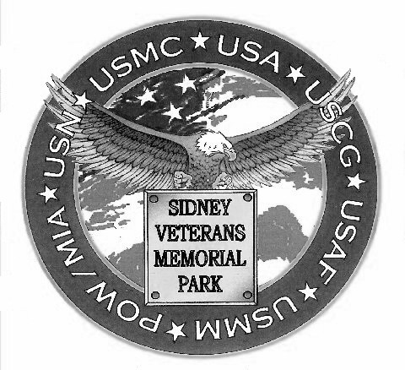
Veterans Memorial Nameplate & Plaque Order Form
(Veteran does not have to be from; or, live in the area – ANY honorably discharged or retired vet is eligible.)

Place “X” in box IF this order is for veteran Husband & Wife or Family Plaque & complete a form for each veteran to be included.

Complete this box for both Nameplate (3”Wx2”H) & Plaque (12”Wx8”H) Orders
Veterans Full Name: ____________________________________________________________
Rank or Rate: _________________________ Branch of Service: ___________________
Conflict (WWII,
Vietnam, etc.): ____________________________________________________________
Service Entry Date: _________________ Place: _____________________________________
Date Wounded or Not
Killed In Action: _________________ or check if: __ Applicable
Where wounded/killed in action: _________________________________
Date Honorably
__Discharged__Retired: _________________ Place: _________________________________
(Attach veteran’s DD-214/other acceptable evidence of service – see Eligibility, Criteria & Guidance information & guidance document)

Order Date: _______________________

Your Name: __________________________________________________________________________
Street Address: ________________________________________________________________________
Apt. #: _____________
City: ______________________________ State: _____________ Zip: _____________________
Phone No (_______) _______ - _______________ Alternate: (_______) _______ - ________________
FAX: (_______) _______ - _______________
E-mail Address: _______________________________________________________
Nameplate Purchasers ONLY: Enclose Check/Postal Money Order for $50 payable to: “Sidney Community Foundation” - on memo line of check/postal money order enter: “Vet Nameplate + Name of Veteran”. Mail to: Sidney Veterans Memorial Park Association, P.O. Box 632, Sidney, NY 13838.

For Plaque Orders ONLY - Complete the following (IF more space needed, add sheet of paper):

Medals, Ribbons, Badges, etc (Optional): ______________________________________________________________________________
______________________________________________________________________________
______________________________________________________________________________
Division/Regiment/Battalion/Company/Ship/Squadron, etc: ____________________________________________________________________________________________________________________________________________________________Page 1 of 2
Symbol Choice(s): __ USA __ USAF __ USN __ USMC __ USCG __ US Merchant Marine
__ US Flag __ American Legion Logo __ VFW Logo __ Disabled American Veterans Logo __ IAVA Logo
__ Religious Symbol (Describe): ___________________________________________________________
__ Other (Describe): ______________________________________________________________

Veterans Military Experience. Brief statement describing veteran’s service consistent with service record which “tells the veteran’s story”. DO NOT include what he/she thought of the service or make references to lineage (NOTE: SVMPA reserves the right to edit and/or limit length consistent with service record data or information available and/or plaque space availability).
____________________________________________________________________________________________________________________________________________________________
______________________________________________________________________________
____________________________________________________________________________________________________________________________________________________________
______________________________________________________________________________
______________________________________________________________________________
______________________________________________________________________________
(Add additional sheet if necessary)

__ Vet Photo. In uniform preferred (especially portrait or in some military activity); but, not required. Attach to order form - will be returned to person ordering plaque (as noted below). Photos subject to approval by SVMPA. NOTE: Alternatively, scan the photo at 400-600 DPI and e-mail as a .jpg/.jpeg attachment to: fmfchief@gmail.com (PLEASE, note name of veteran pictured in subject line of e-mail).

Plaque Purchasers:
Enclose Check/Postal Money Order for $300 payable to: “Sidney Community Foundation” & on memo line of check/postal money order enter, “Vet Plaque + Name of Veteran”.
Mail to: Sidney Veterans Memorial Park Association, P.O. Box 632, Sidney, NY 13838.

NOTES:

1- A veteran may have both a plaque on the Memorial Wall and nameplate on a Service Specific Riser. A veteran named on a “Family Plaque” where only name, rank, service affiliation and dates of service are noted, may also have an individual plaque.

2- Plaque designs are subject to the approval of SVMPA. Coordination of design with a SVMPA representative is highly recommended; and, will be offered upon receipt of a plaque order;

3- Plaque orders will be shipped to SVMPA by the manufacturer to be affixed to the Veteran’s Memorial Wall in the Sidney Veterans Memorial Park by SVMPA prior to the next scheduled Installation Ceremony to be conducted by SVMPA, IF ordered in sufficient time for manufacturing, shipping and installation (normal delivery time is four-six weeks from order receipt date).

4- The tax deductible amount for each item ordered is as follows: Nameplate: $35, Plaque: $125.

Page 2 of 2

