SUNDAY | MONDAY | TUESDAY | WEDNESDAY | THURSDAY | FRIDAY | SATURDAY
www.scschool.ca  follow us on |  | 1 | 2 | 3 | 4 | 5
6 | 7 | 8 | 9 | 10 | 11  Backwards Day | 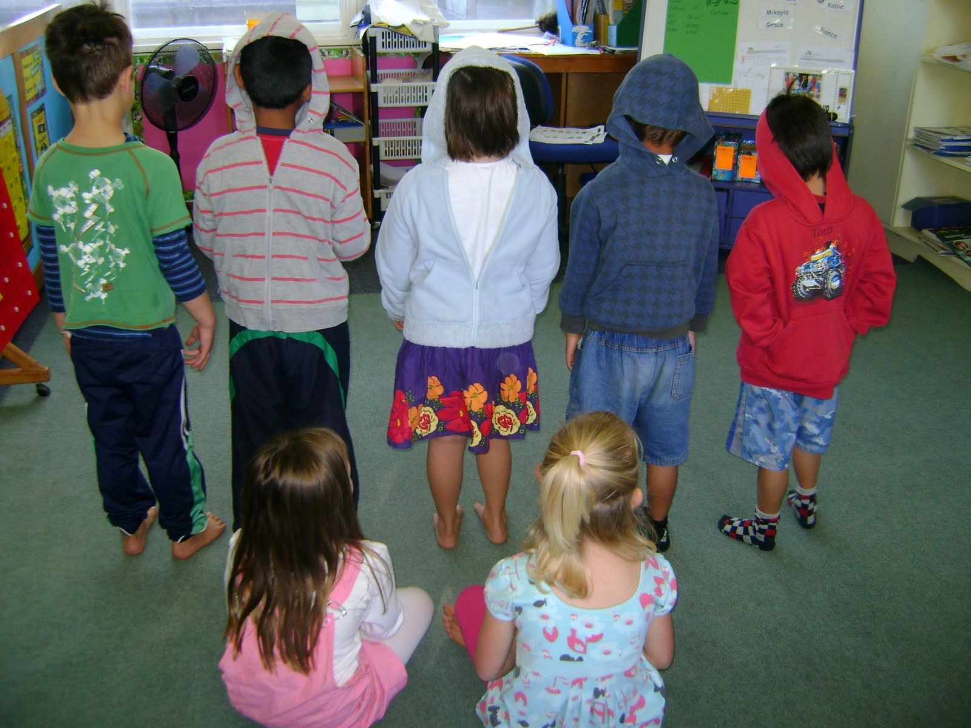  12
13 | 14 | 15  National flag of Canada Day | 16 | 17  Random act of kindness day | 18 | 19
20 | 21  NO SCHOOL | 22 | 23 | 24 | 25 | 26
27 | 28
275 Deadman-Vidette Road Phone: 250-373-2420
Box 178 Principal: 250-373-2421
Savona BC Fax: 250-373-2429
V0K 2J0 E-Mail: sibprincipal@skeetchestn.ca

