 | Product Name | Price | Buy | Qty.
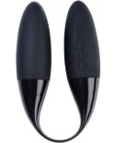 | Mahana Duo Vibe (Black)  Item #: 6703  UPC #: 7350022276703  Manufacturer: LELO  Date Available: 11/11/2011  $34.98 Mahana Duo Vibe (Black) Manufacturer: LELO Date Available: 11/11/2011 UPC #: 7350022276703 .. | $34.98
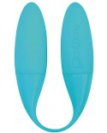 | Mahana Duo Vibe (Blue)  Item #: 6772  UPC #: 7350022276772  Manufacturer: LELO  Date Available: 11/04/2011  $34.98 Mahana Duo Vibe (Blue) Manufacturer: LELO Date Available: 11/04/2011 UPC #: 7350022276772 LELO PicoBong's In the Shadows campaign inaugurates the launch of the new LELO AB brand of colorful sex toys aimed at a 20 and 30 somethings demographic with a message of uncloaking inhibitions and venturing out of comfort zones. In the design of world famous we-vibe and rock chick. Double vibrations, multiple sensations. With dual vibrations, multiple uses, and endless enjoyment Mahana features t.. | $34.98
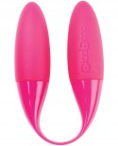 | Mahana Duo Vibe (Cerise)  Item #: PICO6765  UPC #: 7350022276765  Manufacturer: LELO  Date Available: 11/11/2011  $34.98 Mahana Duo Vibe (Cerise) Manufacturer: LELO Date Available: 11/11/2011 UPC #: 7350022276765 .. | $34.98
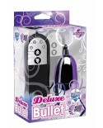 | Deluxe Multi Speed Bullet (Purple)  Item #: PD2660-12  UPC #: 603912261707  Manufacturer: PIPEDREAM PRODUCTS  Date Available: 10/01/2010  $14.00 Deluxe Multi Speed Bullet (Purple) Manufacturer: PIPEDREAM PRODUCTS Date Available: 10/01/2010 UPC #: 603912261707 This powerful little massager teases and pleases with each thrilling pulsation. Choose a speed that’s right for you and run the sleek bullet over your sensitive areas. Try it in the shower or spa and turn water time into passion time!*Requires 2 AAA batteries. (Not Included).. | $14.00
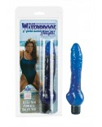 | Waterproof Delights Ballsy (Blue)  Item #: SE0714-12  UPC #: 716770012630  Manufacturer: CALIFORNIA EXOTIC NOVELTIES  Date Available: 10/01/2010  $13.75 Waterproof Delights Ballsy (Blue) Manufacturer: CALIFORNIA EXOTIC NOVELTIES Date Available: 10/01/2010 UPC #: 716770012630 6.5"x 1.25"/17 cm x 3 cmUltra thin, soft and pliable, powerful vibesMulti-speedPVC2 AA batteriesRequires 2 AA batteries. (Not included).. | $13.75
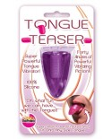 | Tongue Teaser (Purple)  Item #: HP2226  UPC #: 818631022267  Manufacturer: HOTT PRODUCTS  Date Available: 08/18/2010  $3.35 Tongue Teaser (Purple) Manufacturer: HOTT PRODUCTS Date Available: 08/18/2010 UPC #: 818631022267 .. | $3.35
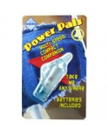 | Power Pals Dolphin Stim (Blue)  Item #: GT636CS  UPC #: 719256706122  Manufacturer: GOLDEN TRIANGLE  Date Available: 01/01/2011  $7.10 Power Pals Dolphin Stim (Blue) Manufacturer: GOLDEN TRIANGLE Date Available: 01/01/2011 UPC #: 719256706122 .. | $7.10
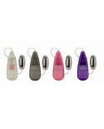 | Oval Battery Case (Clear)  Item #: SE1110-00  UPC #: 716770057105  Manufacturer: CALIFORNIA EXOTIC NOVELTIES  Date Available: 10/01/2010  $2.50 Oval Battery Case (Clear) Manufacturer: CALIFORNIA EXOTIC NOVELTIES Date Available: 10/01/2010 UPC #: 716770057105 Powerful stimulators sold in “bulk”Multi-speedPP (polypropylene) with silver plating (bullet)2 AA batteries2.1” x 1”/5 cm x 3 cmRequires 2 AA batteries. (Not included).. | $2.50
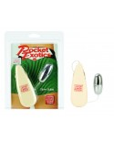 | Pocket Exotic Silver Bullet  Item #: SE1105-05  UPC #: 716770004024  Manufacturer: CALIFORNIA EXOTIC NOVELTIES  Date Available: 10/01/2010  $4.00 Pocket Exotic Silver Bullet Manufacturer: CALIFORNIA EXOTIC NOVELTIES Date Available: 10/01/2010 UPC #: 716770004024 Versatile, compact, powerful and pocket sized!Multi-speedPP (polypropylene) with silver plating2 AA batteries2.1”x 1”/5 cm x 3 cmRequires 2 AA batteries. (Not included).. | $4.00
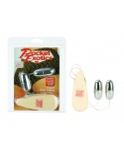 | Pocket Exotic Double Silver Bullet  Item #: SE1104-05  UPC #: 716770004000  Manufacturer: CALIFORNIA EXOTIC NOVELTIES  Date Available: 10/01/2010  $5.00 Pocket Exotic Double Silver Bullet Manufacturer: CALIFORNIA EXOTIC NOVELTIES Date Available: 10/01/2010 UPC #: 716770004000 Versatile, compact, powerful and pocket sized!Multi-speedPP (polypropylene) with silver plating2 AA batteries2.1”x 1”/5 cm x 3 cmRequires 2 AA batteries. (Not included).. | $5.00 | Not  Available
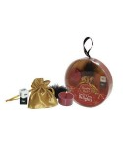 | Sexy Delights Ornament  Item #: LCF0186BX  UPC #: 814371001975  Manufacturer: LOVERS CHOICE  Date Available: 01/01/2007  $7.00 Sexy Delights Ornament Manufacturer: LOVERS CHOICE Date Available: 01/01/2007 UPC #: 814371001975 .. | $7.00
 | Love Drop (Blue)  Item #: GT646BLCS  UPC #: 719256703114  Manufacturer: GOLDEN TRIANGLE  Date Available: 01/01/2011  $7.95 Love Drop (Blue) Manufacturer: GOLDEN TRIANGLE Date Available: 01/01/2011 UPC #: 719256703114 .. | $7.95
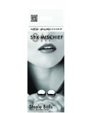 | S&M The Steel Balls  Item #: SS100-84  UPC #: 646709100841  Manufacturer: SPORTSHEETS  Date Available: 09/25/2013  $7.95 S&M The Steel Balls Manufacturer: SPORTSHEETS Date Available: 09/25/2013 UPC #: 646709100841 .. | $7.95
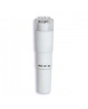 | White Nights Pocket Rocket  Item #: DJ0949-03BX  UPC #: 782421671211  Manufacturer: DOC JOHNSON  Date Available: 01/01/2009  $7.20 White Nights Pocket Rocket Manufacturer: DOC JOHNSON Date Available: 01/01/2009 UPC #: 782421671211 The world's most popular vibe, in a brand new pocket. Never has a rocket been so perfectly, velvety white. Blast off tonight with the White Nights, Pocket Rocket made from the infamous Doc Johnson Velvet Touch material. This waterproof vibe stands 4 inche.. | $7.20
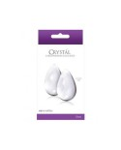 | Crystal Glass Eggs Large Clear  Item #: NSN-0703-21  UPC #: 657447091278  Manufacturer: NS NOVELTIES  Date Available: 01/01/2008  $14.95 Crystal Glass Eggs Large Clear Manufacturer: NS NOVELTIES Date Available: 01/01/2008 UPC #: 657447091278 The entire Crystal collection is made of 100% hand-blown, premium Borosilicate glass. These items are of the highest quality, and represent the most vibrant and durable glass products available today. Crystal items can be heated/cooled to personal taste. These artistic gems are made from 100% Borosilicate glass, and are designed to bring pleasure to PC muscle exercises. Once inserted, they will he.. | $14.95

