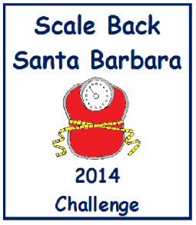

Some
Basic Steps
To Lose Weight…
Step 1: Start.
Step 2: Eat a little less.
Step 3: Do a little more.
Step 4: Have a little fun.
Step 5: Progress not perfection.
Step 6: Never, never, never
give up.
Bonus Step: Help someone with their
steps.

