PUBLIC INFORMATION EVENT

Nottingham Community Housing Association, Derbyshire Dales District Council Housing dept and the Rural Housing Enabler are holding a drop-in event to provide an update and details about the proposed local needs affordable housing for Tideswell.

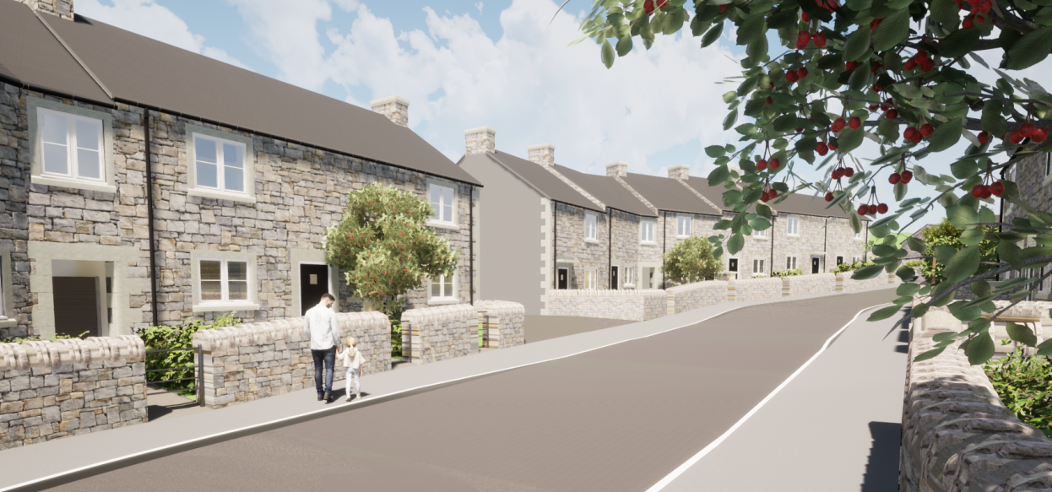
The site for the scheme is located between Sherwood Road & Richard Lane and is currently under consideration by the Peak District National Park Authority planners. A total of 21 dwellings including two bungalows are now proposed following design changes.

Event to be held at the Fountain Square Church

5pm to 7pm

Wednesday 9th March

