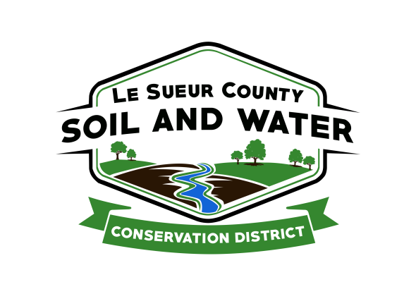

Le Sueur County Soil & Water Conservation District

Le Sueur County SWCD Tel. (507) 419-0365
181 W Minnesota St Website: www.lesueurswcd.org
Le Center, MN 56057

Minutes from February 8, 2022 regular meeting of the Le Sueur County SWCD Board of Supervisors. Le Sueur County Justice Center, Le Center, MN.

Meeting was called to order by Chairman Struck at 9:00 am.

Members present: Chairman, Jim Struck
Vice-Chairman, Greg Entinger
Treasurer, Cletus Gregor
PR&I, Glendon Braun

Members absent: Secretary, Earle Traxler

Others present: District Manager, Mike Schultz
District Technician, Joe Jirik
Ditch Specialist, Nik Kadel
Resource Technician, Karl Schmidtke
NRCS Team Lead, Chris Schmidt
District Conservationist, Steve Breaker
Le Sueur County Commissioner, Lance Wetzel
Le Sueur County Commissioner, Steve Rohlfing

The Pledge of Allegiance was recited.

Secretary’s report from January 11, 2022 was read and approved.

Struck and Schultz attended the Chairman’s meeting in New Ulm and gave an update. Discussed were the amount of area meetings per year and topics for meetings.

Schultz informed the board that all employees are signed up for health/dental benefits and things are moving forward.

Motion by Entinger, second by Gregor to pay MACDE dues for SWCD employees. Dues are $25.00 per employee.
Affirmative: All
Opposed: None
Motion carried

Schultz discussed 2022 personal and office goals with the board and that the Le Sueur County SWCD annual report will be handed out to them at the March board meeting.

Jeremy Maul will be our new board conservationist as Jenny Mocol-Johnson took a different position within BWSR.

Motion by Gregor, second by Entinger to hire Peterson Company to perform the SWCD’s 2021 audit.
Affirmative: All
Opposed: None
Motion carried

Following items discussed:

FY22 Capacity – how capacity money is set and involvement of SWCD board members securing funding.

BWSR storage program – BWSR pilot program for storage to help with floods.

Waterville flood study - $500,000 received by City of Waterville to explore flooding problems.

Cannon 1W1P update was given. CD#40 feasibility study in process.

1W1P Lower MN application awarded and MOA between all partners is next. March 17, 2022 will be the next meeting.

Schultz brought up the idea of the SWCD drafting a 5-year strategic plan. He would like the board and staff to meet and discuss future goals and projects. The board liked the idea and agreed to meet after the March regular board meeting.

There will be an Area 6 meeting on April 6, 2022 in New Ulm.

Legislative Days will be March 9-10, 2022.

There will be a Soil Health meeting on March 16, 2022 in Jordan.

The back room in the SWCD building is empty now that the Clubhouse has moved out. The board would like staff to explore the idea of turning the room into a meeting room and bring cost estimates to the next meeting to accomplish this.

Nik gave the board a county ditch update. He reported on repair and tree removal projects.

Steve and Chris gave an NRCS report. They talked about a new general CRP signup, expiring CRP contracts, designs, seeding certifications, CSP payments, EQIP, cover crops and no till.

The filing period for supervisors wishing to file for election is May 17 – May 31, 2022.

Vouchers were reviewed and filled out.

There being no further business, meeting adjourned at 11:00 am.

___________________________ ________________________________________________
Date District Secretary

