Woonsocket Police / IBPO - Local 404
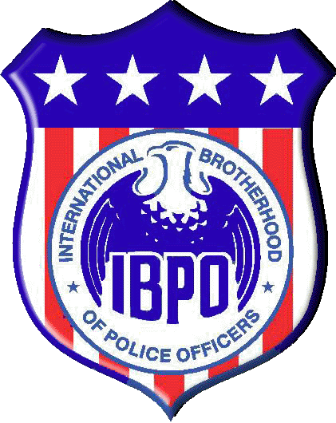

__________________________________________________________________________

The International Brotherhood of Police Officers -Local 404 is currently seeking donations and sponsors for our Annual Woonsocket Police/IBPO 404 “COPSWALK.”

On May 9th, thirteen officers from the Woonsocket Police Department will take part in a 4-day, relay-style walk from Woonsocket to Washington DC. Our mission is to raise funds for the New England Chapter of "Concerns of Police Survivors," a national (not-for-profit) organization that dedicates itself to helping the families of police officers who are killed in the line of duty, through counseling, retreats, legal services and scholarships.

The members of the Woonsocket Police/IBPO 404 feel strongly that we must stand together and do something about this disturbing reality. We would be sincerely grateful if you joined our noble cause, by picking up one of these shields:

Blue Shield Donor $200.00 or more

Full page Ad in program*, listing on website
*On April 22, we will host 400 supporters in our annual COPSWALK Comedy Dinner; programs will be at every table.

Gold Shield Donor $100.00 - $200

Half-page Ad in program*, listing on website

Silver Shield Donor $50.00 - $100.00

Business Card Ad in program*, listing on website

Business Name: ___________________________________________ Donation: _________________

Contact Name: _______________________________________________ Phone: ____________________

Address: _________________________________________________ City_______________________

Specific Advertisement: Y / N I prefer to keep my donation anonymous

(Instructions can be written on reverse side or e-mailed)

Please make checks payable to: COPSWALK // 242 Clinton St. Woonsocket, RI 02895

For more information please contact Lt. Ed Cunanan at 767-8834 // ecunanan@woonsocketri.org
For more information on New England C.O.P.S.: http://www.newenglandcops.org/
www.wpdcopswalk.com

