

# Summer 2018 Season

# Week 9 – 23.05.18

# Singles League Report

# 

**Remember if you cannot play on the scheduled fixture date; please try to play in advance. You must email club with new date within 4 weeks!!!**

Well Matt Pinel is a man on a mission this season, now on seven straight wins after dispatching both Callum Stewart and Geoffroy Buffetrille with ease. Matt has now opened up a 9 point lead over second placed Matt Buesnel who didn’t have a good night, losing to Geoffroy before gaining a draw with Neil Selby.

Neil Selby made it two draws as despite winning the first game 13 – 8 against Toby, lost the second one 13 – 3. Toby blew a 9 – 4 lead in the second game against Ross Payne to also draw two matches on the day. Ross Payne followed suit drawing with David Ibitson.

Bottom placed Jonny Hill got a draw against Alice Ibitson before losing a close match against Brian Harris. Brian though lost his first match to Keith Pinel who sits in third in the league just 12 points!! off top spot.

**Outstanding Matches**

Andrew Bellamy-Burt v Keith Pinel (2nd May)

Andrew Bellamy-Burt v David Ibitson

Andrew Bellamy-Burt v Paul Le Moine

Alice Ibitson v Paul Le Moine

Division 1 saw Joey Le Clech take the top spot in the league with wins over Stephen Stoneman and Harrison Marie, the latter being a much closure affair as Harrison lost his first match of the season.

Joey though is only top by two points and has played two matches more than Richard Williams who is in second place.

The Winter player of the season Laurent Pellaton is on the charge moving up to third in the league following a miserable start to the season. Laurent only picked up two points in his first four matches but has now won three matches in a row. His recent wins over Paul Bell and Stephen Stoneman.

He moved above Alex Stewart who has only played five of the seven matches and Brigitte Ibitson who drew with Cassie Stewart, Brigitte one of just five players unbeaten in Division 1.

Jean Stewart won her first match of the season against Mo De Gruchy before losing to Matt Hutchings who is also unbeaten and a title contender.

**SUPER 6**

**HOW DID YOU DO?**

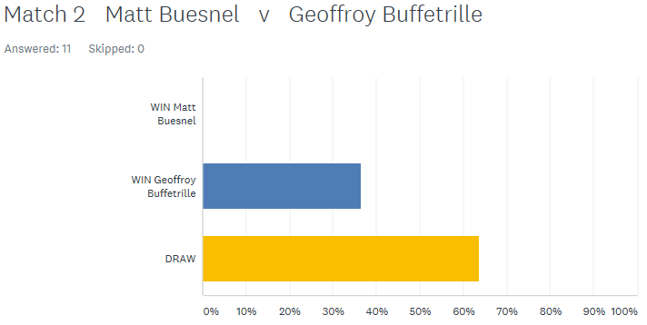

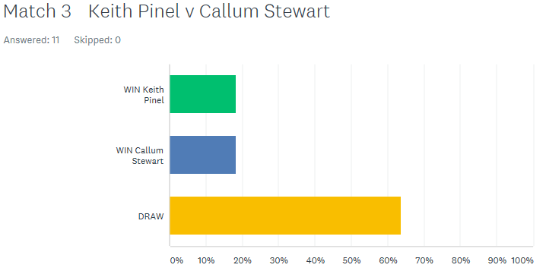

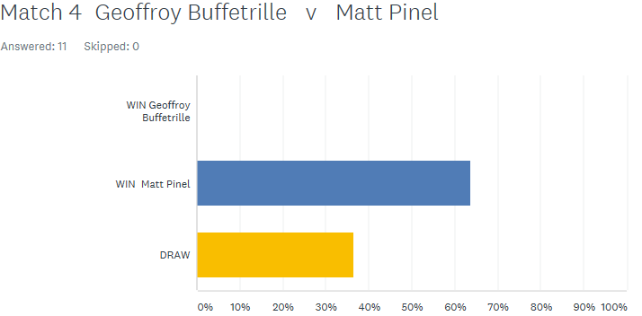

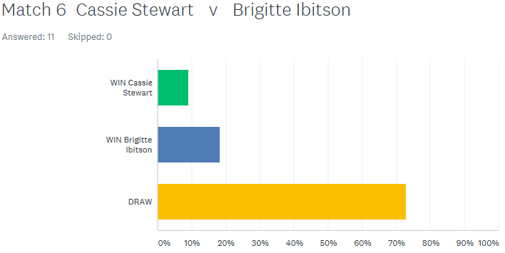

**GOOD LUCK IN THE ISLAND SINGLES CHAMPIONSHIP THIS WEEKEND (26TH MAY) AT THE WEIGHBRIDGE**

Best of Luck to everyone

***NEXT WEEK***

**30th May – Doubles League – Week 3**

**WEBSITE** [**www.liberationpetanque.co.uk**](http://www.liberationpetanque.co.uk)

**EMAIL** [**liberationpc@gmail.com**](mailto:liberationpc@gmail.com)

**Kind Regards**

**Toby Northern**

**Chairman**

**Liberation Petanque Club**

# SPONSORED BY

# http://nebula.wsimg.com/135a1bd6338e1b589a50cdec98bd84d1?AccessKeyId=C6E923731F1A482DD910&disposition=0&alloworigin=1