Massage Client Information
Name: Phone #:
Address: Appt. #:
City: State :_ Zip:
Email:
Date of Birth: Occupation:
Referred by:
Emergency Contact: Phone #:
General and Medical Information
Y N Have you ever had a professional massage? If yes, how often?

Y N Are you pregnant?
Y N Do you wear contact lenses?
Y N Do you have high blood pressure? If yes, is it under control?
Y N Do you suffer from seizure disorders or epilepsy?

Y N Are you diabetic? If yes, is your diabetes under control?
Y N Have you broken any bones in the past two years?

Y N Do you have cardiac or circulatory problems? Please explain.

Y N Have you ever had surgery? If yes, please explain.

Y N Do you have any other medical conditions or injuries?

Y N Are you currently taking any medications? What for?

General and Medical Information (cont.)

Y N Do you suffer from back pain? Upper, mid, lower back?

Y N Do you experience headaches?

Y N Do you have tension or soreness in a specific area?
If so, where?
What activities/movement/positions make this
Worse?

Better?

Y N Are you sensitive to touch/pressure in any area? (ticklish)

Y N Are you allergic or sensitive to any oils (essential oils, nut oils, scents)?
If yes, please list.

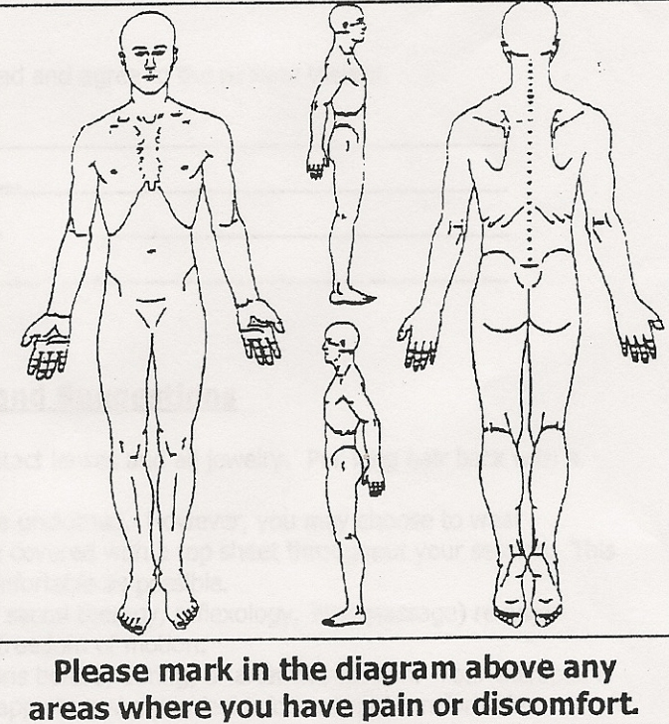
Please provide additional information about your health to assist your therapist in providing a beneficial and therapeutic massage (previous injuries, goals for massage, etc.).

Massage Client Waiver Form
Please take a moment to read and initial the following information:
I understand that massage therapy is provided for stress reduction, relaxation, relief from muscular tension, and improvement of circulation and energy flow. __________
If I experience pain or discomfort during the session, I will immediately inform my therapist so that pressure/strokes can be adjusted to my level of comfort. I will not hold my therapist responsible for any pain or discomfort I experience during or after the session. __________
I understand that the services offered today are not substitute for medical care. I understand that my therapist is not qualified to perform spinal or skeletal adjustments, diagnose, prescribe, or treat physical or mental illness. __________
I affirm that I have notified my therapist of all known medical conditions and injuries. __________
I agree to inform the therapist of any changes in my health and medical condition. I understand that there shall be no liability on the therapist’s part should I forget to do so. __________
I understand that massage is entirely therapeutic and non-sexual in nature. __________
By signing this release, I hereby waive and release my therapist from any and all liability, past, present, and future relating to massage therapy and bodywork. __________
I have received the policy statement, and have read and agree to the policies therein.
Client name:
Client signature:
Date:
Therapist Signature:

Information and Suggestions
- Prior to your massage, please remove contact lenses and all jewelry. Pull long hair back with a clip or band.
- In general, massage is given while you are unclothed. However, you may choose to wear undergarments or a swimsuit. You will be covered with a top sheet throughout your session. This is you massage and you should be as comfortable as possible.
- Certain types of massage (shiatsu, cranial sacral therapy, reflexology, Thai massage) require loose, comfortable clothing that allow for freedom of motion.
- Feel free to ask you therapist any questions before, during, or after the session. Your therapist is a highly trained professional and will be happy to make you feel informed and comfortable.

