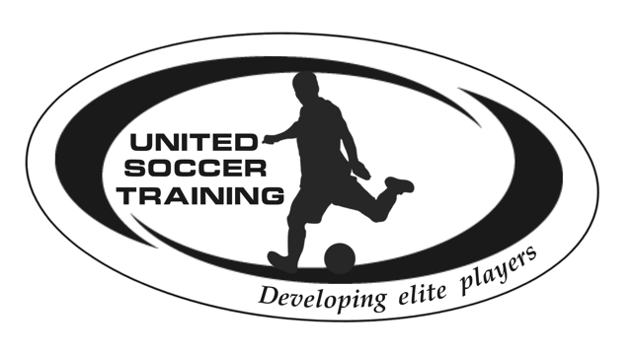  7/31 – 8/4  High school prep Soccer Summer Camp  United Soccer Training is pleased to welcome you to our annual youth summer camp. We pride ourselves on our ability to help your child develop as a soccer player and as a young adult.  Our mission is to develop players while creating a fun and safe environment to do so. We focus on technical skills, small sided games and other activities to make our camp fun and challenging.  All players will have proper attention with our 10:1 Player: Coach ratio. Coaches will evaluate all players throughout camp and individually work with players that need extra help. All coaches are licensed and have worked with some of the best teams and camps in Maryland, include Barcelona C.F.! | 3rd Annual summer camp  ────  Be trained by professional coaches!  ────  All skill levels welcome  ────  NEW VENUE  ────  “Developing Elite Players”  United Soccer training  Davidsonville Athletics Training Ground  301-661-8724  www.Unitedsoccertraining.com  July 21-25
Registration Form, Medical Information and Liability Release

Player’s Name:______________________
DOB :__________
Gender: _____
Address:______________________________________________________
Parent/Guardian Name:_______________________
Email: ____________
Home Phone:__________
Cell Phone:__________
Work Phone:__________
Emergency Contact: _______________________
Phone: _______________
Medical Insurance Company:
______________ Policy Number:___________
Shirt Size: YS
YM
YL
YXL
AS
AM
AL
AXL
Does the player have any orthopedic, medical, or emotional condition that we
should be aware? YES NO
If YES, please indicate nature of condition:
_________________________________________
Player’s Allergies:
_________________________________________
Do you give permission for your child to take over the counter pain
medication at camp?

YES/ NO

If YES please indicates appropriate brands (Advil, Tylenol, Aspirin, etc.)

Parental Consent
I, the undersigned, verify that the child named above is in good health, and has had annual
exam by a licensed physician within the last year. Any special medical conditions or medication requirements that the staff needs to be aware of are clearly indicated above. I authorize United Soccer Training to act on my behalf in the event of a medical emergency. I will not hold United Soccer Training, its staff, agents, officers, and employees assume no liability or damages as a result of participation in this program. The player’s parent or guardian is responsible for any property damages caused by the player. If a player’s property is lost or stolen. United Soccer Training
will make every effort to locate it. However, United Soccer Training accepts no responsibility for the loss or damage to a player’s property. I give my permission to United Soccer Training to use the player’s picture in promotion of United Soccer Training events in printed or electronic media.

I have read and accept the United Soccer Training Policy Statement:
Signature of Parent or Guardian: ___________________________
Date: ___________________

