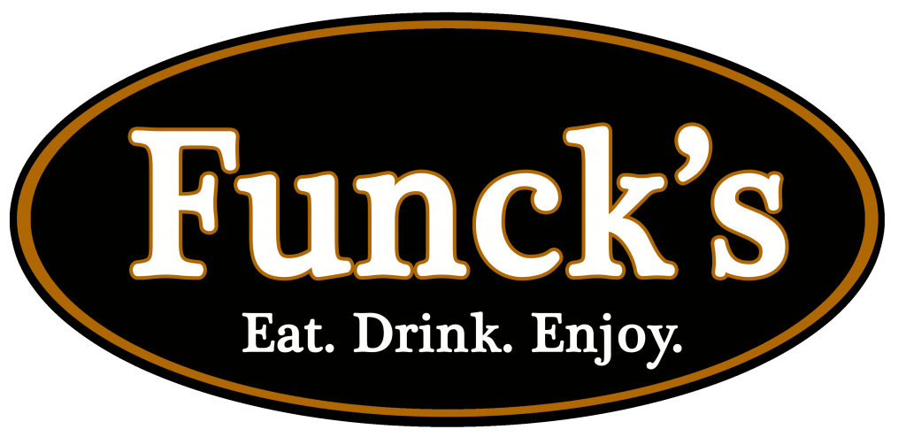

BUY GIFT CARDS AND SUPPORT RISING STAR SOCCER CLUB!

On sale September 5th-22nd

Restaurants Include:

* Funck’s Restaurant Palmyra and Leola
* Snitz Creek Brewery Lebanon and Annville
* The Rising Sun Bar and Kitchen
* T.J. Rockwell’s Elizabethtown and Mechanicsburg
* Mt. Gretna Hideaway
* Quentin Tavern
* Parkside Hotel

Please email Alli MaCauley @ [alliblair112@yahoo.com](mailto:alliblair112@yahoo.com) with any questions.

THANK YOU!

Funck’s Gift Card Order Form

Gift cards on sale Sept. 5th-22nd. Orders will be distributed to players the next week.

Please make all checks payable to “Rising Star Soccer Club”

