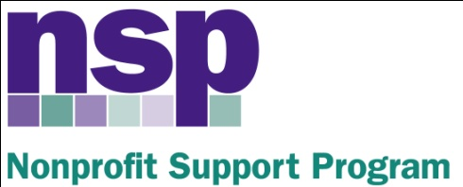

Hartford Foundation for Public Giving

Nonprofit Support Program
Building Evaluation Capacity (BEC) Program
Class of 2017, Session 3 (8)
November16, 2016
8:30 – 12:00

AGENDA

8:30 – 8:40 | Data Visualization Pre-Activities
8:40 – 8:45 | Cool Visualization Example
8:45 – 9:40 | Overview & Developing Effective Tables (Including Table Pre-Activity Check)
9:40 – 10:15 | Developing Effective Graphs – Part 1  (Including Graphics Pre-Activity Check)
10:15 – 10:25 | BREAK
10:25 – 10:55 | Developing Effective Graphs – Part 2
10:55 – 11:15 | Math for Evaluators  (Includes mini-break)
11:15 – 11:45 | Math and Data Visualization Activities// Team Huddles
11:45 – 12:00 | Q/A
HW | WORK ON PROJECT, PREP FOR CONSULT  NEXT SESSION: 12/6 or 12/7 SIGN UP

http://www.percent-change.com/index.php?

