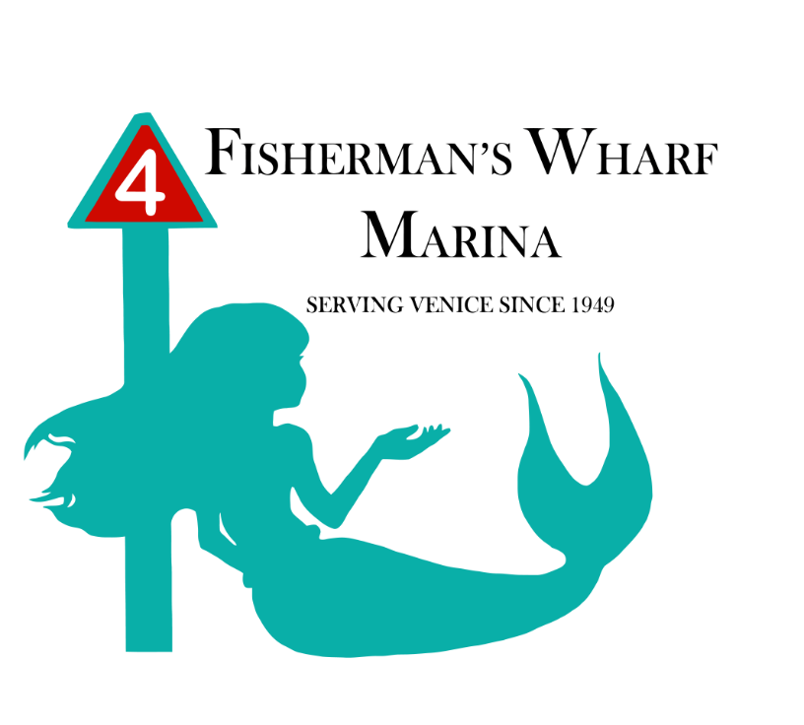

MENU

TIKI AT THE WHARF

Morning Catch Danish
This Morning Catch Danish with take your taste buds for a ride early in the morning before your boat trip. Enjoy as a sweet pick me up snack during the day! At this price, you might want to buy two and take one with you!
Morning Catch Danish……………………………..…………………$1.00
Coffee……………………………………………………….………………$2.00

A Yacht-Of Snacks
We offer an array of snacks for your boating needs. Peanuts, Popcorn, Assorted Crackers, Cookies, Pretzels, M&Ms, Combos and more…
…………………………………………………..………..…………………..$1.00
Assorted Sandwiches………………….………………………………$4.50
(Changes daily)

Ice Cold Drinks
Domestic Beer
12oz ……………………………………………….………………………..$3.00
16oz ……………………………………………….………………………..$4.00
Specialty Beers
12oz …………………………………………………………………………$4.00
16oz …………………………………………………………………………$5.00
Wine…………………………………………………………………………$4.50
Water………………………………………………………………………..$1.50
Gatorade…………………………………………………………..………$2.50
Soft Drinks…………………………………………………………..……$1.50

This Tiki at Fisherman’s Wharf also has all your boating needs including, ice, fuel, bait and supplies. Please inquire for assistance.

(All prices are before taxes and subject to change.)

