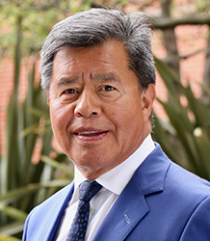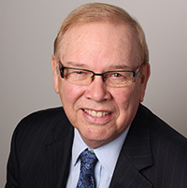
Patrick Kelly, President Kris Jonasson, CEO
Baisakhi Open WCG Organizers and Participants:
It is our pleasure on behalf of the board and membership of British Columbia Golf to offer you best wishes for a successful 2018 Baisakhi Open World Cup Golf Tournament and a warm welcome to our province as the event is being held this year at Northview Golf & Country Club in Surrey, British Columbia.
The organizing committee and the chapters of the International Punjabi Golf Associations are showcasing how the sport of golf can be properly used to promote camaraderie and to support charity.
BC Golf President Patrick Kelly and CEO Kris Jonasson, will be joining British Columbia Golf Director Jolly Dhaliwal participating in the event. We are each looking forward to meeting new as well as renewing acquaintances with Punjabi Golf Association members from around the world.
It is commendable that, as organizers, you have grown participation to the level where you now have golfers who attend the Baisakhi Open World Cup from regions around the world.
Once again on behalf of British Columbia Golf we offer you congratulations and we wish all competitors a rewarding and enjoyable experience.
Yours Truly,
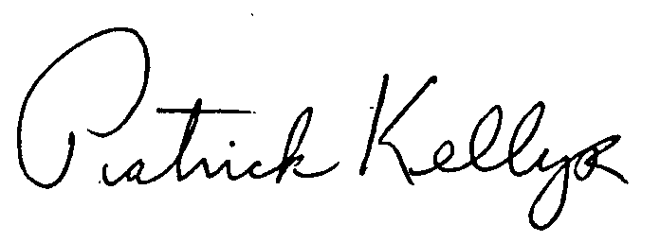 Patrick Kelly, President Kris Jonasson, CEO British Columbia Golf British Columbia Golf

