May 31, 2017

*Via Electronic Filing*

Ms. Kimberly D**.** Bose, Secretary

Federal Energy Regulatory Commission

888 First Street, N.E.

Washington, D.C. 20426

**Re: FERC Project No. P14425-000**

**Scott's Mill Hydropower Project,**

**Liberty University, Inc.**

**Ninth Six-Month Preliminary Permit Progress Report**

Dear Ms. Bose:

On December 6, 2012, the Federal Energy Regulatory Commission (Commission) issued a Preliminary Permit to Liberty University, Inc. ("Liberty") regarding the Scott's Mill Hydropower Project No. 14425 ("Project"). Pursuant to Article 4 of the Preliminary Permit, Liberty University, Inc. hereby submits its ninth, six-month progress report. During the ninth, six-month period of the Preliminary Permit, Liberty and Luminaire Technologies have:

* Continued to consult with the Virginia Department of Game and Inland Fisheries on the project status and fish studies.
* Continued engineering studies and developed layouts and associated costs.
* Added to the tailwater rating curve with a flow of 25,000 cfs.
* Completed the cultural resources study.
* Continued to prepare the draft license application.
* Held additional discussions with Eagle Creek Energy, the new owners of Reusens dam.

Liberty had anticipated filing a draft of the license application during this reporting period. However, discussions with turbine manufacturers are still ongoing and Liberty is continuing to explore construction approaches to reduce project costs. Once a turbine design is selected and the construction approach completed, Liberty plans to move forward with distribution of the draft license applications to resource agencies, Indian tribes and other interested parties.

Please contact the undersigned at (916) 719-7022 if you have any questions or comments regarding this progress report.

.

Respectfully submitted,

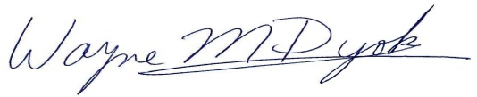

Wayne M. Dyok for

LIBERTY UNIVERSITY, INC.