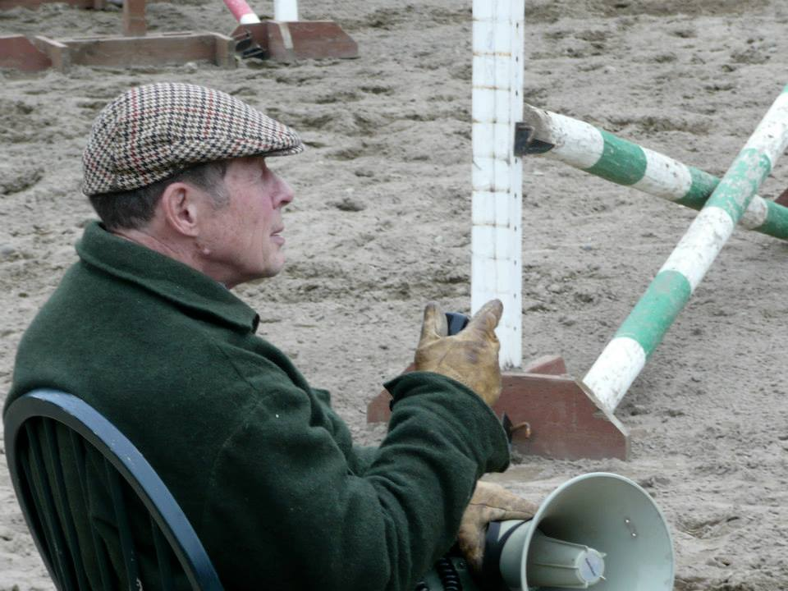

**Robin Hahn Fall 2018 Jumping Clinic**

**November 16, 17, 18**

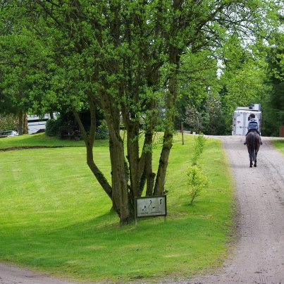

**All Levels Welcome!** **Clinic Fee: $375** Check payable to Northwind Farm

Small group lessons:

* Green/Cross Rails VERY Limited On Site Stabling
* Beginner Novice, Novice/Training First Come First Serve
* Preliminary/Intermediate

Auditors are Welcome!!

|  |  |  |  |  |  |
| --- | --- | --- | --- | --- | --- |
| **Rider** | | | **Amount Enclosed:** | | |
| **Competition level in 2018** | Stabling? Yes No | | | Nights: Th F Sa | |
| **Jumping Height For This Clinic** | | | | |  |
| **HORSE:** | | | | |  |
| **Address:** | | **City, State, Zip:** | |  | |
| **Phone:** | **Email:** | | |  | |
| **Staying On Grounds? Y N If Yes, please provide trailer length** | | | | |  |

**Location:** Northwind Farm 8171 SE Overaa Road, Port Orchard, WA 98367

**Organizer:** Maggie Mittuch 253.370.5395 [mmittuch1@me.com](mailto:mmittuch1@me.com)

Mail Entry form and payment to

Maggie Mittuch, C/O Northwind Farm,

8171 SE Overaa Road, Port Orchard, WA 98367

Immensely Popular Potluck Social on Saturday Night!

***No Visitor Dogs without Permission, Please!***

***RELEASE:*** *The owner, rider and/or any of the agents or representatives agree to hold Northwind Farm and their officials, directors and agents harmless for any injury or loss suffered during or in connection with this event, whether or not such injury or loss resulted directly or indirectly from the negligent acts or omissions of said officials, family or agents of Northwind Farm and it’s owner’s and operators.*

