REGULAR MEETING
JULY 15, 2015

A Regular Meeting of the Town Board of the Town of Hampton, County of Washington and the State of New York was held at the Town Hall, 2629 State Route 22A, Hampton, New York on the15th day of July, 2015.

PRESENT: David K. O’Brien------------Supervisor
Tamme Taran---------------Councilwoman
David Jensen-----------------Councilman-absent
Donald Sady-----------------Councilman
Andrea Sweeney------------Councilwoman
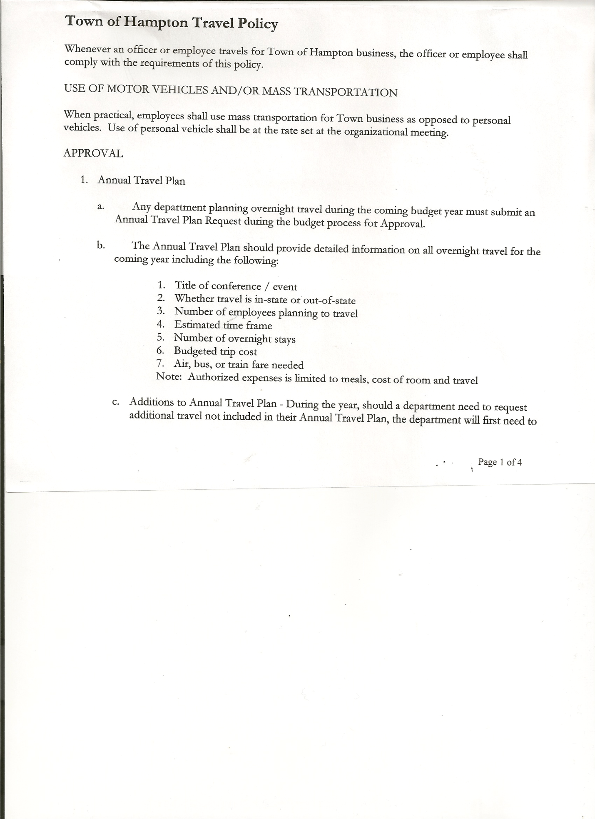
Rebecca Jones---------------Town Clerk
Camilla Shaw----------------Tax Collector/Deputy Town Clerk
Herbert Sady, Jr.-------------Highway Superintendent

Planning Board Member(s): Bonnie Hawley, Chair and Francis Baker

Also present: Artie Pratt and Matthew Pratt

The meeting was called to order by Supervisor O’Brien at 7:30pm followed by the Pledge of Allegiance. Locations of Fire Exits were given.

RESOLUTION NO. 48-2015
APPROVAL OF THE MINUTES
On a motion of Councilwoman Taran, seconded by Councilwoman Sweeney, the following resolution was ADOPTED: Ayes 4 O’Brien, Taran, Sady, Sweeney
Nays 0
Absent 1 Jensen
RESOLVED that the Regular Town Board Minutes for June 17th, 2015 are approved.

Camilla Shaw, Tax Collector submitted her report to the Town Board , she also had board members sign and date bank reconciliation statement dated June 30th, 2015.

Larry Carman, Dog Control Officer submitted his report, which was read by Supervisor O’Brien, copy of report is attached for 6/l5/15 – 7/13/15

Planning Board Report….Bonnie Hawley, Chair gave the report:
- Mobile home park/campground law… will email to Board members for review
- Camara Slate donating slate for around the Town Hall basement
- Next Planning Board meeting will be at 7:00pm at the Town Hall on August 25th, 2015
(will not be having a July Meeting)

TOWN BOARD MEETING
JULY 15, 2015 PAGE 2

Herbert Sady, Jr., Highway Superintendent gave his report: (a copy is attached)
- Mowing roadsides
- Paving on Chapman Road is done
- Filled potholes and cleaned up brush from sides of roads
- Mowed cemeteries
- Attended Safety Day training on June 24th with George and Tyler
- ’97 International back from Turunen’s, then had to go back for Axle seal leak
- Working on getting quotes for new tires for the Dodge and a new mower for the cemeteries

RESOLUTION NO. 49-2015
APPROVAL OF SUPERVISOR’S MONTHLY REPORT
On a motion of Councilman Sady, seconded by Councilwoman Taran, the following resolution was ADOPTED : Ayes 4 O’Brien, Taran, Sady, Sweeney
Nays 0
Absent 1 Jensen
RESOLVED that the Supervisor’s Monthly report be accepted as submitted for JUNE 2015
5/31/15 6/30/15
ACCOUNT BALANCE RECEIPTS DISBURSEMENTS BALANCE
General Fund $ 78813.50 $ 7384.22 $ 7587.88 $ 78609.84
Highway Fund $ 138250.06 $ 5.79 $ 6962.54 $131293.31
Equipment Reserve $ 100175.09 $ 4.25 $ 0.00 $100179.34
Fire #1 $ 34010.90 $ 1.65 $ 0.00 $ 34012.55
Fire #2 $ 4754.00 $ 0.00 $ 0.00 $ 4754.00
Totals $ 356003.55 $ 7395.91 $ 14550.42 $348849.04

All Board Members present signed Supervisor’s Report.

County Updates/Communications
- County Administrative position…on Friday, July 17th County Board of Supervisors will be offering position to the candidate from Hartford.
- Still looking for someone to fill the County Public Safety Director position.
- Cemeteries…still discussing and exploring different options
- Reformatted Resolution #46 regarding Speed limit reduction from Town of Hampton Whitehall has also requested speed reduction on County Route 18.
- Town of Hampton signed over via Quit Claim Deed the Firehouse building and property to Hampton Volunteer Fire Company. The paperwork will be filed and recorded on Friday, July 17th at the County Clerk’s Office.

Francis Baker, member of the Planning Board will be resigning effective September 1st, 2015 due to health reasons. Town Board thanked Frank for his 45+ years of service to the Town of Hampton.

TOWN BOARD MEETING
JULY 15, 2015 PAGE 3

The Town Clerk’s report for June 2015 was submitted to the Board. The Town Clerk had Board Members review and sign bank reconciliation statements for the Town Clerk Account and Special Town Clerk Account dated June 30th, 2015.

RESOLUTION NO. 50-2015

AUDIT OF CLAIMS
On a motion of Councilwoman Taran, seconded by Councilman Sady the following resolution was ADOPTED Ayes 4 O’Brien, Taran, Sady, Sweeney
Nays 0
Absent 1 Jensen
RESOLVED that the bills have been reviewed by the Town Board and are authorized for payment in the following amounts.
General Fund No. 89 through No. 105 $ 2649.25
Highway Fund No. 64 through No. 73 $ 2397.71
Total both funds $ 5046.96

On a motion of Councilwoman Taran, seconded by Councilwoman Sweeney , the meeting adjourned at 8:17pm. All in favor Aye.

Respectfully submitted,

Rebecca S. Jones, RMC
Town Clerk

