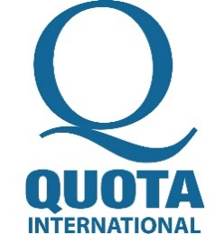

Central Oregon Chapter

Member FAQ

Welcome!
Today you take the first step to making an impact in your community. It is through volunteers like you that true change and success is possible. No one knows what a community needs better than the people in it and Quota gives communities tools, resources, and partnerships to do just that. Thank you for deciding to be an instrument for change and contributing your best to Quota and our world.

Benefits of Membership
- Opportunities to empower women, children, the hearing & speech impaired
- Friendships with others who are like minded
- Experience using talents to help others
- Access to resources to meet community needs
- Connections to strategic partners and initiatives
- Leadership training and personal development
- Awards and public recognition
- Access to international directory and network
- Subscription to The Quotarian ​magazine
- Discounts for Quota International events and items
- Monthly member communications and updates

Member Resources
- Meetings – Generally held the 1st and 3rd Tuesdays, noon, at Deschutes Brewery at 1044 NW Bond St, downtown Bend (check the calendar on our website to confirm)

- Local Club Website: http://www.QICO.club

- Local Facebook Page: https://www.facebook.com/quotaofcentraloregon
- Quota International: https://quotainternational.org/

Questions about Membership?

Please contact Della Bjerk or Charlene Clevenger, Co-VP of Development & Growth, if you have any questions at all about joining the Central Oregon Chapter of Quota International.

verndela46@gmail.com

dcleven@q.com

We look forward to working with you!

