BERKS TRUST APARTMENTS
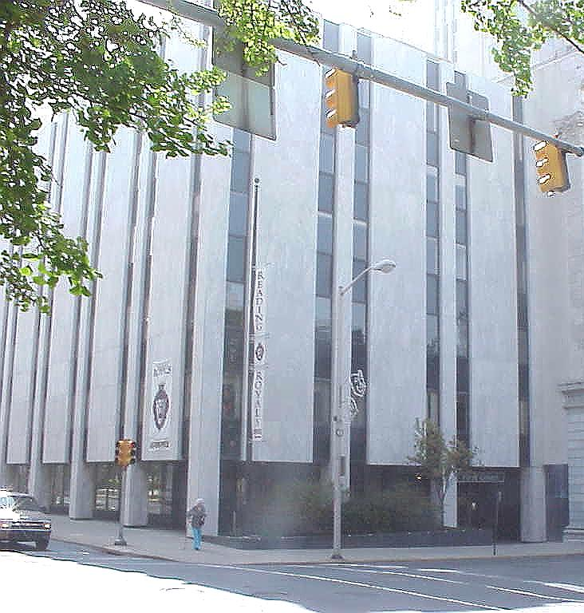
APPLICATION FEE $50.00 PER ADULT APPLICANT
Check or Money Order Accepted Payable to Berks Trust Investments

CHECKLIST FOR ITEMS NEEDED WITH APPLICATION
0 Valid Picture ID/Driver’s License
0 Last 3 pay stubs for all applicants 18 years of age or older
0 Alimony/Child Support orders (if applicable)
0 Anyone over the age of 18 must apply to reside in apartment (no exceptions)
Note: You will receive and email from “Smartmove” asking to verify your information. Please respond so your application can be processed.

RATES Starting at :

- Studio $850
- 1 Bedroom $950
- 2 Bedroom 1 Bath $1,175
- 2 Bedroom 2 Bath $1,300

REQUIREMENTS:
- Income requirements are 3x the rent amount gross before taxes Credit Score must be 600+
- Clear Criminal Background Check
- No Prior Evictions or balances owed to prior landlords

Mail or bring in completed application with application fees and documents to:
Berks Trust Apartments
100 North 5th Street
Reading, PA 19601
Property Manager: Elvin 610-375-3413
BerksTrustMgr@InvestInReading.com
INCOMPLETE APPLICATIONS WILL NOT BE PROCESSED

RENTAL APPLICATION • Each adult (18 or older) must fill out a separate application
•
There is a non-refundable fee of $50/adult to apply

First Middle Last | Birth Date |  | Social Security # |  |  |  | Driver’s License #
Any Other Names You’ve Used In The Past |  | Home Phone |  |  |  | Cell Phone
All Other Proposed Occupants |  |  |  | Birth Date | Relationship To Applicant
RENTAL/RESIDENCE HISTORY
 | Current Residence | Previous Residence | Prior Residence
Street Address
City
State & Zip
Last Rent Amount Paid
Owner/Manager
and Phone Number
Reason for leaving
Is/Was rent paid in full?
Did you give notice?
Were you asked to move?
Name(s) in which your utilities are now billed:
 | From/To | From/To | From/To
Dates of Residency
EMPLOYMENT HISTORY
 | Current Employment | Previous Employment | Prior Employment
Employed By
Address
Employer’s Phone
Occupation
Name of Supervisor
Monthly Gross Pay
 | From/To | From/To | From/To
Dates of Employment
CREDIT HISTORY
 | Bank/Institution Name | Balance On Deposit or Balance Owed
Savings Account
Checking Account
Credit Card
Auto Loan
VEHICLES (Include vehicles belonging to other proposed occupants also)
Make | Model | Color | Year | License Plate

REFERENCES & EMERGENCY CONTACTS
Name
Street Address
City
State & Zip
Phone Number
By signing the application you grant us permission to communicate with all the contacts listed in this section in the event we can’t locate you. Furthermore, if you
abandon the apartment for any reason then you grant us permission to allow your relative listed above to remove all contents of the dwelling on your behalf.
GENERAL INFORMATION
Have you ever been served a late rent notice? | Do any of the people  who would be living in the apartment smoke? |  |  | How long  do you think you would be renting from us?
Have you ever filed for bankruptcy? If so, when? |  | When would you be able to move in? |  |  | Have you ever been convicted of a felony?
Have you ever been served an eviction notice? If so, when? |  |  | How many pets do you have (list Type, Breed, approx Weight & Age)?
Have you had any reoccurring problems with your current apartment or landlord? If yes, please explain:
Why are you moving from your current address?
List any verifiable sources and amounts of income you wish to have considered (optional):
If you were to run into financial difficulty in the future and couldn’t come up with the money to pay the rent, do you know someone that would loan you the money? If so, provide the person’s name, address, & phone # so that we can use them as a reference for you.
Have you been a party to a lawsuit in the past? If yes, please explain why:
We may run a credit check and a criminal background check. Is there anything negative we will find that you want to comment on?
How did you hear about this apartment? |  |  | Do you have an e-mail address we can reach you at?
Do you know of anybody else looking for an apartment? Please provide their name and number. If you refer a friend and you each end up renting separate apartments from us then we will pay you a referral reward.

Agreement & Authorization Signature I believe that the statements I have made are true and correct. I hereby authorize a credit and/or criminal check to be made, verification of information I provided and communication with any and all names listed on this application. I understand that any discrepancy or lack of information may result in the rejection of this application. I understand that this is an application for an apartment and does not constitute a rental or lease agreement in whole or part. I further understand that there is a non-refundable fee to cover the cost of processing my application and I am not entitled to a refund even if I don’t get the apartment. Any questions regarding rejected applications must be submitted in writing and accompanied by a self-addressed stamped envelope.

Signature: Date:

