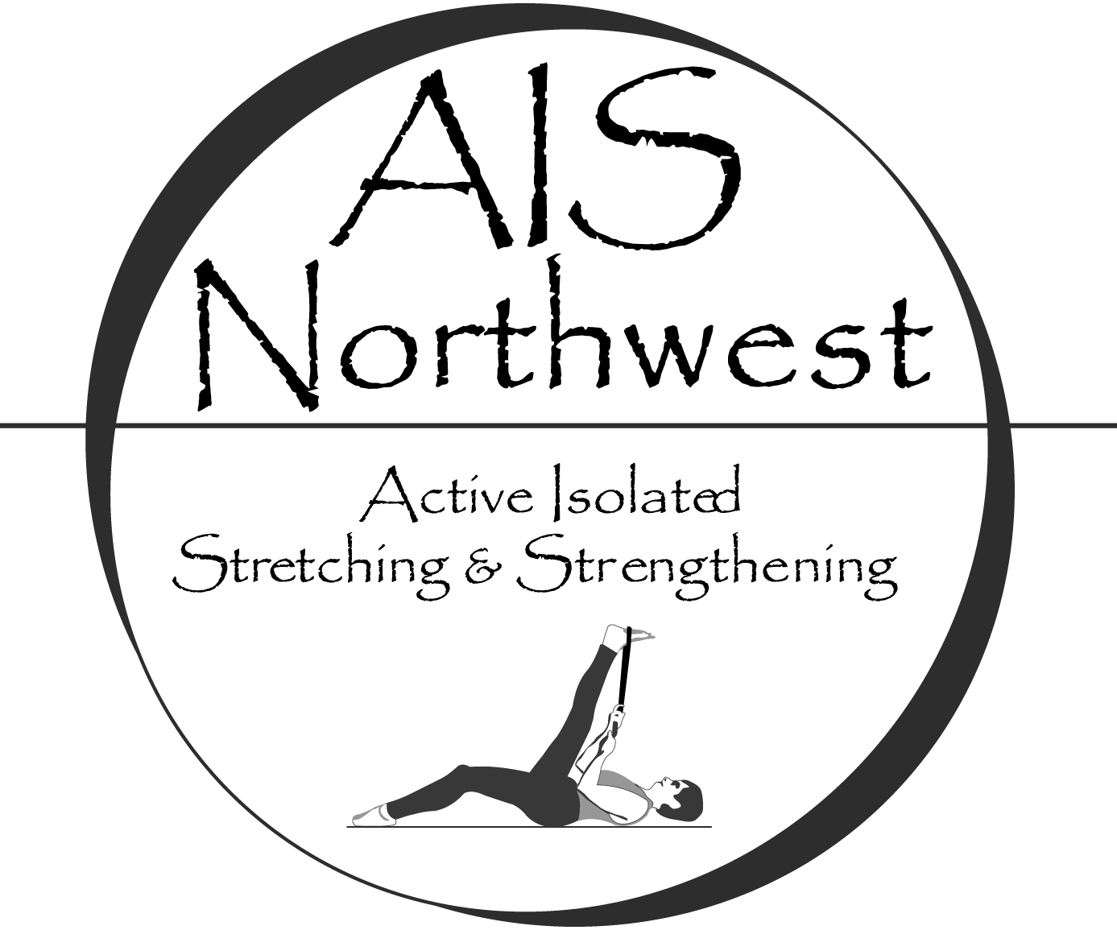

Active Isolated Stretching for the Lower Body
May 4th & 5th, 2018
Anamosa, IA
Active Isolated Stretching (AIS) is a dynamic technique that stretches muscles, tendons, and fascia specific to anatomical planes of movement. It remodels the body using gentle, rhythmic movements that avoid triggering the myotactic reflex, which causes a contraction in the tissues being stretched. Utilizing the principles developed by Aaron Mattes, this unique stretching modality restores joint mobility, reduces muscular/fascial tension and improves circulation. The simple yet profound difference is holding the stretch for only 2 seconds. Repeated, active muscle contractions along with gentle stretches create a venous/lymphatic pump, decreasing inflammation and combating disease. Dysfunctional movement patterns are exposed and retrained; unfavorable postural habits shift.
In this basic level class you will identify the physiology behind AIS and use the techniques to stretch yourself and assist your clients. Evaluate range and quality of movement before and after stretching and apply the techniques to treat a wide variety of disorders in the lumbar spine, hips and knees. The material presented covers disc conditions, nerve impingement, sciatica, groin impingement, S/I dysfunction and ITB syndrome among other disorders. Course content is geared towards healthcare professionals and athletic trainers.
This class completes one of the requirements for gaining basic AIS level certification with AIS Northwest.
Instructor: Joshua Morton, LMT, MAISS
CE Contact Hours: 16 hours (WA, NCBTMB, BOC)
Tuition: $375 two weeks prior to class; $425 thereafter. Tuition includes a stretching strap for new students.
Discount: Register for all classes Friday through Sunday, 22 CEs, $500 2 weeks before; $540 thereafter
Materials: Free electronic access to the instructional manual. A handout of the stretches covered in class will be provided.
Cancellation/Refund Policy: Carlson College of Massage
Day/Time: Friday and Saturday 9 AM – 6 PM (1 hour for lunch)
Location: 11809 Co Rd X28, Anamosa, IA 52205
Registration/Info: Carlson College of Massage
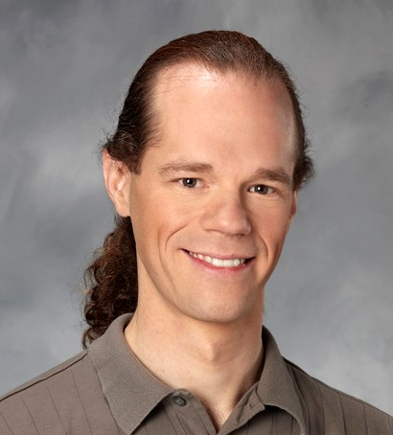 | Joshua Morton, LMT, MAISS, MMLT - Co-owner/Master Instructor with AIS Northwest, LLC. Joshua has over 2000 hrs. training with Aaron Mattes, the creator of Active Isolated Stretching and over 15 years teaching AIS. Joshua is one of the leading AIS practitioners and instructors internationally. Joshua offers students in-depth experience and expertise in a supportive learning environment. (#MA00008567). | 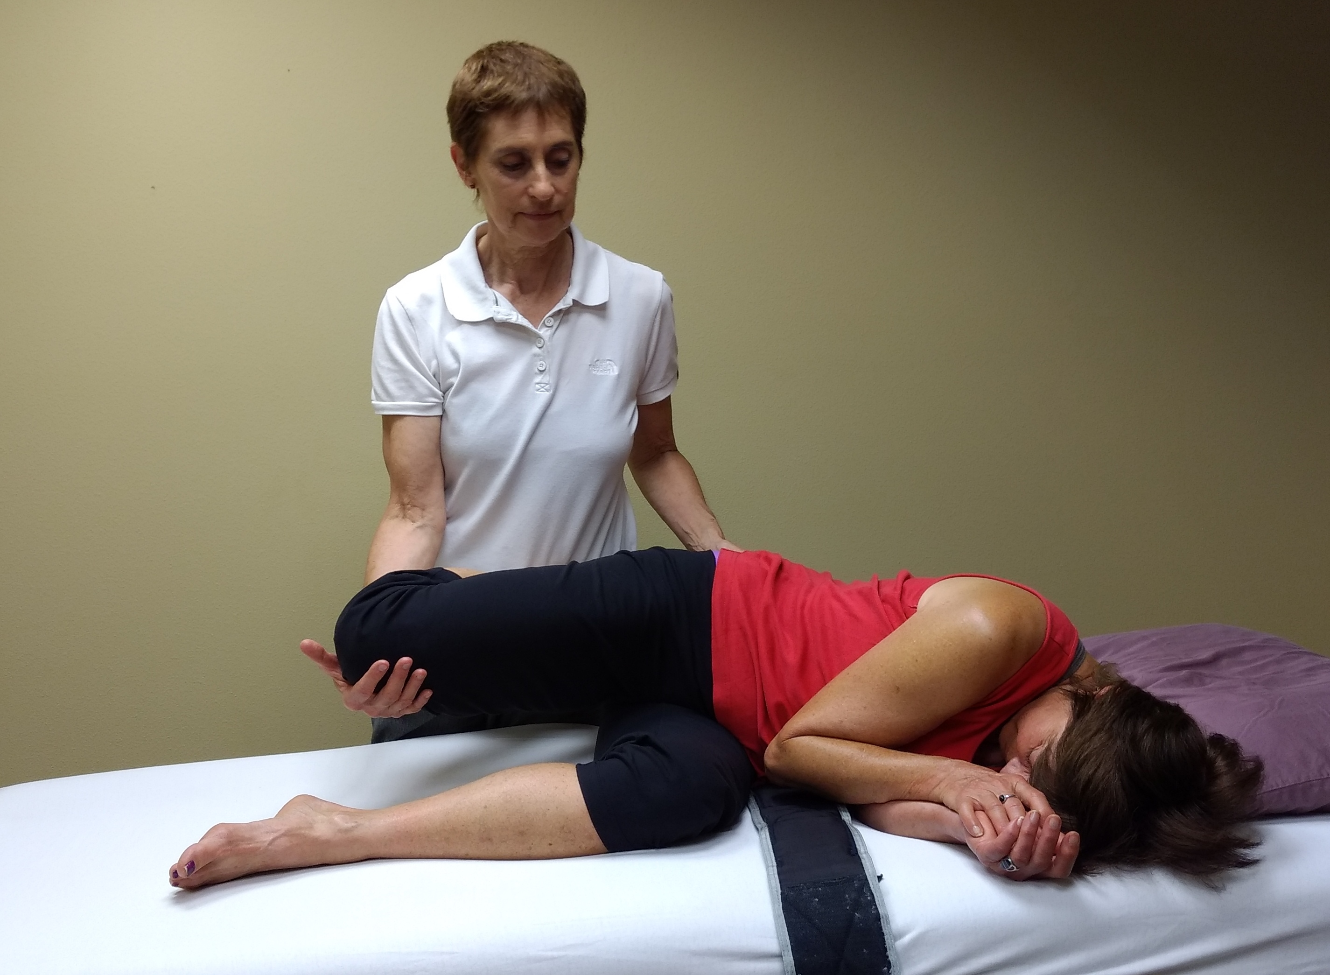
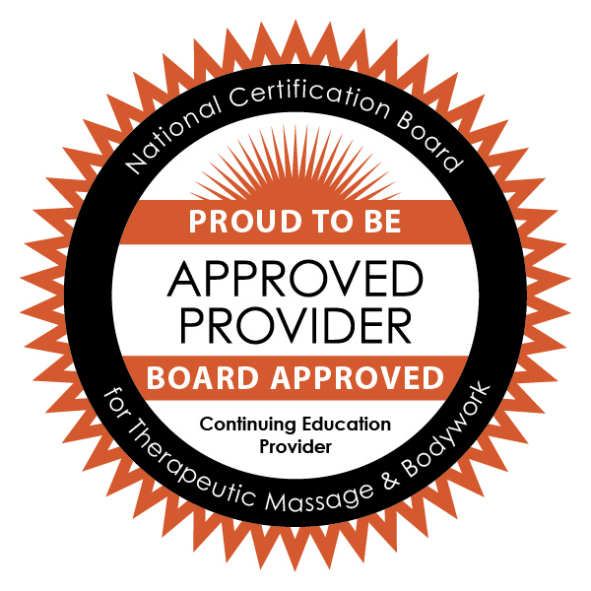AIS Northwest is approved by the National Certification Board for Therapeutic Massage & Bodywork (NCBTMB) as a continuing education Approved Provider (Provider ID: 451194-09).
AIS Northwest, LLC is approved by the Board of Certification, Inc. to offer continuing education for Certified Athletic Trainers.

