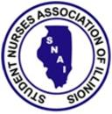
Student Recognition Award Form
By submitting this form you certify that this student should be recognized as a student leader. For the student to be recognized they must be present at the Leadership conference on March 24th. Please email completed form to president@snaillinois.com

Student Name:
Student’s School:
Year in School:
Submitting Instructors Name:
Please attach student’s photo if available.
*Any students that are submitted via this form will automatically be considered for the “Future Nurse Leader Scholarship” which will also be awarded at the Leadership conference.

