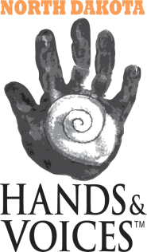
North Dakota Hands & Voices
PO Box 1776
Minot, ND 58702
Phone: 701-484-1605
Email: contact@ndhandsandvoices.org

BOARD MEMBER APPLICATION

Name/Name of business: _______________________________________
Address: __________________________ City:_________________ State: _________ Zip: _______
Phone number: _________________________________ TTY:_______________________________
Email address: __________________________________
Family Members: __________________________________
__________________________________
__________________________________
__________________________________
__________________________________
Are you or a family member deaf or hard of hearing? YES NO
If yes, please list him/her: _______________________________________

Please initial after each applicable statement:

I have read the commitment requirements, and I understand and accept them as a part of the North Dakota H&V Board. _____

I am a parent of a deaf/hh child. _____

I am a professional. _____

I am Deaf or Hard of Hearing. _____

Please Answer the Following Questions:
Why are you interested in serving on the H&V Board?

Can you support a family’s or individual's communication choice that is different from your own personal belief system about modality/methodology? Will communication bias be a challenge for you? Please explain:

Tell us about your personal philosophy of communication choices:

Do you have experience with communication choices that are different from your personal belief system?

Parents, tell us about your child/children or students, and what your family's approach to communication has been:

Are you willing to meet in person and conduct chapter business over the internet?
Other information you would like to share:

