CCUMC COMMUNICATES cCCommunicates
ISSUE
10
Nov
2021


In This Issue
Pg 1 Pastor’s Page
Pg 2, 3 & 4 Coming Up Next
Pg 5 Bible Studis & Small Groups
Pg 6 Keeping You Informed
Pg 7 Calendar & Volunteers needed
Pg 8 Church Information


November all ready where has this year gone? This month I would like to look at two terms in relation to the scriptures. The first term is Biblical inerrancy, and the second term is Biblical infallibility. Let’s look at the definition of Biblical inerrancy first. Biblical Inerrancy is the belief that the Bible "is without error or fault in all its teaching". Biblical infallibility is the belief that what the Protestant Bible says regarding matters of faith and Christian practice is wholly useful and true. It is the "belief that the Bible is completely trustworthy as a guide to salvation and the life of faith and will not fail to accomplish its purpose."
The first question to ask ourselves is this, do I believe that the Bible is without error in all it’s teaching? Let’s look at what John Wesley said about the scriptures, in Article V—Of the Sufficiency of the Holy Scriptures for Salvation" in the Articles of Religion states that:
The Holy Scripture containeth all things necessary to salvation; so that whatsoever is not read therein, nor may be proved thereby, is not to be required of any man that it should be believed as an article of faith or be thought requisite or necessary to salvation. In the name of the Holy Scripture, we do understand those canonical books of the Old and New Testament of whose authority was never any doubt in the Church.
In John Wesley’s Explanatory Notes Upon the New Testament: "2 Timothy 3:16." It says, All scripture is inspired of God -The Spirit of God not only once inspired those who wrote it, but continually inspires, supernaturally assists, those that read it with earnest prayer. Hence it is so profitable for doctrine , for instruction of the ignorant, for the reproof or conviction of them that are in error or sin, for the correction or amendment of whatever is amiss, and for instructing or training up the children of God in all righteousness ."
This view is shared by other theologians, Frank Moore editor-in-chief of Holiness Today. writes in Holiness Today, July/August 2018, “We believe that the Holy Spirit involves Himself directly in the inspiration, transmission, and preservation of Scripture from the time of its original revelation until today. We further believe the Holy Spirit works through the written Word to bring us in contact with Jesus Christ, the living, personal Word. God uses Scripture by the power of His Spirit to reveal Himself to every searching heart.”
The second question to ask ourselves is do we believe in the infallibility of the Bible do we believe; the Bible is completely trustworthy as a guide to salvation and the life of faith and will not fail to accomplish its purpose." In Isaiah 55:10-11 God says through the prophet,10 As the rain and the snow come down from heaven, and do not return to it without watering the earth and making it bud and flourish, so that it yields seed for the Sower and bread for the eater,11 so is my word that goes out from my mouth: It will not return to me empty but will accomplish what I desire and achieve the purpose for which I sent it.
I’ll leave you with Isaiah 55:10-11 to contemplate till next month. As for me I believe in both the inerrancy and infallibility of the scriptures.





Starting in Nov, Commission on Aging will be serving meals every Tue & Thu at Noon. Contact office if interested in attending.




Christmas is coming. It is not too soon to think about decorating. Carson City United Methodist Church is selling evergreen wreaths on a 10” base with 2 pinecones and a red bow for $20.00. Contact Wally at 989-640-0238 to place an order. Proceeds go toward CCUMC mortgage. The more we sell, the greater the debt reduction. Deadline is Nov 21st. Money is due by deadline. They are usually ready by Thanksgiving but Wally will notify when ready.

The weekly offering envelopes are here. If you need a box contact Wally @ 989-640-0238 and she will set one aside and make arrangements to deliver it.



United Methodist Women (UMW) will meet in the Fellowship Hall on Monday, November 1, 2021 at 11:00 am for its annual World Thank Offering and Program. Ladies, join us for a “Bring Your Own” bagged lunch time and enjoy a time of fellowship with the program to follow.
Praising God for your many blessings, this is a time to show your gratitude with a generous monetary donation to the UMW. When we share our gifts and they are combined with the gifts of others, our contributions make possible the support of international projects to meet the physical and social needs of women, children and youth around the world.
In addition to this global ministry, we are also inviting you to participate in a scavenger hunt in your home, looking for fabric you no longer need or want and bring those items with you to the meeting. Our combined collection of fabric will be donated to the Lutheran World Relief, sponsored by Calvary Lutheran Church, which provided 264,585 quilts from January – September of 2021, giving warmth and protection to families all over the world. What a great way to help locally and globally in mission.
A partial list may help you on your search - Please…..NO clothing or sheer fabric

- Old comforters
- Towels
- Bedding/sheets, blankets, mattress covers
- Thorws
- Tablecloths
- Shower curtains
- Drapes

See you ladies on Monday, November 1, 2021 at 11:00 am.
------------------------------------------------------------------------------------------------------------------------
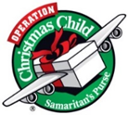
OCC Shoebox: Deadline for collection is Sun, 11/14. We pray to God you're passionate to help this year, because it takes all of us to meet the growing needs. Children need us and collection week is 3 weeks away! If you include a letter, photo and return address, sometimes the children send a note back. Please note, we can no longer pack toothpaste, candy or gum of any kind. How to pack a shoebox, boy/girl labels, and gift suggestions are available in the church foyer. A donation of $9 assists in covering shipping expenses for Samaritan’s Purse. Please make checks out to Samaritan's Purse and place it in the envelopes in the foyer or you can give it to Jeanneane at Toni and Ben's
small group class each Sunday or mail it to:
Samaritan's Purse
P.O. Box 3000
Boone, NC 28607
Phone (828) 262-1980
You can also give or build a shoebox online by following this link - https://www.samaritanspurse.org/operation-christmas-child/ways-to-give/

AD Board, Finance Meeting, Wed. Nov 24th at 6 pm
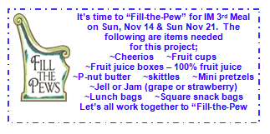
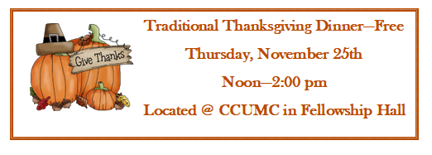
In observance of Thanksgiving the CCUMC Office will be closed and Hall will be open for our Annual Thanksgiving Meal.



pg. 4
The Thanksgiving committee has met and we need a donation of your time on that Thursday. It can be 1/2 hour or more. Please come and help us make this day great for others. It is a blessing to them and in turn to those who hear their gratitude and fellowship. The busiest time is getting food onto the steam table so that starts at 10am. Come join us and make the day special for others.

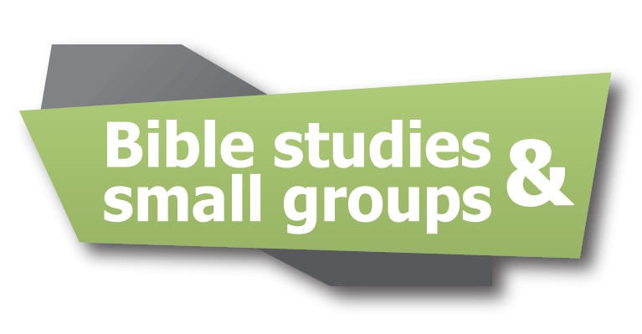

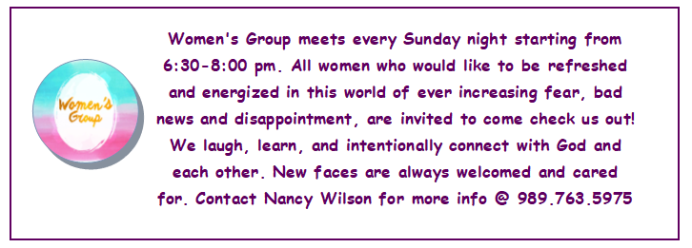
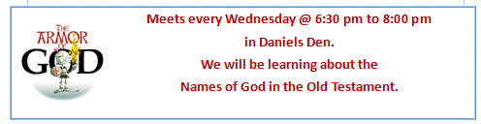
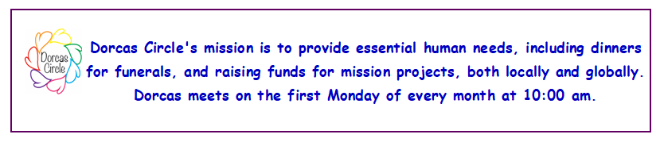
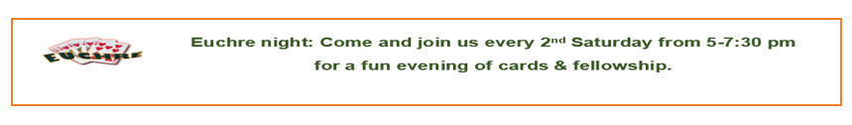

Meets every Wednesday @ 6:30 pm to 8:00 pm
in Daniels Den.
We will be learning about the
Names of God in the Old Testament.
All kids welcome from ages 3 through 7th grade.
Snacks are included.
Meets every Wednesday @ 6:30 pm to 8:00 pm
in Daniels Den.
We will be learning about the
Names of God in the Old Testament.
All kids welcome from ages 3 through 7th grade.
Snacks are included.


**********************************************************************************************
Climate Change Conference:
In just a few weeks, the UK will host the 26th UN Climate Change Conference of the Parties (COP26) in Glascow. The negotiations that will take place at COP 26 will chart the path for the future of our planet.
The climate crisis affects all of us, but not equally. In fact, the poorest people who are the least responsible for the problem are suffering the most. Climate change is one of the primary drivers of hunger, forced migration, poverty and inequality all over the world.
Climate work includes calling for alternative, community-based energy systems and investments; supporting small-scale farmers; standing with indigenous and other communities advocating for their rights; and so much more. Successful climate action will have a ripple effect to address the interlocking crisis of climate change, racial injustice, gender inequality and economic inequality.
We need to make it clear that we expect world leaders to meet the moment with bold, ambitious measures. Write our representatives to urge President Biden to take action; to care for our earth and its inhabitants. And pray. WalthaGaye
**********************************************************************************************
United Methodist Women joins our partners at Dignity In Schools to celebrate this year's week of Action Against School Pushout.
Our Gospel tradition uplifts children and youth. But all across our country harmful policies and practices are criminalizing young people and pushing them out of school. The overreliance on school-based police contributes to this harmful trend. The federal government can help address this issue by passing The Counseling Not Criminalization in Schools Act (H.R.4011/S.2125). This bill would shift federal funding away from harmful, criminalizing approaches (police in schools). Instead, it would make available a pool of federal funding to meet student needs and improve school climate through evidence-based, age-appropriate, trauma-informed practice.
Join over 700 United Methodist Women and friends who have already contacted their representatives in support of the bill and take action today! Send an email to your representatives in support of the Counseling Not Criminalization in Schools Act (H.R.4011/S.2125).
The bill would shift federal funding away from harmful, criminalizing approaches such as police in schools. Instead it would make available a pool of federal funding to meet student needs and improve school climate through evidence-based, age-appropriate, trauma-informed practice.
If you want further information on how to do this, contact WalthaGaye at wally @cmsinter.net and I will send the information and the link. Thank you

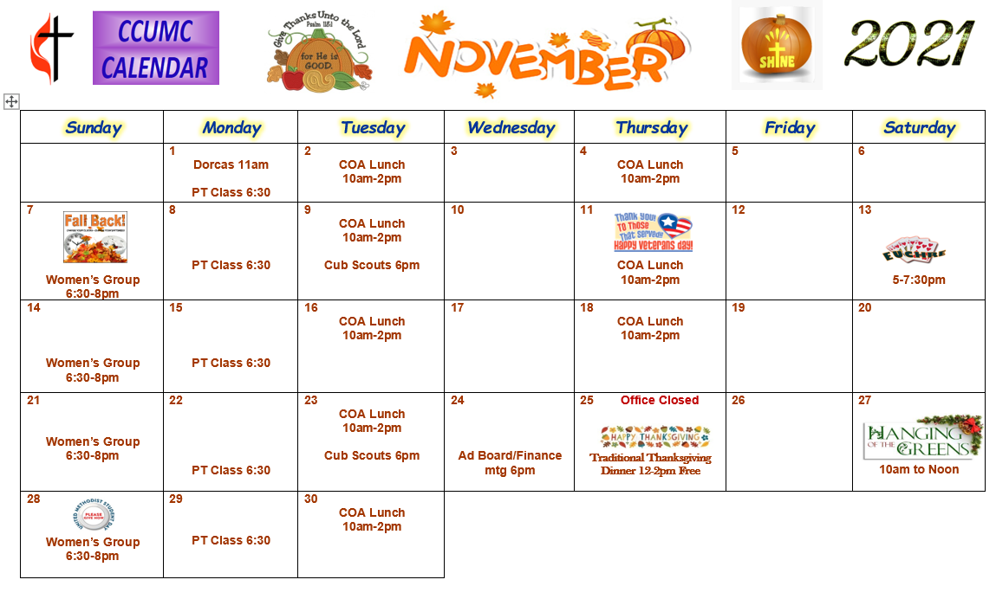


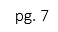
Please consider helping with the nursery on a Sunday @ 10:30 every other month. Contact Roberta Kile @ 989-584-3629 if you would like to be put on the schedule. Thank You.
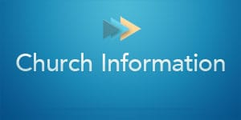
Stay connected! Follow us on:





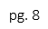

Carson City United Methodist Church
Phone: 989-584-3797
Email: carsoncityumc@gmail.com
Website: carsoncityumc.com
Office Hours: Monday to Thursday, 9:00 am-Noon
After hours by appointment
Pastor: Ian McDonald (906) 322-5318
Secretary: Bonnie Seaman (989) 763-1674

Online giving available - on CCUMC Website: http://www.carsoncityumc.com/donate.html

Join Us Each Sunday

Worship Services 10:30 am

(masks are optional)
Weekly Sunday Bulletin now available on our website
at www.carsoncityumc.com

