FOX RIVER FIELD SPANIEL CLUB | 2025 membership DUES NOTICE  2 WAYS TO PAY: CHECK OR PAYPAL  PLEASE REMIT DUES BY JANUARY 1, 2025
CHECKs PAYABLE TO:  FOX RIVER FIELD SPANIEL CLUB  please print this notice send with payment TO:  Marie Lindquist  3414 87th ST  KENOSHA WI 53142 | 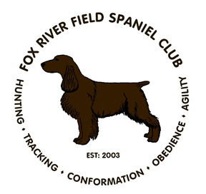
Name:_______________________________________________________________________________________

Address:_____________________________________________________________________________________

City/State/Zip_________________________________________________________________________________

Phone:________________________________Email:_________________________________________________

 | membership type |  | amt due by check | TOTAL
 |  | REGULAR INDIVIDUAL MEMBERSHIP EACH | 35.00
 |  | REGULAR HOUSEHOLD MEMBERSHIP | 60.00
 |  | ASSOCIATE MEMBERSHIP EACH (no voting) | 25.00
 |  | ASSOCIATE MEMBERSHIP HOUSEHOLD (no voting) | 45.00
 |  | JUNIOR MEMBERSHIP EACH | FREE
Paypal: FRFSCpayment@yahoo.com
Please note of membership type, family members and any Juniors in the note section when paying.

