Winter 2015 / 2016
5th December 2015
Christmas Club Mixed Doubles

This year six mixed doubles team entered the Christmas competition instead of groups we did a round robin where ever team plays each other one and who got the most wins then by points difference wins. Prizes were awarded to 1st 2nd and 3rd.

Round One

Last years winners Alice & David started off well by beating Brian & Val 13-3 Ross & Brigitte took lead only beating Cassie & Bells 10-4 only for them to come back to 12-12 with the last end to play Ross & Brigitte held their nerve to win the match. It was tight in the third match with James & Dawn piping Keith & Sue by one point for another tightly fought game.

Round Two

With the tightly fought matches from the first round you would think the second would be the same, Alice & David went to beat Keith & Sue 13-3 and Ross & Brigitte beat Brian & Val 13-1. On a back of a defeat for Cassie & Bells morel was low they went on to play James & Dawn who took full advantage by dishing them out a Fanny first of the day.

Round three

Brian and Val got their first win of the day by beating Keith & Sue 13-1. Alice & David carried on to win their third match beating Cassie & Bells 13-6. Ross & Brigitte lost their first match of the day to James & Dawn 13-4 a game where there was no luck for the loser everything went James & Dawns way.

Round Four.

There’s light at the end of the tunnel for Keith & Sue winning their first match by beating Cassie & Bells 13-9, Brian and Val lost to James & Dawn 13-8 to take there fourth win of the day. Ross & Brigitte pick them self’s up from their previous lost to beat last years champions Alice & David 13-5

Round Five

After miserable day for Cassie & Bells 0 wins and -25 points they pulled back some pride by beating Brian and Val 13-7. On 3 wins + 12 Ross & Brigitte need to win big and hope the other drop points going into the last match they manage to beat Keith & Sue 13-4 which gave them a plus 9 would it be enough. Finally current leaders James & Dawn on 4 wins +28 only need to keep it tight against Alice & David 13-5 who are on 3 wins +19. They played well all day only to go on and lose 13-2 to Alice & David.

Final tables

Seeds | Teams | Match (s) |  | Pts Scored | Place
 |  | Won | Lost
1 | Alice & Dave | 4 | 1 | 30 | 1st
2 | Ross & Brigitte | 4 | 1 | 21 | 2nd
3 | James & Dawn | 4 | 1 | 17 | 3rd
4 | Bells & Cassie | 1 | 4 | -19 | 4th
5 | Brian & Val | 1 | 4 | -25 | 5th
6 | Keith & Sue | 1 | 4 | -28 | 6th

1st Place Alice & David

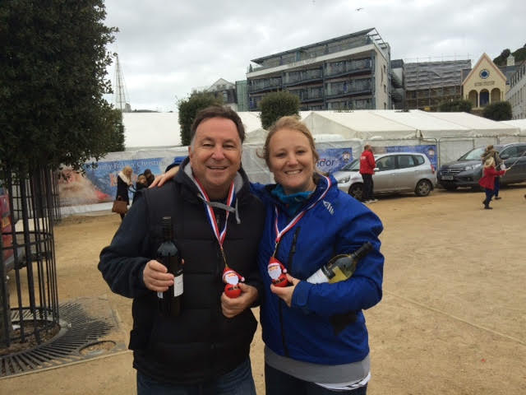

2nd Ross & Brigitte 3rd James & Dawn

Don’t forget Mixed Doubles Christmas Competition Saturday 5th December

Club email address - liberationpc@gmail.com

Club Website - www.liberationpetanque.co.uk

Kind Regards

Toby Northern

Chairman

Liberation Petanque Club

SPONSORED BY

