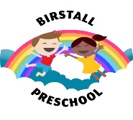
September 1, 2021

Early Years Prospectus

Birstall Pre-School’s Early Years Prospectus for Parents
Carr Street
Birstall
Tel: 01924 444200
staff@birstallpreschool.co.uk

Welcome to Birstall Pre School and thank you for registering your child with us.

We know how important your child is and aim to deliver the highest quality of care and education to help them to achieve their best.

This prospectus aims to provide you with an introduction to Birstall Pre-School, our routines, our approach to supporting your child’s learning and development and how we aim to work together with you to best meet your child’s individual needs. This should be read alongside our Childcare Terms and Conditions for a full description of our services.

Our setting aims to:

- provide high quality care and education for children below statutory school age;
- work in partnership with parents to help children to learn and develop;
- add to the life and well-being of the local community; and
- offer children and their parents a service that promotes equality and values diversity.

Parents

You are regarded as members of our setting who have full participatory rights. These include a right to be:
- valued and respected;
- kept informed;
- consulted;
- involved; and
- Included at all levels.

As a voluntary/charitable managed setting, we also depend on the good will of parents and their involvement to keep going. Membership of the setting carries expectations on you for your support and commitment.

Children's development and learning

We aim to ensure that each child:
- is in a safe and stimulating environment;
- is given generous care and attention, because of our ratio of qualified staff to children, as well as volunteer helpers;
- has the chance to join in with other children and adults to live, play, work and learn together;
- is helped to take forward her/his learning and development by being helped to build on what she/he already knows and can do;
- has a personal key person who makes sure each child makes satisfying progress;
- is in a setting that sees parents as partners in helping each child to learn and develop; and
- Is in a setting in which parents help to shape the service it offers.

The Early Years Foundation Stage
Provision for the development and learning of children from birth to 5 years is guided by the Early Years Foundation Stage. Our provision reflects the four overarching principles of the Statutory Framework for the Early Years Foundation Stage (DfE 2012):

- A Unique Child
Every child is a unique child who is constantly learning and can be resilient, capable, confident and self-assured.

- Positive Relationships
Children learn to be strong and independent through positive relationships.

- Enabling Environments
Children learn and develop well in enabling environments, in which their experiences respond to their individual needs and there is a strong partnership between practitioners, parents and carers.

- Learning and Development
Children develop and learn in different ways and at different rates. The framework covers the education and care of all children in early year’s provision including children with special educational needs and disabilities.

How we provide for development and learning

Children start to learn about the world around them from the moment they are born. The care and education offered by our setting helps children to continue to do this by providing all of the children with interesting activities that are appropriate for their age and stage of development.

The Areas of Development and Learning comprise:
- Prime Areas
- Personal, social and emotional development.
- Physical development.
- Communication and language.

- Specific Areas
- Literacy.
- Mathematics.
- Understanding the world.
- Expressive arts and design.

For each area, the level of progress that children are expected to have attained by the end of the Early Years Foundation Stage is defined by the Early Learning Goals. These goals state what it is expected that children will know, and be able to do, by the end of the reception year of their education.

The Early Years Outcomes (DfE 2013) guidance sets out the likely stages of progress a child makes along their progress towards the Early Learning Goals. Our setting has regard to these when we assess children and plan for their learning. Our programme supports children to develop the knowledge, skills and understanding they need for:

Personal, social and emotional development
- making relationships;
- self-confidence and self-awareness; and
- Managing feelings and behaviour.

Physical development
- moving and handling; and
- Health and self-care.

Communication and language
- listening and attention;
- understanding; and
- Speaking.

Literacy
- reading; and
- Writing.
Mathematics
- numbers; and
- Shape, space and measure.

Understanding the world
- people and communities;
- the world; and
- Technology.

Expressive arts and design
- exploring and using media and materials; and
- Being imaginative.

Our approach to learning and development and assessment

Learning through play
Being active and playing supports young children’s learning and development through doing and talking. This is how children learn to think about and understand the world around them. We/I use the EYFS statutory guidance on education programmes to plan and provide opportunities which will help children to make progress in all areas of learning. This programme is made up of a mixture of activities that children plan and organise for themselves and activities planned and led by practitioners.

Characteristics of effective learning
We understand that all children engage with other people and their environment through the characteristics of effective learning that are described in the Early Years Foundation Stage as:
- playing and exploring - engagement;
- active learning - motivation; and
- Creating and thinking critically - thinking.

We aim to provide for the characteristics of effective learning by observing how a child is learning and being clear about what we can do and provide in order to support each child to remain an effective and motivated learner.

Assessment
We assess how young children are learning and developing by observing them frequently. We use information that we gain from observations, as well as from photographs or videos of the children, to document their progress and where this may be leading them. We believe that parents know their children best and we will ask you to contribute to assessment by sharing information about what your child likes to do at home and how you, as parents, are supporting development.

We make periodic assessment summaries of children’s achievement based on our on-going development records. These form part of children’s records of achievement. We undertake these assessment summaries at regular intervals, as well as times of transition, such as when a child moves into a different group or when they go on to school.

The progress check at age two
The Early Years Foundation Stage requires that we supply parents and carers with a short written summary of their child’s development in the three prime areas of learning and development - personal, social and emotional development; physical development; and communication and language - when a child is aged between 24 - 36 months. Your child’s key person is responsible for completing the check using information from on-going observational assessments carried out as part of our everyday practice, taking account of the views and contributions of parents and other professionals.

Records of achievement

We keep a record of achievement for each child. Your child's record of achievement helps us to celebrate together her/his achievements and to work together to provide what your child needs for her/his well-being and to make progress.

Your child's key person will work in partnership with you to keep this record. To do this you and she/he will collect information about your child's needs, activities, interests and achievements. This information will enable the key person to identify your child's stage of progress. Together, we will then decide on how to help your child to move on to the next stage.

Working together for your children

We maintain the ratio of adults to children in the setting that is set by the Safeguarding and Welfare Requirements. We also have volunteer parent helpers, where possible, to complement these ratios. This helps us to:
- give time and attention to each child;
- talk with the children about their interests and activities;
- help children to experience and benefit from the activities we provide; and
- Allow the children to explore and be adventurous in safety.

The staff who work at setting are:
Name | Job Title | Qualifications and Experience
Sue | Manager | Level 3  Designated Safeguarding Lead  First aider
Heather | Admin Manager | Safeguarding Lead  First aider
Alex | Floor manager | Level 3  Safeguarding Lead  First aider
Frankie | Floor manager & out of school | Level 3  Safeguarding Lead  First aider
Diana | Senco | Degree Social Care  First aider
Clare | Childcare practitioner | Level 3  Safeguarding Lead  First aider
Maxine | Childcare practitioner | Level 3  First aider
Jamie leigh | Childcare practitioner | Level 3  First aider
Amy | Childcare practitioner | Level 3  First aider
Katie | Childcare practitioner | Level 5  First aider
Sally | Childcare practitioner | Level 6  First aider
Emily | COOK | Level 3  Health and safety
Kelly | Childcare practitioner | Level 3  First aider
Naheeda | Bank Staff | First aider  Level 2
Bianca | Apprentice | Working towards level 2
Kim | Child care assistant

We are open for |  |  | 51 |  | Weeks each year.
We are closed |  |  | Christmas week
We are open |  |  | Monday-Friday |  | Days each week, term time only.
The times we are open are |  |  | 7.30am -6pm
We provide care and education for young children between the ages of:
3 mths | and | 11 |  | Years.

How parents take part in the setting

Our setting recognises parents as the first and most important educators of their children. All of our staff see themselves as partners with parents in providing care and education for their children. There are many ways in which parents take part in making our setting a welcoming and stimulating place for children and parents, such as:
- exchanging knowledge about their children's needs, activities, interests and progress with our staff;
- contributing to the progress check at age two;
- helping at sessions of the setting;
- sharing their own special interests with the children;
- helping to provide and look after the equipment and materials used in the children's play activities;
- being part of the management of the setting where appropriate;
- taking part in events and informal discussions about the activities and curriculum provided by the setting;
- joining in community activities, in which the setting takes part; and
- Building friendships with other parents in the setting.

The parents' rota

Our setting has a dated rota which parents can sign if they would like to help at a particular session or sessions of the setting. Helping at the session enables parents to see what the day-to-day life of our setting is like and to join in helping the children to get the best out of their activities.

Joining in

Joining the rota is not the only means of taking part in the life of the setting. Parents can offer to take part in a session by sharing their own interests and skills with the children. Parents have visited the setting to play the clarinet for the children, show pictures of the local carnival held in their neighbourhood, and show the children their collection of shells.

We welcome parents to drop into the setting to see it at work or to speak with the staff.

Key person and your child

Our setting uses a key person approach. This means that each member of staff has a group of children for whom she/he is particularly responsible. Your child's key person will be the person who works with you to make sure that the childcare that we provide is right for your child's particular needs and interests. When your child first starts at the setting, she/he will help your child to settle and throughout your child's time at the setting, she/he will help your child to benefit from our activities.

Learning opportunities for adults

As well as gaining childcare qualifications, our staff take part in further training to help them to keep up-to date with thinking about early years care and education. We also keep up-to-date with best practice, as a member of the Pre-school Learning Alliance, through Under 5 magazine and other publications produced by the Alliance. The current copy of Under 5 is available for you to read. From time to time we
Hold learning events for parents. These usually look at how adults can help children to learn and develop in their early years.

The setting's timetable and routines

Our setting believes that care and education are equally important in the experience which we offer children. The routines and activities that make up the day in our setting are provided in ways that:
- help each child to feel that she/he is a valued member of the setting;
- ensure the safety of each child;
- help children to gain from the social experience of being part of a group; and
- Provide children with opportunities to learn and help them to value learning.

The session*

We organise our sessions so that the children can choose from, and work at, a range of activities and, in doing so, build up their ability to select and work through a task to its completion. The children are also helped and encouraged to take part in adult-led small and large group activities, which introduce them to new experiences and help them to gain new skills, as well as helping them to learn to work with others. Outdoor activities contribute to children's health, their physical development and their knowledge of the world around them. The children have the opportunity, and are encouraged, to take part in outdoor child-chosen and adult-led activities, as well as those provided in the indoor playroom(s).

OR

The day*

We organise the day so that children can take part in a variety of child-chosen and adult-led activities. These take account of children's changing energy levels throughout the day. We cater for children's individual needs for rest and quiet activities during the day. Outdoor activities contribute to children's health, their physical development and their knowledge of the world around them.

Snacks

We make snacks and meals a social time at which children and adults eat together. We plan the menus for snacks so that they provide the children with healthy and nutritious food. Please tell us about your child's dietary needs and we will plan accordingly.

Clothing

We provide protective clothing for the children when they play with messy activities (please note don’t send your children in their best clothes, with all good intention at times children will get messy). We encourage children to gain the skills that help them to be independent and look after themselves. These include taking themselves to the toilet and taking off, and putting on, outdoor clothes. Clothing that is easy for them to manage will help them to do this.

Policies

Copies are available within the setting in the main entrance, both paper/electronic copies will be issued on request.

Our policies help us to make sure that the service provided by our setting is a high quality one and that being a member of the setting is an enjoyable and beneficial experience for each child and her/his parents.

Our staff and parents work together to adopt the policies and they all have the opportunity to take part in the annual review of the policies/I work together with parents to adopt the policies and provide them with the opportunity to take part in the annual review of the policies. This review helps us to make sure that the policies are enabling our setting to provide a quality service for its members and the local community.

Safeguarding children

Our setting has a duty under the law to help safeguard children against suspected or actual ‘significant harm’. Our employment practices ensure children against the likelihood of abuse in our setting and we have a procedure for managing complaints or allegations against a member of staff.

Our way of working with children and their parents ensures that we are aware of any problems that may emerge and can offer support, including referral to appropriate agencies when necessary, to help families in difficulty.

Special needs

To make sure that our provision meets the needs of each individual child, we take account of any special needs a child may have. We work to the requirements of the Special Educational Needs Code of Practice (2001).

Our Special Educational Needs Co-ordinator is | Diana Lister

The management of our setting

Our setting is a charity and as such is managed by a volunteer management committee - whose members are elected by the parents of the children who attend our setting. The elections take place at our Annual General Meeting. The committee make up the registered person with Ofsted and are responsible for:
- managing our finances;
- employing and managing our staff;
- making sure that we have, and work to, policies that help us to provide a high quality service; and
- Making sure that we work in partnership with parents.

The Annual General Meeting is open to the parents of all of the children who attend our setting. It is our shared forum for looking back over the previous year's activities and shaping the coming year's plan. Without a committee in place, the setting is unable to function legally, therefore requires the support of all parents/carers.

Fees

The fees are payable monthly in advance. Fees must still be paid if children are absent without notice for a short period of time. If your child has to be absent over a long period of time, talk to Sue/Heather who are our managers.

For your child to keep her/his place at our setting, you must pay the fees. We are in receipt of nursery education funding for two, three and four year olds; where funding is not received, then fees apply. Fees are still payable even if your child if off absent, to avoid any confusion this includes, sickness, holidays, any absence for any other reason, including applying for any form of funding.

Starting at our setting

The first days
We want your child to feel happy and safe with us. To make sure that this is the case, our will work with you to decide on how to help your child to settle into the setting. Our policy on the Role of the Key Person and Settling-in is enclosed with this prospectus.

We hope that you and your child enjoy being members of our setting and that you both find taking part in our activities interesting and stimulating. Our staff are always ready and willing to talk with you about your ideas, views or questions.

Dear parents/careers

Welcome to Birstall preschool, we do hope you enjoyed your pre visit with your child and that it is a rewarding experience.

We have a duty to safe guard and promote children’s welfare at all times and take necessary steps to ensure this, please note that all staff and volunteers are aware of and follow the procedures below.

- Staff ensure children will be kept safe and be supervised at all times
- Parents/carers wishing to take their child to the toilet are asked to use the disabled toilet in the reception/or ask a member of staff to accompany you to the main toilets
- That parents are supervised at all times
- That any drinks are contained to the kitchen and not allowed into any other area of the building
- The use of mobile phones and cameras are prohibited at all times
- Please do not open the main entrance door into the main room for parents/children
- Information regarding other children remains confidential

Thank you for you appreciation on this matter and we look forward to meeting you.

Dear parents/Carers

Can we kindly inform you Birstall Pre-school operates a zero tolerance policy at all times. Any policies and procedures we have in place are followed correctly by staff to ensure that your child’s safety is not compromised in anyway.

Your child’s welfare is always our first concern and will be treated as such. We can assure you that if any person behaves in such a way that anyone’s safety is compromised, the police will be called. The person offending will be barred from the setting and charges will be made against them.

We have a responsibility to ensure the safety of our children and as parents you will appreciate the procedures that are in place.

We ask that our policies are respected and adhered to at all times and allow staff to follow procedures.

Thank you

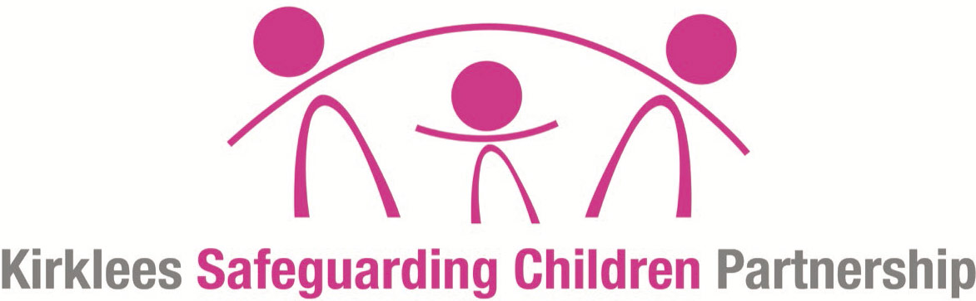

“Our first concern will always be the welfare of your child.
As a care provider for your child, we are required to follow the Local Safeguarding Board procedures. As carers for your child we will at all times try to share with you any concerns we may have about your child.
However, there may be times when we have to talk to Social Care before We talk to you”

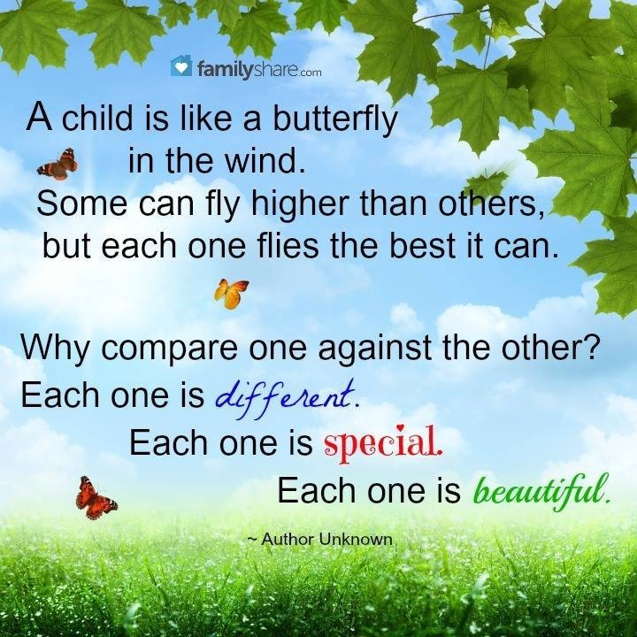
Mobile phones and cameras are prohibited on the premises at all times, for all staff, volunteers, visitors and parents (unless prior arrangements have been made with the management)
Thank you for your co-operation on this matter

Dear Parent/Carer’s

With regards to your child’s lunch box, I am sure you are aware, Birstall Pre-School work to the statutory requirements, as it is a legal welfare requirement to ensure that the children in our care are encouraged to be healthy. This “shows an awareness of a range of healthy practices with regards to eating” EYFS “Health and Bodily Awareness”; this includes providing them with a balanced diet appropriate to their needs. We understand that sometimes it can be difficult to find new and exciting healthy options for your child’s lunch box; however it can be very difficult for us to manage mealtimes when some children are permitted to have high fat/sugar content food when others are only offered healthy alternatives. We would therefore request that you consider carefully what you pack in your child’s lunch box.
We are happy to provide you with suggestions that we have found other children have enjoyed.
We have also got some health lunch box ideas on our notice board.

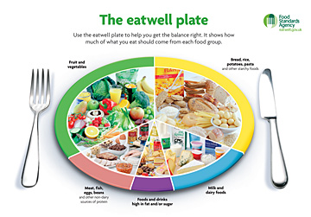
Please do not hesitate to discuss your child’s diet/eating with us at any time Drinks must be provided in lunchboxes and should only include either water, milk or low fat milkshake, sugar free juice drink, sugar free flavored water or 100% fruit juice.
The following foods are not encouraged for lunch:
- Sugared/toffee popcorn
- Chewing gum
- Fizzy drinks in cartons, bottles or cans
- Crisps as a filling for sandwiches
- Chocolate, snacks, yogurts containing sweets
- Sweets

RESOURCES &WEBSITES INFORMATION Please note this is for information only and not a recommended list, Kirklees Council does not endorse any websites, products or services.

Food Standards Agency - Eat well, be well - Children
Practical healthy eating advice for children, from toddlers to teenagers.
www.eatwell.gov.uk/agesandstages/children/ -
Healthy Kids, the website for the Education Link Project. We are based in Lambeth in South London.www.healthykids.org.uk/
Children First for Health - the latest facts on obesity, how to eat healthily, tasty recipes! It's all by the Children First for Health team at www.childrenfirst.nhs.uk/kids/health/eat_smart/ -
Allkids Childrens Healthy Eating, Food and Nutrition Resources, Kids Recipes, Vegetarian, Organic and Food Problems.www.allkids.co.uk › Parenting Support
Lunchbox Tool - Healthy Eating for Kids - Food - Healthy Living ...
With our lunch box tool, you can design healthy lunches for you and your family. The tool will tell you what proportion of your Guideline Daily Allowance ...
www.tesco.com/health/food/healthy_kids/lunchbox_tool.page -

Healthy eating for kids - Morrisons
Recipe search· Healthy eating . Tasty sandwich fillers ... Healthy eating for kids ...
www.morrisons.co.uk/food/healthy-eating/Healthy-Eating-for-kids/ -

“shows an awareness of a range of healthy practices with regards to eating” EYFS “Health and Bodily Awareness”;
Birstall preschool
Carr Street
Birstall
West Yorkshire
WF17 9DY

Tel: 01924 444200
Email: birstallpreschool@hotmail.com

Registered charity no: 1023323

Dear Parent/carer

Under direction from the government we have now been instructed by Ofsted to follow up children that are absent from pre-school. We now have a duty to make contact with you if you do not inform us they are going to be absent, whether that due to illness or holidays (even if this is only for one day).

Could we please ask you to contact/inform as soon as possible if your child will be absent on the above contact details

You can leave messages on our answer phone.

Any children that are absent without notification will be telephoned by the setting.

Thank you for your cooperation on this matter.

Trustees of Birstall Pre-School

Policies

Our staff can explain our policies and procedures to you. Copies of which are available within the setting.

Our policies help us to make sure that the service provided by our setting is a high quality one and that being a member of the setting is an enjoyable and beneficial experience for each child and her/his parents.

Our staff and parents work together to adopt the policies and they all have the opportunity to take part in the annual review of the policies we work together with parents to adopt the policies and provide them with the opportunity to take part in the annual review of the policies. This review helps us to make sure that the policies are enabling our setting to provide a quality service for its members and the local community.
Information we hold about you and your child
We have procedures in place for the recording and sharing of information [data] about you and your child that is compliant with the principles of the General Data Protection Regulations (2018) as follows:
The data is we collect is
- Processed fairly, lawfully and in a transparent manner in relation to the data subject [you and your family]
- Collected for specified, explicit and legitimate purposes and not further processed for other purposes incompatible with those purposes.
- Adequate, relevant and limited to what is necessary in relation to the purposes for which data is processed.
- Accurate and, where necessary, kept up to date.
- Kept in a form that permits identification of data subjects [you and your family] for no longer than is necessary for the purposes for which the personal data is processed.
- Processed in a way that ensures appropriate security of the personal data including protection against unauthorised or unlawful processing and against accidental loss, destruction or damage, using appropriate technical or organisational measures.

When you register your child with us we will provide you with a privacy notice that gives you further details of how we fulfil our obligations with regard to your data.

Dear Parent/carer

We are happy to announce that we can now accept bank transfers as a method of payment for you child.

Please can I ask for any payments to be made to the details below also if this option suits your circumstances better, can you inform Heather

Bank- Yorkshire bank
Reference- (your Childs name)
Sort code – 05-01-31
Account number- 67359588

Many thanks

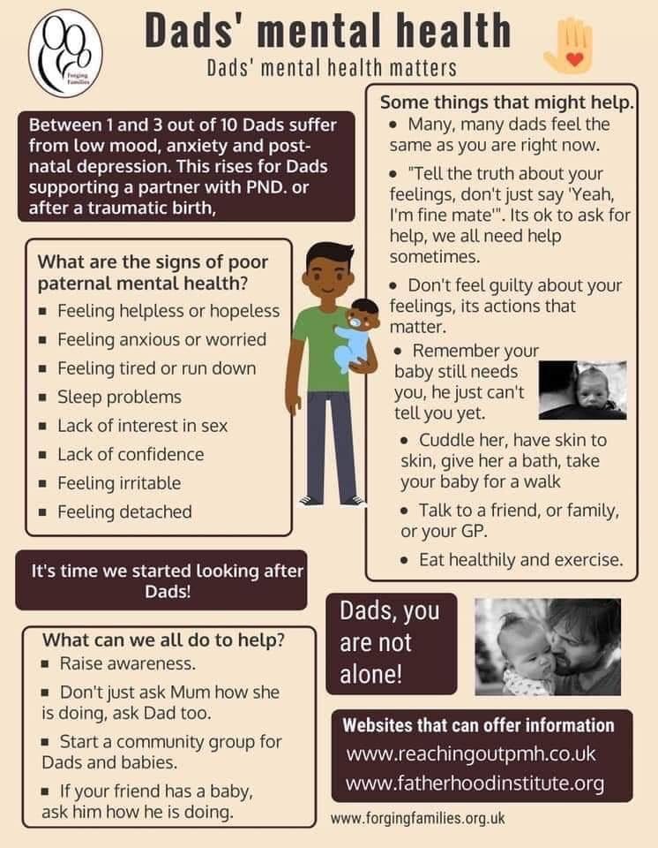

Breakfast, After school, and holiday Club

Here at Birstall preschool we are pleased announce the opening of our breakfast and After-school club.
The breakfast club is an opportunity for your child to gain a healthy, nutritious breakfast to kick start there day, whilst the after-school club provides fun and a light tea.
The breakfast club will run Monday to Fridays from
7.30am -9:00am with school drop off if required.
The cost per session is £7.00
The After-school club will run Monday -Friday from school collection to 6pm
The cost per session is £11.00
Holiday club will run during the school Holidays.

Please complete the application form to enrol your child and please return to Heather

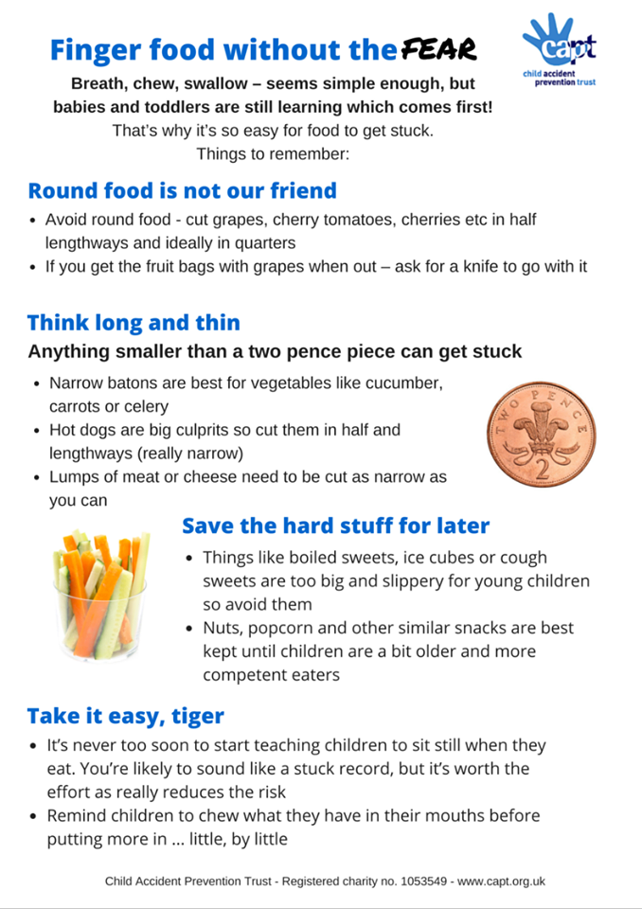

Privacy notice

Birstall Preschool Privacy Notice

Birstall Preschool
Carr Street
Birstall
West Yorkshire
WF17 9DX
Registered Charity No. 1023323

Name of data controller is: Sue Brooke

Introduction
We are committed to ensuring that any personal data we hold about you and your child is protected in accordance with data protection laws and is used in line with your expectations.

This privacy notice explains what personal data we collect, why we collect it, how we use it and how we protect it.

What personal data do we collect?
We collect personal data about you and your child to provide care and learning that is tailored to meet your child’s individual needs. We also collect information in order to verify your eligibility for free childcare as applicable.

Personal details that we collect about your child include:
- your child’s name, date of birth, address, health and medical needs, development needs, and any special educational needs, nationality, religion and if your child attends any other providers and how information is shared with other providers and professionals.

Where applicable we will obtain child protection plans from social care and health care plans from health professionals.

We will also ask for information about who has parental responsibility for your child and any court orders pertaining to your child.

Personal details that we collect about you include:
- your name, home and work address, phone numbers, emergency contact details, and family details.

This information will be collected from you directly in the registration form.

If you apply for up to 30 hours free childcare, we will also collect:
- your national insurance number or unique taxpayer reference (UTR), if you’re self-employed. We may also collect information regarding benefits and family credits that you are in receipt of.

Why we collect this information and the legal basis for handling your data
We use personal data about you and your child in order to provide childcare services and fulfil the contractual arrangement you have entered into. This includes using your data to:
- contact you in case of an emergency
- to support your child’s wellbeing and development
- to manage any special educational, health or medical needs of your child whilst at our setting
- to carry out regular assessment of your child’s progress and to identify any areas of concern
- to maintain contact with you about your child’s progress and respond to any questions you may have
- to process your claim for up to 30 hours free childcare (only where applicable)
- to keep you updated with information about our service

With your consent, we will also record your child’s activities for their individual learning record. This may include photographs and videos. You will have the opportunity to withdraw your consent at any time, for images taken by confirming so in writing.

We have a legal obligation to process safeguarding related data about your child should we have concerns about their welfare. We also have a legal obligation to transfer records and certain information about your child to the school that your child will be attending (see Transfer of Records policy).

Who we share your data with
In order for us to deliver childcare services we will also share your data as required with the following categories of recipients:
- Ofsted – during an inspection or following a complaint about [my/our] service
- banking services to process chip and pin and/or direct debit payments (as applicable)
- the Local Authority (where you claim up to 30 hours free childcare as applicable)
- the government’s eligibility checker (as above)
- our insurance underwriter (if applicable)
- our setting software management provider (if applicable)
- the school that your child will be attending

We will also share your data if:
- We are legally required to do so, for example, by law, by a court or the Charity Commission;
- to enforce or apply the terms and conditions of your contract with us;
- to protect your child and other children; for example by sharing information with social care or the police;
- it is necessary to protect our/or others rights, property or safety
- We transfer the management of the setting, in which case we may disclose your personal data to the prospective buyer so they may continue the service in the same way.

We will never share your data with any other organisation to use for their own purposes

How do we protect your data?
We protect unauthorised access to your personal data and prevent it from being lost, accidentally destroyed, misused, or disclosed by:
All electronic files are password protected on all electronic devices and encrypted, these are retained and locked away in a security cupboard. All paper documents are locked away in a security cupboard. The setting is fully secured with an alarm system that is logged with a security company in the event of a break in.

How long do we retain your data?
We retain your child’s personal data for up to 3 years after your child no longer uses our setting, or until our next Ofsted inspection after your child leaves our setting. Medication records and accident records are kept for longer according to legal requirements. Your child’s learning and development records are maintained by us and handed to you when your child leaves.

In some instances (child protection, or other support service referrals) we are obliged to keep your data for longer if it is necessary to comply with legal requirements (see our Children’s and Provider Records policies).

Automated decision-making
We do not make any decisions about your child based solely on automated decision-making. Or explain details if this is the case.

Your rights with respect to your data
You have the right to:
- request access, amend or correct your/your child’s personal data
- request that we delete or stop processing your/your child’s personal data, for example where the data is no longer necessary for the purposes of processing; and
- request that we transfer your, and your child’s personal data to another person

If you wish to exercise any of these rights at any time or if you have any questions, comments or concerns about this privacy notice, or how we handle your data please contact us. If you have continue to have concerns about the way your data is handled and remain dissatisfied after raising your concern with us you have the right to complain to the Information Commissioner Office (ICO). The ICO can be contacted at Information Commissioner’s Office, Wycliffe House, Water Lane, Wilmslow, Cheshire, SK9 5AF or ico.org.uk/

Changes to this notice
We keep this notice under regular review. You will be notified of any changes where appropriate.

