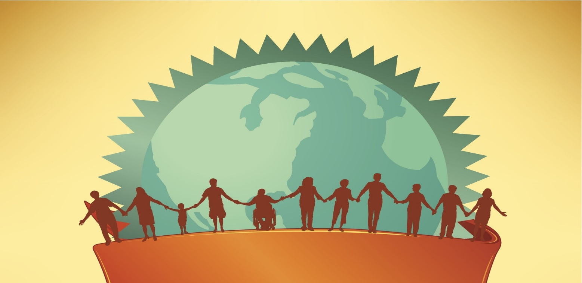

**When:** September 20 -24th

**Where:** King Salmon

**Hosted by:** SAFE & BBNA

**Facilitated by:** Christina Love

**Guest Presenters:** Johon Adkinson, Mary Cavalier, Doug Koester, JJ Larson

* **Our** History
* **Our** Trauma
* **Our** Systems
* **Our** Voices
* **Our** Healing
* **Our** Stories

*“As we focus on clearing our generational trauma, do not forget to claim our generations strengths. Our ancestors gave us more than just wounds.”*

This is a (1) Credit UAF/BBC credit course - enrollment is limited.

Travel and lodging will be provided

Contact Karen Carpenter: [auction@safebristolbay.org](mailto:auction@safebristolbay.org) or call 842-2320

You’re not going to want to miss this amazing training!

**SAVE THE DATE**

**Trauma informed advocacy training for Bristol Bay**